Greetings to Stainton and Hemlington Church Members and Friends of Stainton Church

Welcome to the e-News for
Friday 27th May 2022
We hope you are well and keeping safe. If you need any
practical support please do get in touch.


Come and join the Platinum Jubilee celebration!

Stainton Church is hosting a bring-and-share Picnic / Afternoon Tea to celebrate HM The Queen's 70-years as our Monarch; we do hope you will be able to come and join the party!!!!
Come and join us from 2.00-4.00pm on Friday 3rd June 2022 in the Churchyard and Parish Room. Please bring something delicious that you would like to share with others who come.
The Church will be open with a History Display and all manner of family activities.
We hope to have a display of Royal memorabilia so if you have commemorative china etc celebrating royal events (eg the Coronation or any of the Queen's Jubilees) please bring your items and display them for all to see; the Church will be open from 1.30pm to set up the display.

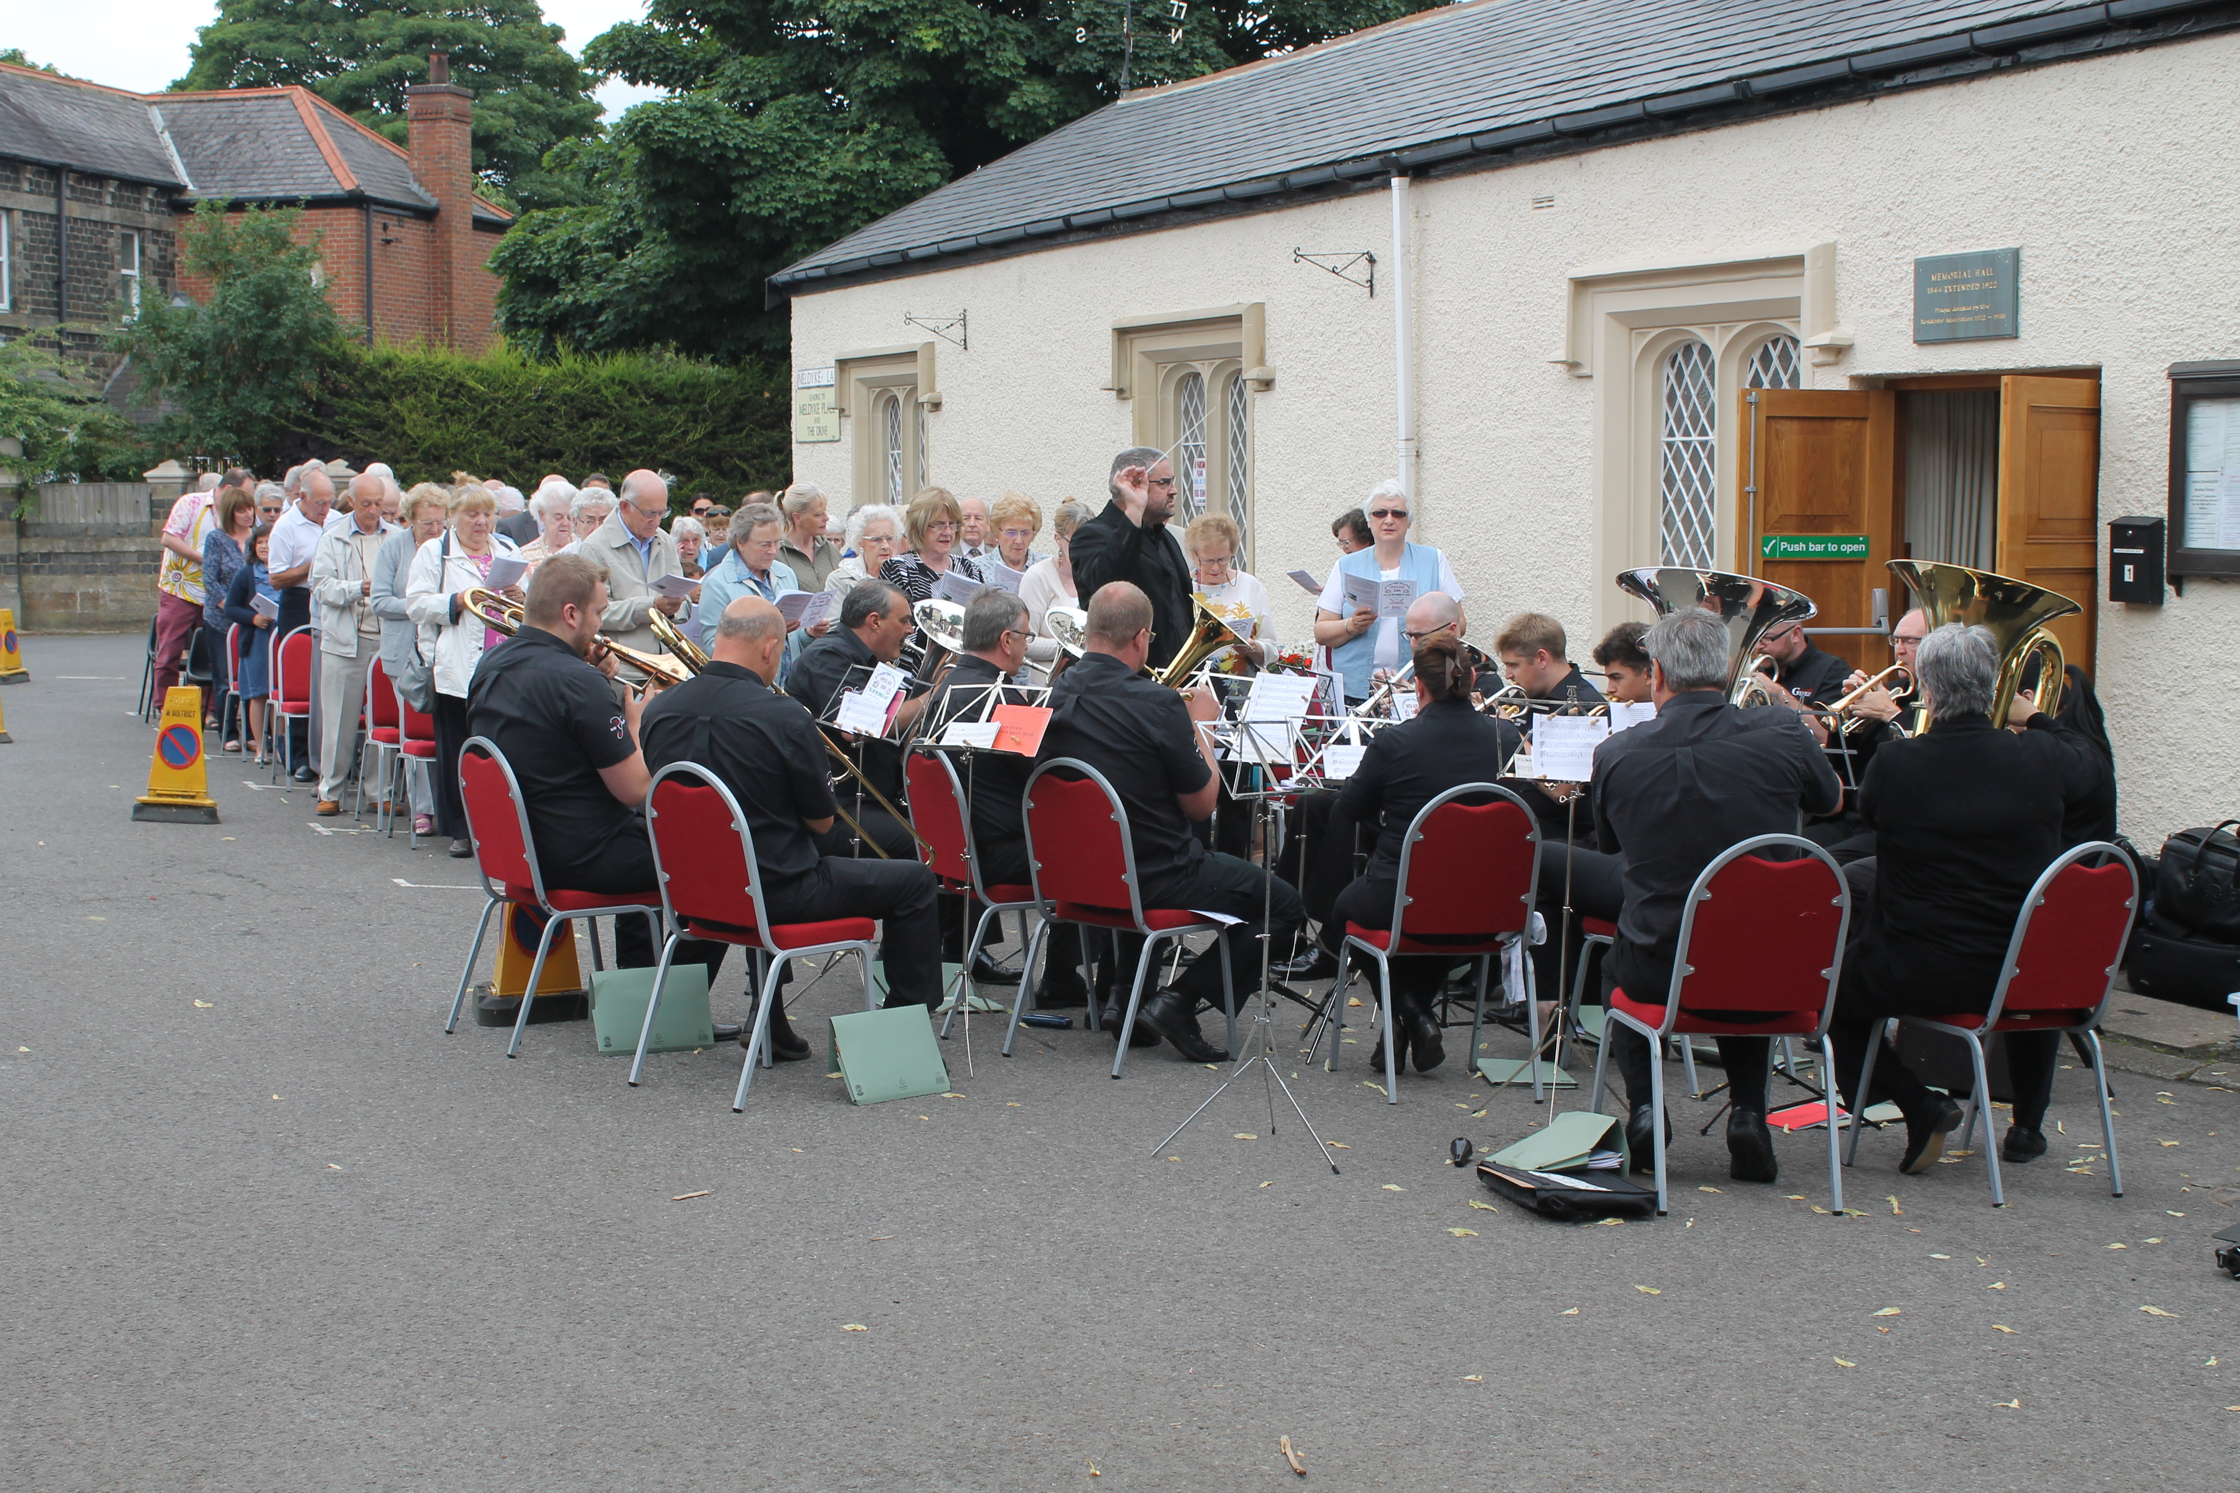
Stainton “Big Sing” – July 2017

Stainton "Big Sing" 2022
Dear e-News Readers: can we urge you to make a note in your diaries to attend the 2022 Stainton "Big Sing" at 3.00pm on Sunday 5th June 2022 (Pentecost Sunday).

The "Big Sing" is a joint venture between Stainton Parish Church and Stainton Methodist Church and will be held outside the Stainton Memorial Hall in Meldyke Square. There will be a number of readings given by members of the two Churches and some hymns led by a Brass/Silver Band.
Let's use this opportunity to proclaim our faith to those who live around us.

Jottings from Julia
for Ascensiontide
When I was a child, there was Easter (marked in our house by an outing on Bank Holiday Monday) and there was ‘Whit’. When I was very small, ‘Whit’ meant a new summer dress, new white ankle socks and sandals, and a parade behind the banner and band of the local Wesleyan church to Sheffield’s Weston Park, where we sang hymns and picnicked. I’ve been told that similar events took place in Middlesbrough at Whitsuntide and/or at Corpus Christi.
It was many years before I realised that there is another significant date in the Christian calendar between Easter and Pentecost. That date is Ascension – a Principal Feast, always falling on a Thursday. And I have to admit that my ideas about Ascension are fairly hazy even now. For a start, I’m not sure I can remember ever having gone to a service to mark it. I tell myself that this has more to do with the fact that Ascension falls midweek, or with the churchmanship of congregations I have belonged to, than with my ignorance or lack of motivation. But enough of my excuses. Better to come late to the party than not go at all – so what could Ascension mean for me now?
Forgive me, if you would, a linguistic excursion. Sine qua non is a Latin tag I return to often in my thoughts. It means ‘without which, nothing’. I use it to remind myself of what is important: those things I regard as ‘fundamental’, the foundations without which nothing can be built. This phrase also makes me pay attention to sequence: the order in which things occur. First things first, you might say. Here’s an example of what I mean. On the evening of the first Easter Day, the risen Christ gave his disciples a mission (John 20:21-23). Next he breathed on them, inviting them to ‘receive the Holy Spirit’. And then, in his final words to them before his ascension, he told them to wait: to stay in Jerusalem until they received the promise of the Father, the baptism of the Holy Spirit (Luke 24:49; Acts 1:4-5). So here’s the sequence. Go: there’s a job to do. Receive the Spirit. But wait. What are we to make of that?
In John’s gospel, Jesus promises that those who believe in him will do greater works than his, ‘because I am going to the Father’ (John 14:12). Putting all these scriptures together, I think I begin to see the point of the Ascension. Sine qua non. The ‘power from on high’ would not be fully received unless Jesus first ascended to the Father. The mission he gave to his followers – to do his works, to make disciples, to build his church – would not be fulfilled unless his physical presence with all of its limitations were first withdrawn from the earth: unless and until these limitations were transcended in the person of the Holy Spirit. It is the Spirit, the third person of the Trinity, unconstrained by space and time, who guides all Christian believers (John 14:26; John 16: 13-14), making real our relationship with Christ in God (Romans 8:16-17). Pentecost comes ten days after Ascension. How do we fill that time? Like those early Christians, we wait and we pray, as we have been encouraged to do in recent years through the worldwide initiative known as ‘Thy Kingdom Come’.
I must apologise that my exploration of Ascensiontide has turned out to be so wordy. I’m going to end now with a paraphrase. I hope you won’t think it flippant.
Wait. Don’t rush. The Spirit will give you the clout, the costume, the lines. I’ll be backstage from now on. Not out front where you can see me, but still directing the show. Never forget: I have a plan – we have a plan. You’ve passed the audition. And when the curtain goes up, there’ll be a part for every one of you. This isn’t a rehearsal; this is IT: life in all its fulness. TRUST ME.
Julia Ardley
______________________________________________________________

Services in our Churches this week
Sunday 29th May 2022 - Easter 7 - there will be services in our Churches as follows:

Brookfield 9.30am - Holy Communion, led by Revd Laura Wild, Assistant Curate at St Mary the Virgin, Nunthorpe;
Stainton 11.00am - Holy Communion, also led by Revd Laura Wild; and
Hilton 6.00pm - Evensong
On Wednesday 1st June 2022 there will be a Service of Holy Communion at 10.00am at Brookfield Church led by our Vicar, Revd Claire Todd.
____________________________
If you are unable to join us for the services on Sunday 29th May 2022 please do use the sheet for worship-at-home prepared by Joan Mason which we shall send out by separate e-mail and which you can download and print off from this link.
___________________________
Also you might like to watch and listen to the Diocesan Reflection for this Sunday, Easter 6 which is given by the Revd Jan Nobel, Diocesan Green Ambassador. Jan reflects on the Gospel reading for Easter 7 (John 17: 20-end). You can find the Reflection at this link.

________________________________________________________________



Please continue to pray for Ukraine
Here is a prayer from the Charity Christian Aid (CA), written by their Ireland Church and Community Manager David Thomas.
Lord of all people and all nations,
We lift before you the people of Ukraine and the people of Russia, each girl and boy, each woman and man living in fear of what tomorrow might bring, we long for a time you spoke of through your prophet Isaiah, when weapons of war would be beaten into ploughshares, when nation will no longer lift up sword against nation.

We cry out to you for peace, protect those who only desire and deserve to live in security and safety, comfort those who fear for their lives and the lives of their loved ones, change the hearts of those set on violence and aggression, fill earthly leaders with great wisdom to find paths to peace.

Please Lord come and have your way in your world, may your will be done here, on earth as it is in heaven, may your peace reign, now and always.

We lift this prayer to you, our God who is able to do more than we can ever ask or imagine, in the name of Christ our saviour.
Amen

___________________________________________________________

Leading Your Church into Growth
Can we remind you that it would be really good to use the LYCiG "prayer for growth" in your personal quiet times with God?

God of mission, Who alone brings growth to your Church, send your Holy Spirit to give:
- Vision to our planning,
- Wisdom to our actions,
- Joy to our worship, and
- Power to our witness.
Help our church to grow in numbers, in spiritual commitment to You and in service to our local community, through Jesus Christ our Lord.
Amen

Clergy Support
Here are our Vicar Revd Claire Todd's contact details:
Revd Claire Todd
Brookfield Vicarage, 89 Low Lane, Brookfield Middlesbrough TS5 8EF
Tel: 01642-975984
E-mail: revtoddy@gmail.com
Claire's day off is Friday; if you ring her please leave a message so that she can get back to you.

With all good wishes to you
Bob Ardley Ashdale House, 26 Meldyke Lane, Stainton, Middlesbrough TS8 9AU Tel: 01642-284525 E-mail: bob.ardley@ntlworld.com

