Greetings to Stainton and Hemlington Church Members and Friends of Stainton Church

Welcome to the weekly e-News for Friday 16th April 2021
We hope you are well and keeping safe.
If you need any practical support please do get in touch.

HRH Prince Philip,

the Duke of Edinburgh:

10th June 1921 - 9th April 2021

Funeral on Saturday 17th April 2021

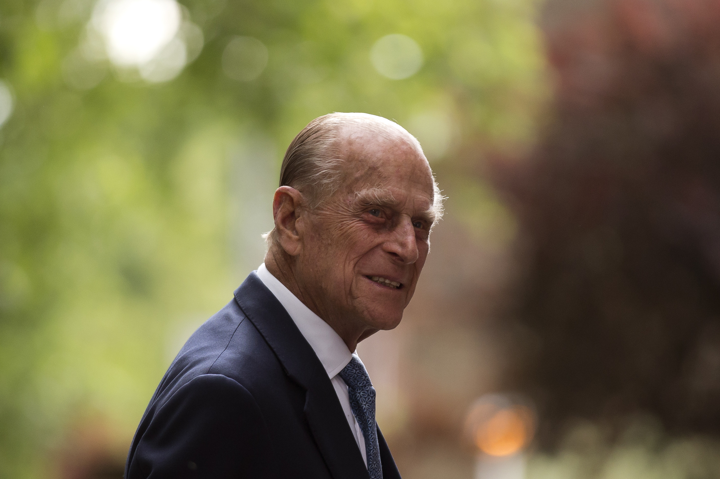

Many e-News readers will wish to watch the funeral of HRH Prince Philip which will be held at Windsor Castle at 3.00pm on Saturday 17th April 2021. Here are the details:
The event will be a Ceremonial Royal Funeral, the same as for Queen Elizabeth The Queen Mother, rather than a State Funeral (something which is generally reserved for Monarchs). There will be a small-scale Ceremonial Procession (in accordance with Prince Philip's wishes) from the Windsor Castle State Entrance to St George's Chapel for the Funeral Service. Prince Philip's Coffin will be followed by Military Service Chiefs reflecting his relationship with all areas of Defence. The Prince of Wales and other members of the Royal Family will follow the Coffin on foot; the Queen and her lady-in-waiting will travel by car.
The Coffin will emerge from the State Entrance to Windsor Castle at 2.40pm; the Procession will set off at 2.45pm and is expected to arrive at the steps to St George's Chapel at 2.53pm and the private Funeral Service will begin at 3.00pm with a National Minute's Silence. The private Service will be attended only by a small number of members of the Royal Family and Prince Philip's Private Secretary - a maximum of 30 "guests" in compliance with Covid-19 regulations - and will be led by the Archbishop of Canterbury and the Dean of Windsor.
The Funeral event will be broadcast by The BBC, ITV and Sky, as follows:
BBC1 from 12.30pm;
ITV1 from 1.45pm;
Sky One from 2.45pm
BBC Radio 4 from 2.00pm; and
BBC Radio 5 Live from 2.00pm

Services in our Churches this week
Our Services of Holy Communion on Sunday 18th April 2021 (Easter 3) will be led by our Vicar Revd Claire Todd. The services are: at 9.30am at Brookfield (*) and at 11.00am at Stainton.
On Wednesday 21st April 2021 at 10.00am there will be a Service of Holy Communion at Brookfield, led by Claire Todd.
Hilton Church remains closed for the time being.
There will be an on-line service of Compline ("Night Prayer") via Zoom at 6.30pm on Sunday once a fortnight; the next Compline Service will be on Sunday 25th April 2021 and the details you need to join the Zoom Compline are given below (**).
If you are unable to join us for the services in Church on Sunday 18th April 2021 please do use the sheet for worship-at-home prepared by Joan Mason which we shall send out by separate e-mail and which you can download and print off from this link.
Also you might like to watch and listen to the Diocesan Reflection for this Sunday which is given by the Revd John Lee, Team Leader for "Multiply" (the Diocesan initiative to reach the "20s to 40s" age group). John reflects on Jesus appearing to the Disciples after the Resurrection when He "opened their minds so they could understand the Scriptures" as told in the Gospel reading for Easter 3 (Luke 24:36b-48); you can find the Reflection at this link.
(*) Technology permitting, we hope that the Sunday service at Brookfield will be live-streamed on the St Margaret of Scotland, Brookfield Facebook page which you can find at this link.
(**) Topic: Claire Todd Compline Zoom Meeting - Join Zoom Meeting
https://us04web.zoom.us/j/75257354852?pwd=dVlGZmRvTW9EQXNSV1RNeTBuREZWZz09
Meeting ID: 752 5735 4852 Passcode: r1WmCL

Stainton Church is open for public worship
At Stainton our Covid Risk Assessment allows us to accommodate between 30-35 people safely and the Church is rarely full.
You:
- may attend as households;
- must wear a face covering in Church (unless exempt on medical grounds);
- should use the hand sanitiser when entering and leaving the Church;
- should follow the one-way route (in via the Parish Room door and out via the Main West door); and
- not mingle in the Church.

In the current Step 2 of the "Roadmap" to relax the Covid-19 lockdown people are asked to "stay local"; however, we can meet up outdoors with friends and family that we do not live with, either:
- in a group of up to 6 from any number of households (children of all ages count towards the limit of 6)
- in a group of any size from up to two households (each household can include an existing support bubble, if eligible)
So, whilst we cannot "mingle" with others in Church we can now at least pause for a chat in the Churchyard after the service as long as we follow this modified "rule of six".

Claire's Contemplation
This weekend sees the low-key funeral of HRH Prince Philip, Duke of Edinburgh. In keeping with the rules, there will only be 30 people in attendance, as opposed to the 800 who would have been on the official list. This is something the Duke would apparently have approved of, as he really didn’t want much fuss around it all. I imagine it will be dignified and poignant, a quiet farewell to a life well lived. A life in service and devotion: to his wife, to the nation and the Commonwealth, to his family, and most of all, to God.
As we have heard greatly over the last week, he had an extraordinary life, from not having anywhere to call home as a child despite being a Prince, no secure family base, having to flee and become a refugee, enduring much grief and loss, then joining the Navy and rising up the ranks, before meeting and eventually marrying a Princess, a woman who would become Queen of England. It was indeed a unique life.
Most of us of course have our own story to tell, and we may think our own lives unremarkable by comparison. But we shouldn’t compare really. Our stories and lives are just that. Ours. And this makes each and every one of them unique and special. I think my life is fairly unremarkable; that is, until I begin sharing it, and then I find others reflecting that it has been anything other than ordinary. Even though Jesus has always been part of my life, I haven’t always been obedient, and often gone off and done my own thing. Avoiding the call to ordination for several years is just one example. However, and you may have heard me say this before, and I will say it again and again, that I’m a firm believer that God will use anything and everything He is given for His greater glory. We have an Eco God, who wastes nothing.
When I look back over my own life and ponder events and experiences, I recognise where God has used it all, even though I may not have at the time. From the people I have encountered, to the places I’ve been, to the experiences I’ve had, both positive and negative, He has used it all. I see the thread and links of His guiding and leading. And more the fool me if I ever thought I’d escaped His loving gaze upon my life. Just because I haven’t always been obedient and instead gone off with my own stubbornness and agenda, does not mean He has for one minute ceased His tender watch over me. Like any loving parent/child relationship, children may think they’ve been able to escape unnoticed and get up to all kinds of mischief, without realising that the parent is watching and knows. When I was little, my mum used to tell us that she had eyes everywhere, and always found out what we’d been up to.
So as the nation, the commonwealth and the world pay tribute to a remarkable man and life, let us take this time to reflect on our own life stories, each unique, each special in its own way, and each one under the loving and watchful gaze of our Lord and creator God.
Revd Claire

Stainton with Hemlington Annual meetings 2021
A change of plan!

The 2021 Church Annual Meetings will be held online via "Zoom" at 2.00pm on Sunday 25th April 2021 rather than in Church after the morning service as originally planned. This is to comply with Government, National Church of England, and Diocesan Covid-19 guidance. Church members on the Electoral Roll will have received details of the "Zoom" joining instructions. Copies of the Agendas, Minutes, Annual Report for 2020 and Accounts for 2020 are available at this link.

As these meetings will the first for the new Stainton with Hemlington Parish we need to elect:
- two Churchwardens for one year;
- one Deanery Synod Rep for the remainder of the 2020-2023 term; and
- a full set of six Lay Reps on the Parochial Church Council (PCC).
Nomination forms are available in Church (or from Bob Ardley (tel: 01642-284525)); please do consider and pray about who you might nominate for these important roles.

Clergy Support - Here are our Vicar Revd Claire Todd's contact details:
Revd Claire Todd, Brookfield Vicarage, 89 Low Lane, Brookfield, M’bro TS5 8EF
Tel: 01642-975984 E-mail: revtoddy@gmail.com
Claire's day off is Friday; if you ring her please leave a message so that she can get back to you.

With all good wishes to you - Bob

Mr R G Ardley,
Ashdale House, 26 Meldyke Lane, Stainton, Middlesbrough TS8 9AU Tel: 01642-284525 E-mail: bob.ardley@ntlworld.com

