Greetings to Stainton and Hemlington Church Members and Friends of Stainton Church
Welcome to the weekly e-News for Friday 26th March 2021
We hope you are well and keeping safe, and are surviving the new national Covid19 lockdown. If you need any practical support please do get in touch.
In the current Covid19 lockdown people are asked to stay at home as much as possible; however, our Covid-safe Churches remain open for Communal Worship and we look forward to welcoming you.

There is some light at the end of the tunnel; the Government is relaxing some of the Covid19 restrictions from Monday 29th March 2021.

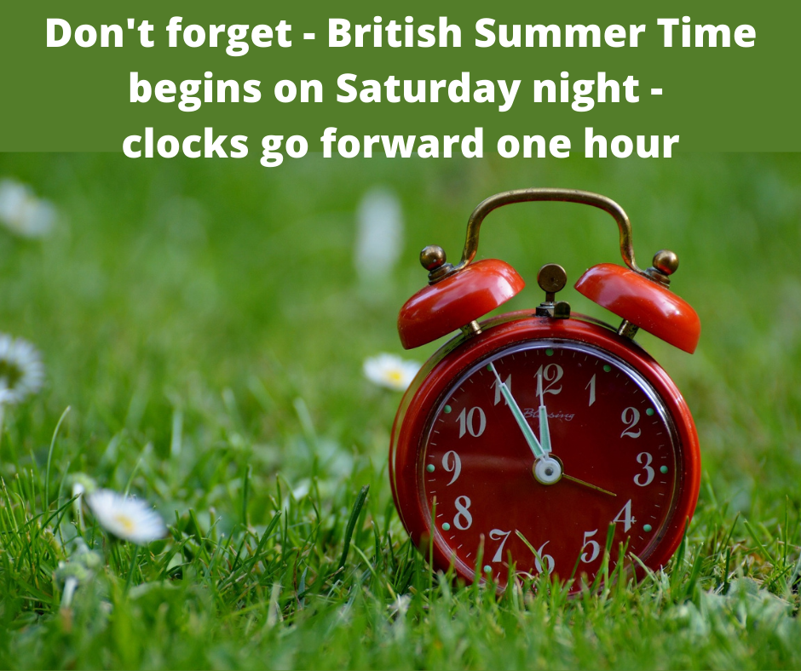
Please don't forget to change your clocks this weekend; move the time forward one hour when you go to bed on Saturday so that you get up at the right time on Sunday morning.
[Editor's Note: Technically BST begins at 2.00am on Sunday morning but I do not suggest you stay up past midnight just so that you can change your clock(s) at "zero hour"]

This week is Holy Week; here is what is happening in our Churches.
Sunday 28th March 2021 - Palm Sunday
Brookfield 9.30am Holy Communion
Stainton 11.00am Holy Communion
On "Zoom" 6.30pm Church Family Compline [ Meeting ID: 752 5735 4852; Passcode: r1WmCL ]

Monday 29th March 2021
Brookfield 6.30pm: Holy Week meditation - led by Revd Claire Todd
Stainton 6.30pm: Holy Week meditation - led by Julia Ardley, Parish Assistant

Tuesday 30th March 2021
Brookfleld 6.30pm: Stations of the Cross - led by Revd Claire Todd
Stainton 6.30pm: Stations of the Cross - led by Joan Mason, Lay Reader with PTO

Wednesday 31st March 2021
Brookfield 10.00am Holy Communion
On "Zoom" 6.30pm Lent Study Course [ Meeting ID: 957 0623 6640; Passcode: 495753 ]

Thursday 1st April 2021 - Maundy Thursday
Brookfield 6.30pm: Maundy Thursday Holy Communion led by Rt Revd Paul Ferguson, Bishop of Whitby
Stainton 6.30pm: Maundy Thursday Holy Communion led by Revd Claire Todd

Friday 2nd April 2021 - Good Friday
Stainton 10.00am: Children's event - Family outdoor activity and "walk-through-the-Church" activities with activity packs and Easter Eggs for the children - more details to follow.
Brookfield 1.00pm - 2.00pm: Good Friday Vigil - led by Revd Claire Todd
Stainton 2.30pm - 3.30pm: Good Friday Vigil - led by Revd Claire Todd

Saturday 3rd April 2021 - Holy Saturday
Hilton 3.00pm - 4.00pm: Family Easter Trail and Quiz with activity packs and Easter Egss for the children - more details to follow.

Sunday 4th April 2021 - Easter Day
Brookfield 9.00am Lighting of the Paschal Candle, the "Exsultet" (*) and procession into Church
Brookfield 9.30am Easter Day Holy Communion

Stainton 11.00am Lighting of the Paschal Candle, the "Exsultet"(*) and procession into Church
Stainton 11.30am Easter Day Holy Communion (note: later than usual service time)

(*) The Exsultet is part of the Easter Liturgy - you can find more details at this link: https://www.churchofengland.org/prayer-and-worship/worship-texts-and-resources/common-worship/churchs-year/holy-week-and-easter-3#mm075

Stainton Church is open for public worship
At Stainton our Covid Risk Assessment allows us to accommodate between 30-35 people safely and the Church is rarely full.
You:
- may attend as households;
- must wear a face covering in Church (unless exempt on medical grounds);
- should use the hand sanitiser when entering and leaving the Church;
- should follow the one-way route (in via the Parish Room door and out via the Main West door); and
- must not mingle before or after the service.
Hurrah! From Monday 29th March 2021 the Government is relaxing slightly some of the Covid19 restrictions; we shall be allowed to meet outdoors as a group of six people or two households. I guess that some of us will wish to take advantage of this freedom when we gather for worship during Holy Week and on Easter Day.

Services in our Churches this Sunday
Our Services of Holy Communion on Sunday 28th March 2021 (Lent 6 - Palm Sunday) will be led by our Vicar Revd Claire Todd. The services are: at 9.30am at Brookfield (*) and at 11.00am at Stainton.
On Wednesday 31st March 2021 at 10.00am there will be a service of Holy Communion at Brookfield, led by Claire Todd. Also on Wednesday 31st March 2021 at 6.30pm there will be the last (sixth) session of our Church Family (Plurality) Lent study course which is being held online via Zoom; the course will be led by Claire Todd.
Hilton Church remains closed for the time being.
Claire is hosting an on-line service of Compline ("Night Prayer") for the whole Church Family (Plurality) via Zoom at 6.30pm on Sunday once a fortnight; the next Compline Service will be on Sunday 28th March 2021 - here are the details you need to join the Zoom Compline:
Topic: Claire Todd Compline Zoom Meeting - Join Zoom Meeting
https://us04web.zoom.us/j/75257354852?pwd=dVlGZmRvTW9EQXNSV1RNeTBuREZWZz09
Meeting ID: 752 5735 4852; Passcode: r1WmCL
If you are unable to join us for the services in Church this Palm Sunday 28th March 2021 please do use the sheet for worship-at-home prepared by Joan Mason which we shall send out by separate e-mail and which you can download and print off from this link.
Also you might like to watch and listen to the Diocesan Reflection for this Sunday which is given by Revd Dr Jake Belder. Jake, who is the Priest-in-Charge of Londesborough Wold and Pocklington Wold, reflects on Jesus' entry into Jerusalem as told in the Gospel reading for this Sunday (Mark 11:1 - 11); you can find the Reflection at this link https://vimeo.com/528261885
(*) Technology permitting, we hope that the Sunday service at Brookfield will be live-streamed on the St Margaret of Scotland, Brookfield Facebook page which you can find at this link.

Claire’s Contemplation
On Sunday we embark on the beginning of Holy Week; we begin with Palm Sunday and follow the events of Jesus’ last week on earth as a human being. I say this not forgetting that Jesus is both fully human and fully divine (otherwise I could be tried for heresy!) It a time for us to engage with the range of emotions and feelings from the joy and triumph of Jesus’ entry into Jerusalem; the anger as he overturned tables in the temple; the poignancy of the last supper; the sense of despair and anguish in the garden of Gethsemane; his arrest and façade of a trial; the ridicule, mockery and abuse at the hands of the soldiers; his agonising, excruciating and torturous crucifixion; the desolateness and bereftness following his death, and waiting in the empty silence; before the confusion and bewilderment, turning to the elation and ecstasy of his glorious resurrection.
Life in all of its glory presents us with times in our lives when we come face to face with many (or all) of these emotions and feelings at some point. Some of them are welcome, others not so much. But through our emotions and feelings arising from our experiences, we encounter the reality of life in all of its fullness, and the reality of ourselves, including our own mortality. As we are all aware, this last year has left many with mental health issues, impacted those with existing mental health issues more severely, and sadly resulted in many taking their own lives, including far too many young people. The sorrow I feel at such loss is deep, and timely pressure needs to be put onto the government to plough resources and investment into this critical and essential area of our national life. It should not be left to struggling charities to try to plug the gap. The government have a national duty to step up and reverse their cut-backs and slow demise of mental health services.
Although faith in itself is not a cure for health problems, it is well documented that people who have a faith tend to recover more quickly and better from operations and hospital admissions. Good mental health involves addressing the spiritual side of our lives. The two cannot be entirely separated. And for me, the question is how we go about caring for those who are poor in terms of mental health; how we seize those opportunities to enable people to either turn back to God, or to come to know him in the first place, and place their lives in his hands. The impact of this epidemic is not lost with God, so let’s not ever underestimate the power of God.
Good Friday connects with something which touches the very core of our being. A time when we can strip away all of the shades of life which we put in place to cover up our own deep-seated fear of being mortal, and enter into the silence in the darkness, and also the paradox of that crucible where we are held and contained. There is a saying that the darkest time is just before the dawn, and if we can hold on, then we know that the dawn will surely come. For the dawn carries with it the darkness into the light of day, dispelling its power and might.
God wants us to become more fully ourselves, as well as filled with His divinity. Together, these aspects enable us to be the true selves that God calls us to be, through entering in some way into that suffering of God with a sense of empathy whilst knowing that the darkness is not forever, and this the light of the hope of life eternal, which transcends this life, is nearer than we can ever imagine.
Light heralds the end of darkness, and so as we approach the cross which awaits us on Good Friday, and then the waiting for the celebration of the glory of Easter, let us find our continuing strength and fortitude through the despair, in the God who paid the ultimate sacrifice to offer us that precious gift of eternal life.
May God be with you throughout this holiest of weeks in the year.
Revd Claire

Can you help with the "Household Impact of Coronavirus (COVID-19) Survey"?


Residents across the region are being urged to complete a Covid-19 impact survey which features questions about health, work, testing, self-isolating, vaccines and how Covid-19 has impacted life.
The survey, which is available from Tuesday 9 March, is being coordinated by Alice Wiseman, Director of Public Health, Gateshead Council [Editor's note: you may have heard her interviewed many times on the BBC News programmes] who is leading a workstream on behavioural change as part of the North East Region’s pandemic response and recovery plans. The survey aims to get region wide insight into the impact of Covid-19 and is being supported by Durham University, the National Institute for Health Research, and the NHS Integrated Covid Hub North East.
Karen Deen, Food Insecurity Project Officer at Together Middlesbrough and Cleveland (TMC)(*), said: “We recognise how difficult it has been for people to cope with the coronavirus (COVID-19) pandemic. Please complete our survey to help us understand more about how your day-to-day life has been affected, including health and wellbeing, work, household finances, shopping, social and leisure activities. We are keen to hear your views on vaccination, the economy and the easing of lockdown restrictions and social distancing.
“The results will help us to identify additional support people might need to manage changes to livelihoods and day to day living. Your responses are vital to informing local recovery plans over the coming months.
“Information provided by you will be used by local councils, Durham University, NHS NE Integrated Covid Hub, and the National Institute for Health Research in line with current data sharing practices. The information being asked for is anonymous and will be securely held and kept confidential. If the data is published it will be entirely anonymous and cannot be identifiable as yours.”
We would urge all of those who live in the Middlesbrough Council Area to fill in the survey and help shape our future work.”
You can find the survey at the link below. The closing date for responses is Sunday 28th March 2021.
https://consultation.gateshead.gov.uk/kms/elab.aspx?CampaignId=1033&noip=1

(*) TMC is a joint venture between the Church Urban Fund and the Diocese of York

Stainton with Hemlington Annual meetings 2021
Can we remind you that the 2021 Church Annual Meetings will be held in Church at 12.00pm on Sunday 25th April 2021 immediately after the 11am morning service (*).
In preparation for the Annual Meetings the Church Electoral Roll for 2019-2025 will be revised. The revision will commence on Saturday 27th March 2021 and end on Saturday 3rd April 2021. Applications forms to join the Roll are available in Church (or from Bob Ardley, Electoral Roll Officer - Tel: 01642-284525 or e-mail: bob.ardley@ntlworld.com). Copies of the new combined Roll (previous Stainton Roll and previous Hemlington Roll) are on the notice boards in the Church porch and Parish Room; those whose name is on the new combined Roll do not need to re-apply.
(*) The Meetings will be held in Church provided that this is allowed by the Government Covid19 restrictions; if the Covid19 restrictions do not permit non-worship gatherings in Church on that day the two meetings will be held online via "Zoom".

Clergy Support - Here are our Vicar Revd Claire Todd's contact details:
Revd Claire Todd, Brookfield Vicarage, 89 Low Lane, Brookfield
Middlesbrough TS5 8EF
Tel: 01642-975984 E-mail: revtoddy@gmail.com
Claire's day off is Friday; if you ring her please leave a message so that she can get back to you.

With all good wishes to you

Bob
Mr R G Ardley, Ashdale House, 26 Meldyke Lane, Stainton, Middlesbrough TS8 9AU
Tel: 01642-284525 mailto: bob.ardley@ntlworld.com

