Greetings to Stainton and Hemlington Church Members and Friends of Stainton Church

Welcome to the Stainton Church e-News for

Friday 3rd October 2025

We hope you are well and keeping safe. If you need any
practical support, please do get in touch.

Celebrating Generosity!

Our PCCs are so, so grateful for the generosity of Church Members and Friends who donate money to fund the activities of the three Churches in our Group (Plurality).

In 2024 it cost about £38,000 - that is about £730 per week - to run Stainton Church, all of which came from kind and generous donations from individuals (the Church does not receive any funding from the Government).

On Saturday 4th October 2025 Stainton Church is holding its annual Gift Day; from 09.30 until 12.00noon the Vicar and Churchwarden will be at the Church Gates on Hemlington Road to receive donations from Church Friends in our Parish. The Church will be open and refreshments served; at the same time the Church will be decorated for the Harvest Festival “Café Church” service to be held at 11.00am the following morning (Sunday 5th October). We would be very pleased to receive any Harvest gifts of non-perishable foodstuffs that you would like to donate at this service, all of which will be sent to the Hemlington Eco-Shop.

A “Gift Day” letter from the Vicar and a donation envelope was delivered to each household in Stainton and Thornton during the week beginning on Monday 29th September 2025.

Introducing “Cornerstone”

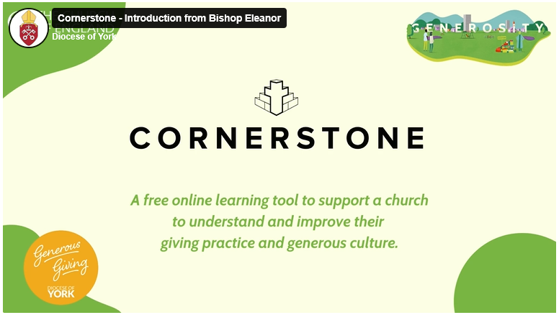

Stainton with Hemlington PCC and Brookfield PCC have each signed up to use “Cornerstone”, an online platform/tool to help us understand and improve our giving practice and generous culture.

“Cornerstone” has been developed by the Church of England National Giving Team and is supported by Phil McBride and Jan Grey of the York Diocesan Generous Giving Team.

The two PCCs will each be conducting a survey of Church Members to gather some basic data which will help them to populate the Cornerstone tool so that “it” can give us useful information.

Important: If you are a Member of Stainton Church – or of Brookfield Church - we would strongly encourage you to complete the survey online for us; it will only take you about five minutes. You will be asked to answer less than 30 tick-box questions covering 8 key categories, based on your personal experience as a church member. Please respond quickly and honestly—don’t overthink your answers, just go with your initial thoughts.
Important: To complete the survey please just click on this link .
- If you are from Stainton, please use the Questionnaire Code 4.1b
- If you are from Brookfield, please use the Questionnaire Code 4.1a

Important: If you would like to complete the survey but are unable to do this online, please send the Editor a text message to mobile number 07910-075752 and he will let you have a paper copy of the questionnaire to complete instead.

Important: It would help enormously if you can complete the survey as soon as possible and before bedtime on Sunday 5th October 2025.

Once again, a big “Thank You” to all those who give money to support the work of our Churches.

_____________________________________

Plurality Bible Study Course


Picture Credit: The Bible Society
Our Vicar, Revd Laura Wild, is running a seven-week Bible Study Course for people from all three of our Churches. The Course is held at St Margaret's Church Hall, Brookfield at 2.00-3.00pm on the Mondays 8th September to 20th October 2025 and will follow "The Bible Series" material from the Bible Society.

The Bible Series will deepen our understanding of the Bible and its over-arching story and help us engage in great conversation. Discover the Bible: world-shaping literature, in one big story, which still cuts through to the heart today. The seven sessions are:
Part 1: Introducing the Bible – What is the Bible? See the Bible's relevance in the twenty-first century.
Part 2: Origins and Meaning – Why were we created? Genesis shows us that we are created on purpose, for a purpose.
Part 3: Exodus and Freedom – What is freedom? Explore freedom from captivity and freedom in Jesus.
Mon 29th Sept - Part 4: Exile and Peace – How do we deal with suffering? Find hope beyond the darkness.
Mon 6th Oct - Part 5: Messiah and Love – Who is Jesus? Discover the source of true love.
Part 6: Spirit and Community – What part do we have to play? See how God uses normal people like us and how we are made for community.
Part 7: Hope and home – How does the story of the Bible end? Our future hope inspires confidence in our uncertainty today.
____________________________________

Services and Events in our Churches over the next two weeks
On Saturday 4th October 2025 Stainton Church is holding its annual Gift Day; from 09.30 until 12.00noon the Vicar and Churchwarden will be at the Church Gates on Hemlington Road to receive donations from Church Friends in our Parish. The Church will be open and refreshments served; at the same time the Church will be decorated for the Harvest Festival “Café Church” service to be held at 11.00am the following morning (Sunday 5th October). If you cannot attend the Harvest Café Church service you can bring an offering of non-perishable foodstuffs to the Church on the Saturday morning, all of which will be sent to the Hemlington Eco-Shop.
_____________________________________
On Sunday 5th October 2025 – Trinity 16 – there will be services as follows:
At 9.30am at Brookfield Church a service of Holy Communion at which our Vicar, Revd Laura Wild, will preside.
At 9.30am at Hilton Church a service of Holy Communion at which Revd Marie Edwards will preside.
At 11.00am at Stainton Church an informal Harvest Festival Café Church service with discussion, quizzes and simple refreshments led by our Vicar, Revd Laura Wild. [Editor's note: There will NOT be Holy Communion at this service]. We would be very pleased to receive any Harvest gifts of non-perishable foodstuffs that you would like to donate at this service, all of which will be sent to the Hemlington Eco-Shop.
The lessons set in the Lectionary for Trinity 16 (Proper 22) are:
- Habakkuk 1:1-4, 2:1-4
- Psalm 37:1-9
- 2 Timothy 1:1-14
- Luke 17:5-10

The lessons set in the Lectionary for a Harvest Festival service are:
- Deuteronomy 26:1-11
- Psalm 100
- Philippians 4:4-9 or Revelation 14:14-18
- John 6:25-35
The Diocese says: We are temporarily taking a break from publishing weekly Sunday Reflections. In the meantime, you can watch Church of England’s weekly service, broadcast live every Sunday at 9.00am by following this link: Weekly Online Service

On Monday 6th October 2025 at 2.00pm in Brookfield Church Hall there will be the fifth session (“Messiah and Love – Who is Jesus?”) of our Plurality Bible Study Course led by our Vicar, Revd Laura Wild. The sessions last for about one hour and follow “The Bible Series” material from The Bible Society.
On Tuesday 7th October 2025 at 9.30am at Stainton Church there will be a half-hour Plurality Prayer Gathering.
On Wednesday 8th October 2025 at 10.00am at Brookfield Church there will be a service of Holy Communion.
On Thursday 9th October 2025 at 6.00-7.30pm at Brookfield Church there will be a Baby Loss Awareness Event to remember all of the much-loved babies who died too soon, as part of Baby Loss Awareness Week 2025 which takes place 9th-15th October 2025.

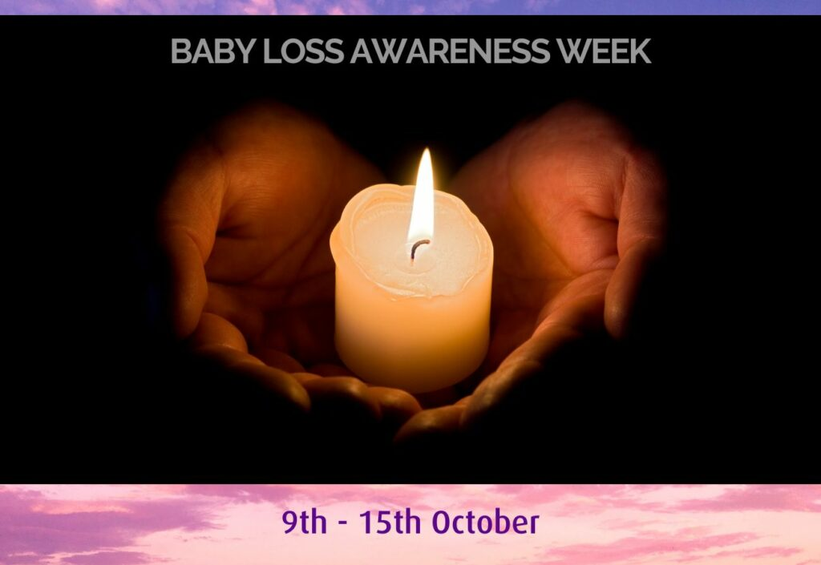

On Saturday 11th October 2025 it is the Hilton Annual Gift Day. From 10.00am to 12.00noon the Church will be open. Envelopes for donations will be posted throughout the village prior to this occasion. You are welcome to join us on the day, or you can deliver your donation anytime during the week. Hilton PCC are grateful for any help and support, to keep our Grade 1 listed church open for services and in good order.
_____________________________________
On Sunday 12th October 2025 – Trinity 17 there will be services as follows:
At 9.30am at Brookfield Church a service of Holy Communion at which our Vicar, Revd Laura Wild, will preside and at which we shall welcome our guest speaker the Venerable John Day (Diocesan Growing Healthy Churches Adviser).
At 11.00am at Stainton Church a service of Holy Communion at which Revd Laura will also preside and at which we shall welcome our guest speaker the Venerable John Day (Diocesan Growing Healthy Churches Adviser).
At 4.00pm at Hilton Church a service of Evensong led by Revd Laura.
The lessons set in the Lectionary for Trinity 17 (Proper 23) are:
- 2 Kings 5:1-3, 7-15c
- Psalm 111
- 2 Timothy 2:8-15
- Luke 17:11-19
The Diocese says: We are temporarily taking a break from publishing weekly Sunday Reflections. In the meantime, you can watch Church of England’s weekly service, broadcast live every Sunday at 9.00am by following this link: Weekly Online Service
The Diocesan Reflections up to Trinity 12 are available at this link.

On Monday 13th October 2025 at 2.00pm in Brookfield Church Hall there will be the sixth session (Spirit and Community – What part do we have to play?) of our Plurality Bible Study Course led by our Vicar, Revd Laura Wild. The sessions last for about one hour and follow “The Bible Series” material from The Bible Society.
On Tuesday 14th October 2025 at 9.30am at Stainton Church there will be a half-hour Plurality Prayer Gathering.
On Wednesday 15th October 2025 at 10.00am at Brookfield Church; there will be a service of Holy Communion at which our Vicar, Revd Laura Wild, will preside.
_____________________________________
Please continue to pray

… for Myanmar and neighbouring Thailand
… for Afghanistan
… for Israel and Palestine

… and for Ukraine and Russia

_____________________________________

Please join us in praying for our Churches to Grow

Can we invite you to use our Revitalise "prayer for growth" in your personal quiet times with God?

Revitalise us Lord,
Enthuse in our congregations the desire for mission. Give
Vision to our planning and
Inspire our thoughts as we seek Your will.
Teach us to be more like You, Christ
Abiding in You and
Loving one another.
In growing healthy churches,
Sharing our faith, living Christ’s story
Every day, help us to be faithful disciples and bear much fruit. Amen.
_____________________________________

Pastoral Support - Here are the contact details for our Vicar, Revd Laura Wild:

Address: The Vicarage, 89 Low Lane, Brookfield, Middlesbrough TS5 9EF
Phone: 01642-598621
E-mail: rev.laura.wild@gmail.com

Laura's normal "day off" is Friday - if you need to contact her on that day, please leave a message on the answerphone.
______________________________________

Bob Ardley

26 Meldyke Lane,
Stainton,
Middlesbrough TS8 9AU

T: 01642-284525
E: bob.ardley@ntlworld.com

