Greetings to Stainton and Hemlington Church Members and Friends of Stainton Church

Welcome to the Stainton Church e-News for

Friday 5th September 2025

We hope you are well and keeping safe. If you need any
practical support, please do get in touch.

Plurality Bible Study Course


Picture Credit: The Bible Society

Our Vicar, Revd Laura Wild, is running a seven-week Bible Study Course for people from all three of our Churches. The Course is held at St Margaret's Church Hall, Brookfield at 2.00-3.00pm on the Mondays 8th September to 20th October 2025 and will follow "The Bible Series" material from the Bible Society.
The Bible Series will deepen our understanding of the Bible and its over-arching story, and help us engage in great conversation. Discover the Bible: world-shaping literature, in one big story, which still cuts through to the heart today. The seven sessions are:
Part 1: Introducing the Bible – What is the Bible? See the Bible's relevance in the twenty-first century.
Part 2: Origins and Meaning – Why were we created? Genesis shows us that we are created on purpose, for a purpose.
Part 3: Exodus and Freedom – What is freedom? Explore freedom from captivity and freedom in Jesus.
Part 4: Exile and Peace – How do we deal with suffering? Find hope beyond the darkness.
Part 5: Messiah and Love – Who is Jesus? Discover the source of true love.
Part 6: Spirit and Community – What part do we have to play? See how God uses normal people like us and how we are made for community.
Part 7: Hope and home – How does the story of the Bible end? Our future hope inspires confidence in our uncertainty today.
_____________________________________
Plurality Confirmation Service 2025

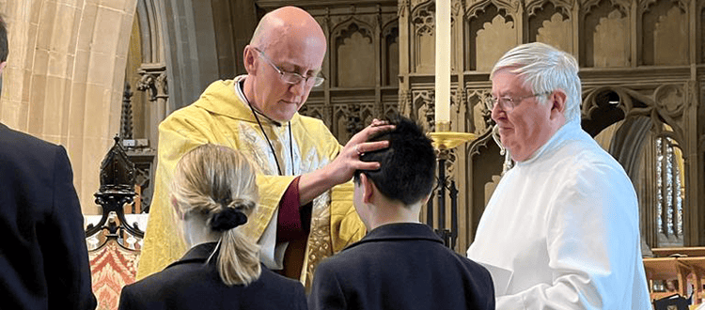
Picture credit: Wells Cathedral School

On Sunday 7th September 2025 at 9.30am at St Margaret’s Church Brookfield our Bishop of Whitby, the Rt Revd Barry Hill will conduct a Confirmation service for our Plurality. Bishop Barry will confirm two people as they take their next steps in their Christian Faith journey. This is a service of public worship and is open to anyone to attend.

Please do pray for the two Confirmation candidates, and for Bishop Barry, as they prepare for this special “life-event” service.

[Editor’s note: The photo above shows the Bishop of Bath and Wells, the Rt Revd Michael Beasley, laying hands on a student at the Wells Cathedral School during a Confirmation service at the school in April 2023]
_____________________________________

Services and Events in our Churches over the next two weeks
On Sunday 7th September 2025 – Trinity 12 – there will be services as follows:
At 9.30am at Brookfield Church a Confirmation service at which our Bishop of Whitby, the Rt Revd Barry Hill, will preside;
At 9.30am at Hilton Church a service of Morning Prayer led by one of the Hilton Churchwardens; and
At 11.00am at Stainton Church a “Café Church” service of informal worship with discussions, quizzes, worship songs and hymns and simple refreshments, led by our Vicar, Revd Laura Wild. At this service we shall be thinking about new beginnings – a new term at school or college, or perhaps a new job. Our Vicar invites you to bring your school bag or work bag to the service for a blessing as we contemplate these new beginnings. [Editor’s note: there will not be Holy Communion at this service].
The lessons set in the Lectionary for Trinity 12 (Proper 18) are:
- Deuteronomy 30:15-20
- Psalm 1
- Philemon 1-21
- Luke 14:25-33
The Diocesan Reflection for Trinity 12 is given by the Revd Canon Liz Hassall, Acting Archdeacon of York. Archdeacon Liz reflects on the Gospel reading set in the Lectionary (Luke 14:25-33); you can find the Reflection at this link.

On Monday 8th September 2025 at 2.00pm in Brookfield Church Hall there will be the first session (“Introducing the Bible”) of our Plurality Bible Study Course led by our Vicar, Revd Laura Wild. The sessions last for about one hour and follow “The Bible Series” material from The Bible Society.
On Tuesday 9th September 2025 at 9.30am at Stainton Church there will be a half-hour Plurality Prayer Gathering.
On Wednesday 10th September 2025 at 10.00am at Brookfield Church there will be a service of Holy Communion
_____________________________________
On Sunday 14th September 2025 – Trinity 13 (it is also Holy Cross Day) there will be services as follows:
At 9.30am at Brookfield Church a service of Holy Communion at which our Vicar, Revd Laura Wild, will preside.
At 11.00am at Stainton Church a service of Holy Communion at which our Pioneer Minister, Revd Vanessa Kirby, will preside.
At 4.00pm at Hilton Church a service of Evensong led by Revd Vanessa.
The lessons set in the Lectionary for Trinity 13 (Proper 19) are:
- Exodus 32:7-14
- Psalm 113
- 1 Timothy 2:1-7
- Luke 15:1-10
The lessons set in the Lectionary for Holy Cross Day are:
- Numbers 21:4-9
- Psalm 32:23-28
- Philippians 2:6-11
- John 3:13-17
The Diocesan Reflection for Trinity 13 will be available at this link from about the Thursday before Trinity 13 Sunday.

On Monday 15th September 2025 at 2.00pm in Brookfield Church Hall there will be the second session (“Origins and meaning”) of our Plurality Bible Study Course led by our Vicar, Revd Laura Wild. The sessions last for about one hour and follow “The Bible Series” material from The Bible Society.
On Tuesday 16th September 2025 at 9.30am at Stainton Church there will be a half-hour Plurality Prayer Gathering.
On Wednesday 17th September 2025 at 10.00am at Brookfield Church; there will be a service of Holy Communion at which our Vicar, Revd Laura Wild, will preside.
_____________________________________
Please continue to pray

… for Myanmar and neighbouring Thailand

Pray for all those affected by the recent massive earthquake that occurred in Myanmar on Friday 28th March 2025: for the Military Junta in Myanmar; the success of the DEC Myanmar Earthquake Appeal, and all the humanitarian aid agencies seeking to support those in great need. Nearly five months on from the earthquake, people still need critical support including food, water, shelter and medical aid.

… for Israel, Palestine and now Iran

The situation in the Middle East has become catastrophic! We need as much specific prayer as possible. Please pray for;
- Hamas to release the remaining Israeli hostages as soon as possible
- A softening of Israel’s stance on Palestine and a willingness to negotiate constructively for an end to the war in Gaza and the West Bank.
- The opening up of the border crossings between Israel and Gaza, and for the resumption of humanitarian aid and relief to reach those who so desperately need it.
- For Iranian, Palestinian and Israeli Christians that they would be strong in their faith as they trust God for their future.

…. and for Ukraine and Russia

For an early end to the war between Russia and Ukraine, giving thanks that talks are taking place and pray that there will be a satisfactory outcome to those talks which is acceptable to both sides.

Your Editor has found a prayer video for Ukraine which you can watch on our website at this link

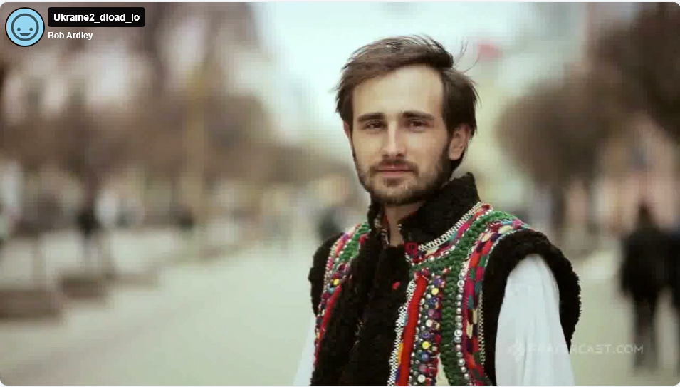.
_____________________________________

Please join us in praying for our Churches to Grow

Can we invite you to use our Revitalise "prayer for growth" in your personal quiet times with God?

Revitalise us Lord,
Enthuse in our congregations the desire for mission. Give
Vision to our planning and
Inspire our thoughts as we seek Your will.
Teach us to be more like You, Christ
Abiding in You and
Loving one another.
In growing healthy churches,
Sharing our faith, living Christ’s story
Every day, help us to be faithful disciples and bear much fruit. Amen.

_____________________________________

Pastoral Support - Here are the contact details for our Vicar, Revd Laura Wild:

Address: The Vicarage, 89 Low Lane, Brookfield, Middlesbrough TS5 9EF
Phone: 01642-598621
E-mail: rev.laura.wild@gmail.com

Laura's normal "day off" is Friday - if you need to contact her on that day, please leave a message on the answerphone.
______________________________________

Bob Ardley

26 Meldyke Lane,
Stainton,
Middlesbrough TS8 9AU
T: 01642-284525
E: bob.ardley@ntlworld.com

