Greetings to Stainton and Hemlington Church Members and Friends of Stainton Church

Welcome to the Stainton Church e-News for

Friday 29th August 2025

We hope you are well and keeping safe. If you need any
practical support, please do get in touch.

Our next 5th Sunday Special Plurality Holy Communion



Picture credit: Photo by Jarritos Mexican Soda on Unsplash

Our next 5th Sunday Special Plurality Holy Communion will be held at 10.30am on Sunday 31st August 2025 at St Peter’s Church, Hilton, and at which our Vicar, Revd Laura Wild will preside.

After the service there will be a “bring and share” picnic lunch in the playground next to Hilton Village Hall. We would love you to come and join with us for this Communion service and to share fellowship with us afterwards. Please do bring a picnic lunch, and a picnic rug and/or a folding chair if you are able to.

_____________________________________

Plurality Confirmation Service 2025

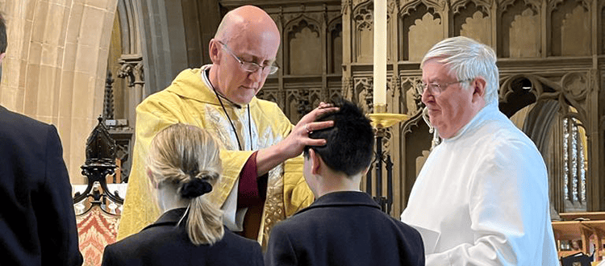
Picture credit: Wells Cathedral School

On Sunday 7th September 2025 at 9.30am at St Margaret’s Church Brookfield our Bishop of Whitby, the Rt Revd Barry Hill will conduct a Confirmation service for our Plurality. Bishop Barry will confirm two people as they take their next steps in their Christian Faith journey. This is a service of public worship and is open to anyone to attend.

Please do pray for the two Confirmation candidates, and for Bishop Barry, as they prepare for this special “life-event” service.

[Editor’s note: The photo above shows the Bishop of Bath and Wells, the Rt Revd Michael Beasley, laying hands on a student at the Wells Cathedral School during a Confirmation service at the school in April 2023]
_____________________________________

Services and Events in our Churches over the next two weeks
On Sunday 31st August 2025 – Trinity 11 there will be a single joint fifth-Sunday special Plurality Holy Communion Service at 10.30am at St Peter’s Church, Hilton, at which our Vicar, Revd Laura Wild, will preside. The service will be followed by a “bring and share” picnic lunch in the playground next to the Hilton Village Hall. Please bring a picnic lunch, and a picnic rug and/or a folding chair if you can.
The lessons set in the Lectionary for Trinity 11 (Proper 17) are:
- [Ecclesiasticus 10:12-18 or] Proverbs 25:6-7
- Psalm 112
- Hebrews 13-:1-8, 15, 16
- Luke 14:1, 7-14
The Diocesan Reflection for Trinity 11 is given by the Rt Revd Flora Winfield, Bishop of Selby. Bishop Flora reflects on the Gospel reading set in the Lectionary (Luke 14:1, 7-14); you can find the Reflection at this link.

On Tuesday 2nd September 2025 at 9.30am at Stainton Church there will be a half-hour Plurality Prayer Gathering.
On Wednesday 3rd September 2025 at 10.00am at Brookfield Church; there will be a service of Holy Communion at which our Vicar, Revd Laura Wild, will preside.
_____________________________________

On Sunday 7th September 2025 – Trinity 12 – there will be services as follows:
At 9.30am at Brookfield Church a Confirmation service at which our Bishop of Whitby, the Rt Revd Barry Hill, will preside;
At 9.30am at Hilton Church a service of Morning Prayer led by one of the Hilton Churchwardens; and
At 11.00am at Stainton Church a “Café Church” service of informal worship with discussions, quizzes, worship songs and hymns and simple refreshments, led by our Vicar, Revd Laura Wild. At this service we shall be thinking about new beginnings – a new term at school or college, or perhaps a new job. Our Vicar invites you to bring your school bag or work bag to the service for a blessing as we contemplate these new beginnings. [Editor’s note: there will not be Holy Communion at this service].
The lessons set in the Lectionary for Trinity 12 (Proper 18) are:
- Deuteronomy 30:15-20
- Psalm 1
- Philemon 1-21
- Luke 14:25-33
The Diocesan Reflection for Trinity 12 will be available at this link from about the Thursday before Trinity 12 Sunday.

On Tuesday 9th September 2025 at 9.30am at Stainton Church there will be a half-hour Plurality Prayer Gathering.
On Wednesday 10th September 2025 at 10.00am at Brookfield Church there will be a service of Holy Communion
_____________________________________

Please continue to pray

… for Myanmar and neighbouring Thailand

Pray for all those affected by the recent massive earthquake that occurred in Myanmar on Friday 28th March 2025: for the Military Junta in Myanmar; the success of the DEC Myanmar Earthquake Appeal, and all the humanitarian aid agencies seeking to support those in great need. Nearly five months on from the earthquake, people still need critical support including food, water, shelter and medical aid.

… for Israel, Palestine and now Iran

The situation in the Middle East has become catastrophic! We need as much specific prayer as possible. Please pray for;
- Hamas to release the remaining Israeli hostages as soon as possible
- A softening of Israel’s stance on Palestine and a willingness to negotiate constructively for an end to the war in Gaza and the West Bank.
- The opening up of the border crossings between Israel and Gaza, and for the resumption of humanitarian aid and relief to reach those who so desperately need it.
- For Iranian, Palestinian and Israeli Christians that they would be strong in their faith as they trust God for their future.

…. and for Ukraine and Russia

For an early end to the war between Russia and Ukraine, giving thanks that talks are taking place and pray that there will be a satisfactory outcome to those talks which is acceptable to both sides.

_____________________________________

Please join us in praying for our Churches to Grow

Can we invite you to use our Revitalise "prayer for growth" in your personal quiet times with God?

Revitalise us Lord,
Enthuse in our congregations the desire for mission. Give
Vision to our planning and
Inspire our thoughts as we seek Your will.
Teach us to be more like You, Christ
Abiding in You and
Loving one another.
In growing healthy churches,
Sharing our faith, living Christ’s story
Every day, help us to be faithful disciples and bear much fruit. Amen.
_____________________________________

Pastoral Support - Here are the contact details for our Vicar, Revd Laura Wild:

Address: The Vicarage, 89 Low Lane, Brookfield, Middlesbrough TS5 9EF
Phone: 01642-598621
E-mail: rev.laura.wild@gmail.com

Laura's normal "day off" is Friday - if you need to contact her on that day, please leave a message on the answerphone.
______________________________________

Bob Ardley

26 Meldyke Lane,
Stainton,
Middlesbrough TS8 9AU
T: 01642-284525
E: bob.ardley@ntlworld.com

