Greetings to Stainton and Hemlington Church Members and Friends of Stainton Church

Welcome to the Stainton Church e-News for

Friday 11th July 2025

We hope you are well and keeping safe. If you need any
practical support, please do get in touch.

Men’s Breakfast 2025 – Come and hear Gram Seed’s story!

Following on from the very successful “Our Golden Girls” afternoon tea held at St Margaret’s, Brookfield on 27th March 2025 our Pioneer Minister, Revd Vanessa Kirby has organised a “Men’s Breakfast” on Saturday 12th July 2025 from 9.30am to 11.30am, also at St Margaret’s Church, Brookfield.

The guest speaker at the “Men’s Breakfast” is Gram Seed of Sowing Seeds Ministries – Gram will be sharing about his “life transformed by Jesus”. The event is free of charge to attend and is open to all men across Teesside – please arrive promptly at 9.30am for the breakfast. There will be an opportunity to make a donation to support the work of Sowing Seeds. Here is Gram’s “potted biog”

Gram Seed was written off by family, neighbours, teachers and the police as a lost cause. His chaotic life led him on a journey of drugs, violence, prison, and homelessness, culminating in a coma. The medics encouraged Gram's mother to switch off the life support machines, as they believed all hope of him surviving had gone. However, after a group of Christians prayed for him, Gram made a miraculous recovery and awoke from the coma.

With the strength of his newfound faith, Gram founded Sowing Seeds Ministries, and he, along with his team, helps others struggling with life's trials to find hope in God's amazing love and forgiveness.



To assist with the catering for the Breakfast please e-mail Revd Vanessa to let her know that you are coming, especially if you will be bringing a friend (which we hope you will do!) – e-mail to rev.vanessakirby@gmail.com
Our PCC is now (almost) complete!

Members of Stainton Church offer their very grateful thanks to Colin Mason for all his hard work over very many years as Churchwarden (since March 1979) and as PCC Treasurer (since March 2003 when he retired from his work with HMRC) now that he has decided to retire from these two roles. Colin – we owe you an enormous debt of gratitude!
Colin stepped down from these roles at the Stainton with Hemlington Annual Meetings on 11th May 2025. At the Meeting of Parishioners (MoP) we elected Vernon Clare to continue as our Churchwarden (CW) for another year but we were unable to elect a second Churchwarden to replace Colin so we have a CW vacancy to fill.
At the Parochial Church Council (PCC) meeting held immediately after the Annual Parochial Church Meeting (APCM), also on 11th May, we appointed nearly all of the Church Officers but were unable to appoint a PCC Treasurer to succeed Colin at that time.
Your Editor is pleased now to report that at the PCC meeting held on 7th July 2025 we appointed Petula Grimley as our new PCC Treasurer.
Please keep Petula, and Joan and Colin Mason, in your prayers as they work through the handover of this essential role in our Church life.
Here are the details of our current PCC:
Name | Role and term | Name | Role and term
Revd Laura Wild  (ex officio) | Vicar, PCC Chair | Revd Vanessa Kirby  (ex officio) | Pioneer Minister
Vernon Clare  (ex officio) | Churchwarden  (admitted 9/7/25) and  PCC Vice-chair | Vacancy | Churchwarden
Julia Ardley  (ex officio) | Deanery Synod Rep  2023-2026 | Angela Russell | Co-opted PCC Member  2025-2026
Petula Grimley | PCC Member 2025-2028  PCC Treasurer | Jacqui Gedney | PCC Member 2025-2028
Judith Clare | PCC Member 2024-2027 | David Gatenby | PCC Member 2024-2027
Bob Ardley | PCC Member 2023-2026  PCC Secretary  Electoral Roll Officer  Parish Safeguarding Officer | Joan Mason | PCC Member 2023-2026

_____________________________________

Plurality Bible Study Course

Our Vicar, Revd Laura Wild, is running a Bible Study course for people from each of the three Parishes in our Plurality. Everybody will be most welcome! The sessions will be held fortnightly in Brookfield Church Hall at 2.00pm for one hour.

The course follows on from the “Faith Pictures” Lent Study Course that Revd Laura led for us. This Study Course will look at the “Companions on our (Faith) Journey”. The fourth session will be on Monday 14th July 2025 when we will look at Solomon.

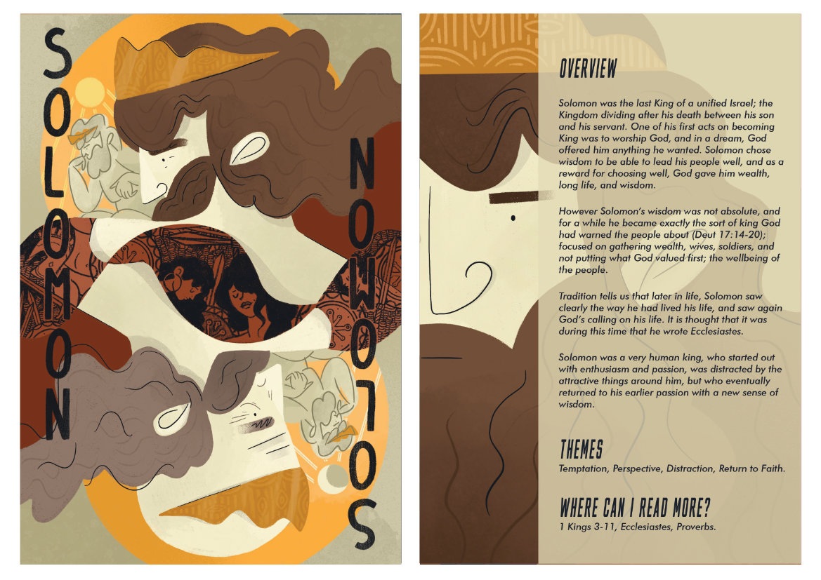
Picture credit: Church Army
_____________________________________

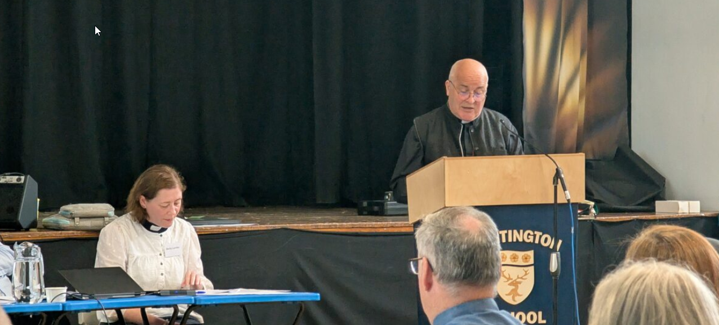

On Saturday 5th July 2025 our Archbishop, Stephen Cottrell, gave his Presidential Address to a Meeting of the York Diocesan Synod. In his address, the text of which you can find on the Diocesan website at this link, Archbishop Stephen reflects on the approach of the Church of England to the issue of same-sex relationships over the past 21 years when he was appointed as Bishop of Reading; this was a short notice appointment following the withdrawal of the Revd Jeffrey John as Bishop-designate of Reading (Jeffrey John made headlines in 2003 when he was the first person to have openly been in a same-sex relationship to be nominated as a Church of England bishop).

Your Editor would like to commend Archbishop Stephen’s address to all e-News readers – please do try and make time to read it.
_____________________________________

Services and Events in our Churches over the next two weeks
On Sunday 13th July 2025 – Trinity 4 - there will be services as follows:
At 9.30am at Brookfield Church a service of Holy Communion at which our Vicar, Revd Laura Wild, will preside.
At 11.00am at Stainton Church a service of Holy Communion at which our Pioneer Minister, Revd Vanessa Kirby, will preside.
At 4.00pm at Hilton Church there will be a service of Evensong led by Revd Laura.
The lessons set in the Lectionary for Trinity 4 (Proper 10) are:
- Deuteronomy 30:9-14
- Psalm 25:1-10
- Colossians 1:1-14
- Luke 10:1-13
The Diocesan Reflection for the Trinity 4 is given by the Rt Revd Eleanor Sanderson, Bishop of Hull. Bishop Eleanor reflects on the Gospel set for Trinity 4 (Luke 10:25-37). You can find the Reflection at this link.

On Monday 14th July 2025 at 2.00pm at Brookfield Church (Hall) there is the fourth session of our fortnightly Plurality Bible Study “Companions on our Journey” when we shall be looking at Solomon. These study sessions are open to anyone from any of the three Churches in our Plurality, will last about one hour, and will be led by our Vicar, Revd Laura Wild.
On Tuesday 15th July 2025 at 9.30am at Stainton Church there will be a half-hour Plurality Prayer Gathering.
On Wednesday 16th July 2025 at 10.00am at Brookfield Church there will be a service of Holy Communion at which our Vicar Revd Laura Wild, will preside.
_____________________________________
On Sunday 20th July 2025 – Trinity 5 there will be services as follows:
At 9.30am at Hilton Church a service of Morning Praise, led by Revd Marie Edwards
At 9.30am at Brookfield Church a “Breakfast Church” service of informal worship with discussions, quizzes and simple refreshments, led by our Vicar, Revd Laura Wild. [Editor’s note: there will NOT be Holy Communion at this service];
At 11.00am at Stainton Church a service of Holy Communion at which our Pioneer Minister, Revd Vanessa Kirby, will preside.
The lessons set in the Lectionary for Trinity 5 (Proper 11) are:
- Genesis 18:1-10a
- Psalm 15
- Colossians 1:15-28
- Luke 10:38-42
The Diocesan Reflection for Trinity 5 will be available on the Diocesan website at this link by about the Thursday of the previous week.

On Tuesday 22nd July 2025 at 9.30am at Stainton Church there will be a half-hour Plurality Prayer Gathering.
On Wednesday 23rd July 2025 at 10.00am at Brookfield Church; there will be a service of Holy Communion at which our Vicar, Revd Laura Wild, will preside.
_____________________________________
Please continue to pray

… for Myanmar and neighbouring Thailand

Pray for all those affected by the recent massive earthquake that occurred in Myanmar on Friday 28th March 2025: for the Military Junta in Myanmar; the success of the DEC Myanmar Earthquake Appeal, and all the humanitarian aid agencies seeking to support those in great need.

… for Israel, Palestine and now Iran

The situation in the Middle East has become catastrophic! We need as much specific prayer as possible. Please pray for;
- Hamas to release the remaining Israeli hostages as soon as possible
- A softening of Israel’s stance on Palestine and a willingness to negotiate constructively for an end to the war in Gaza and the West Bank.
- The opening up of the border crossings between Israel and Gaza, and for the resumption of humanitarian aid and relief to reach those who so desperately need it.
- An urgent enduring ceasefire between Israel and Iran following the new war that has opened up between them just a few weeks ago.
- For Iranian, Palestinian and Israeli Christians that they would be strong in their faith as they trust God for their future.

…. and for Ukraine and Russia

For an early end to the war between Russia and Ukraine, giving thanks that talks are taking place and pray that there will be a satisfactory outcome to those talks which is acceptable to both sides.
_____________________________________

Please join us in praying for our Churches to Grow

Can we invite you to use our Revitalise "prayer for growth" in your personal quiet times with God?

Revitalise us Lord,
Enthuse in our congregations the desire for mission. Give
Vision to our planning and
Inspire our thoughts as we seek Your will.
Teach us to be more like You, Christ
Abiding in You and
Loving one another.
In growing healthy churches,
Sharing our faith, living Christ’s story
Every day, help us to be faithful disciples and bear much fruit. Amen.
_____________________________________

Pastoral Support - Here are the contact details for our Vicar, Revd Laura Wild:

Address: The Vicarage, 89 Low Lane, Brookfield, Middlesbrough TS5 9EF
Phone: 01642-598621
E-mail: rev.laura.wild@gmail.com

Laura's normal "day off" is Friday - if you need to contact her on that day, please leave a message on the answerphone.
______________________________________

Bob Ardley

