Greetings to Stainton and Hemlington Church Members and Friends of Stainton Church

Welcome to the Stainton Church e-News for

Friday 4th July 2025

We hope you are well and keeping safe. If you need any
practical support, please do get in touch.

Men’s Breakfast 2025 – Come and hear Gram Seed’s story!

Following on from the very successful “Our Golden Girls” afternoon tea held at St Margaret’s, Brookfield on 27th March 2025 our Pioneer Minister, Revd Vanessa Kirby has organised a “Men’s Breakfast” on Saturday 12th July 2025 from 9.30am to 11.30am, also at St Margaret’s Church, Brookfield.

The guest speaker at the “Men’s Breakfast” is Gram Seed of Sowing Seeds Ministries – Gram will be sharing about his “life transformed by Jesus”. The event is free of charge to attend and is open to all men across Teesside – please arrive promptly at 9.30am for the breakfast. There will be an opportunity to make a donation to support the work of Sowing Seeds. Here is Gram’s “potted biog”

Gram Seed was written off by family, neighbours, teachers and the police as a lost cause. His chaotic life led him on a journey of drugs, violence, prison, and homelessness, culminating in a coma. The medics encouraged Gram's mother to switch off the life support machines, as they believed all hope of him surviving had gone. However, after a group of Christians prayed for him, Gram made a miraculous recovery and awoke from the coma.

With the strength of his newfound faith, Gram founded Sowing Seeds Ministries, and he, along with his team, helps others struggling with life's trials to find hope in God's amazing love and forgiveness.



To assist with the catering for the Breakfast please e-mail Revd Vanessa to let her know that you are coming, especially if you will be bringing a friend (which we hope you will do!) – e-mail to rev.vanessakirby@gmail.com

Plurality Bible Study Course

Our Vicar, Revd Laura Wild, is running a Bible Study course for people from each of the three Parishes in our Plurality. Everybody will be most welcome! The sessions will be held fortnightly in Brookfield Church Hall at 2.00pm for one hour.

The course follows on from the “Faith Pictures” Lent Study Course that Revd Laura led for us. This Study Course will look at the “Companions on our (Faith) Journey”. The fourth session will be on Monday 14th July 2025 when we will look at Solomon.

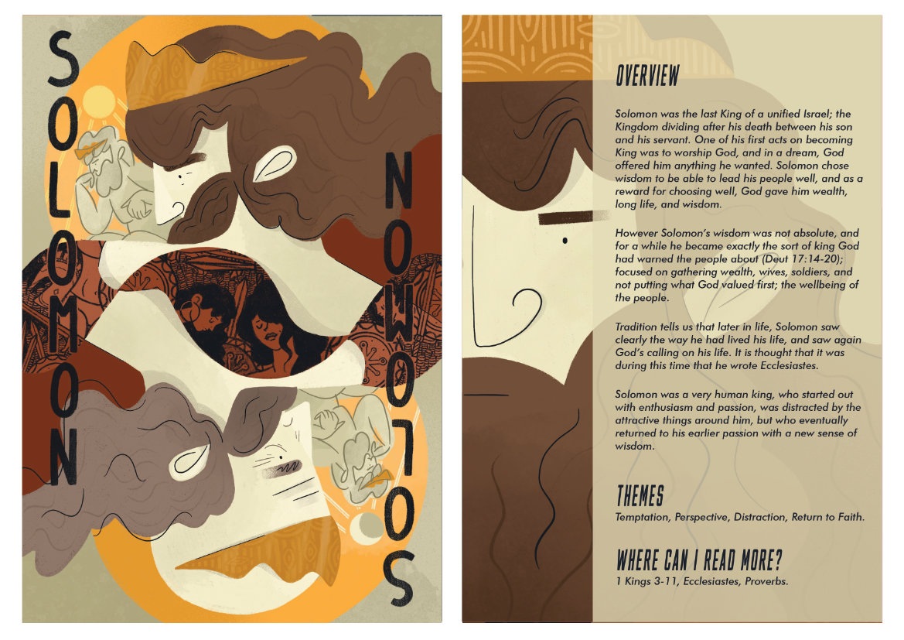
Picture credit: Church Army
_____________________________________

Services and Events in our Churches over the next two weeks
On Sunday 6th July 2025 – Trinity 3 we shall be celebrating St Margaret’s Brookfield’s 65th Anniversary; there will be services as follows:
At 9.30am at Hilton Church a service of Holy Communion at which Revd Marie Edwards, will preside.
At 11.00am at Stainton Church a “Café Church” service of informal worship with quizzes, discussions and simple refreshments, led by our Vicar, Revd Laura Wild [Editor’s note: There will NOT be Holy Communion at this service].
At 2.00pm to 4.00pm at Brookfield Church there will be a time of Family Fun and a Photography Exhibition celebrating St Margaret’s 65th Anniversary
At 5.00pm at Brookfield Church there will be a Celebration Songs of Praise led jointly by our Vicar Revd Laura Wild and our Pioneer Minister, Revd Vanessa Kirby.
The lessons set in the Lectionary for Trinity 3 (Proper 9 in the Common Lectionary) are:
- Isaiah 66:10-14
- Psalm 66:1-8
- Galatians 6: (1-6), 7-16
- Luke 10:1-11, 16-20
The Diocesan Reflection for the Trinity 3 will soon be available on the Diocesan website at this link (the Reflection is delayed this week).

On Tuesday 8th July 2025 at 9.30am at Stainton Church there will be a half-hour Plurality Prayer Gathering.
On Wednesday 9th July 2025 at 10.00am at Brookfield Church there will be a service of Holy Communion at which our Vicar Revd Laura Wild, will preside.
_____________________________________
On Sunday 13th July 2025 – Trinity 4 - there will be services as follows:
At 9.30am at Brookfield Church a service of Holy Communion at which our Vicar, Revd Laura Wild, will preside.
At 11.00am at Stainton Church a service of Holy Communion at which our Pioneer Minister, Revd Vanessa Kirby, will preside.
At 4.00pm at Hilton Church there will be a service of Evensong levy by Revd Laura.
The lessons set in the Lectionary for Trinity 4 (Proper 10) are:
- Deuteronomy 30:9-14
- Psalm 25:1-10
- Colossians 1:1-14
- Luke 10:1-13
The Diocesan Reflection for the Trinity 4 will be available on the Diocesan website at this link by about the Thursday of the previous week.

On Monday 14th July 2025 at 2.00pm at Brookfield Church (Hall) there is the fourth session of our fortnightly Plurality Bible Study “Companions on our Journey” when we shall be looking at Solomon. These study sessions are open to anyone from any of the three Churches in our Plurality, will last about one hour, and will be led by our Vicar, Revd Laura Wild.
On Tuesday 15th July 2025 at 9.30am at Stainton Church there will be a half-hour Plurality Prayer Gathering.
On Wednesday 16th July 2025 at 10.00am at Brookfield Church there will be a service of Holy Communion at which our Vicar Revd Laura Wild, will preside.
_____________________________________
Please continue to pray

… for Myanmar and neighbouring Thailand

Pray for all those affected by the recent massive earthquake that occurred in Myanmar on Friday 28th March 2025: for the Military Junta in Myanmar; the success of the DEC Myanmar Earthquake Appeal, and all the humanitarian aid agencies seeking to support those in great need.

… for Israel, Palestine and now Iran

The situation in the Middle East has become catastrophic! We need as much specific prayer as possible. Please pray for;
- Hamas to release the remaining Israeli hostages as soon as possible
- A softening of Israel’s stance on Palestine and a willingness to negotiate constructively for an end to the war in Gaza and the West Bank.
- The opening up of the border crossings between Israel and Gaza, and for the resumption of humanitarian aid and relief to reach those who so desperately need it.
- An urgent ceasefire between Israel and Iran following the new war that has opened up between them just a week ago.
- For Iranian, Palestinian and Israeli Christians that they would be strong in their faith as they trust God for their future.

…. and for Ukraine and Russia

For an early end to the war between Russia and Ukraine, giving thanks that talks are taking place and pray that there will be a satisfactory outcome to those talks which is acceptable to both sides.
_____________________________________

Please join us in praying for our Churches to Grow

Can we invite you to use our Revitalise "prayer for growth" in your personal quiet times with God?

Revitalise us Lord,
Enthuse in our congregations the desire for mission. Give
Vision to our planning and
Inspire our thoughts as we seek Your will.
Teach us to be more like You, Christ
Abiding in You and
Loving one another.
In growing healthy churches,
Sharing our faith, living Christ’s story
Every day, help us to be faithful disciples and bear much fruit. Amen.
_____________________________________

Pastoral Support - Here are the contact details for our Vicar, Revd Laura Wild:

Address: The Vicarage, 89 Low Lane, Brookfield, Middlesbrough TS5 9EF
Phone: 01642-598621
E-mail: rev.laura.wild@gmail.com

Laura's normal "day off" is Friday - if you need to contact her on that day, please leave a message on the answerphone.
______________________________________

Bob Ardley

Ashdale House,
26 Meldyke Lane,
Stainton,
Middlesbrough TS8 9AU

T: 01642-284525
E: bob.ardley@ntlworld.com

