Greetings to Stainton and Hemlington Church Members and Friends of Stainton Church

Welcome to the Stainton Church e-News for

Friday 27th June 2025

We hope you are well and keeping safe. If you need any
practical support, please do get in touch.

Stainton Big Sing 2025

We were not put off by some intermittent showers! We gathered together to praise God with jubilant voices. Anglicans and Methodists gathered outside the Stainton Memorial Hall on Sunday 22nd June for the 2025 Big Sing event. Many thanks go to Marske Brass Band for playing for us.

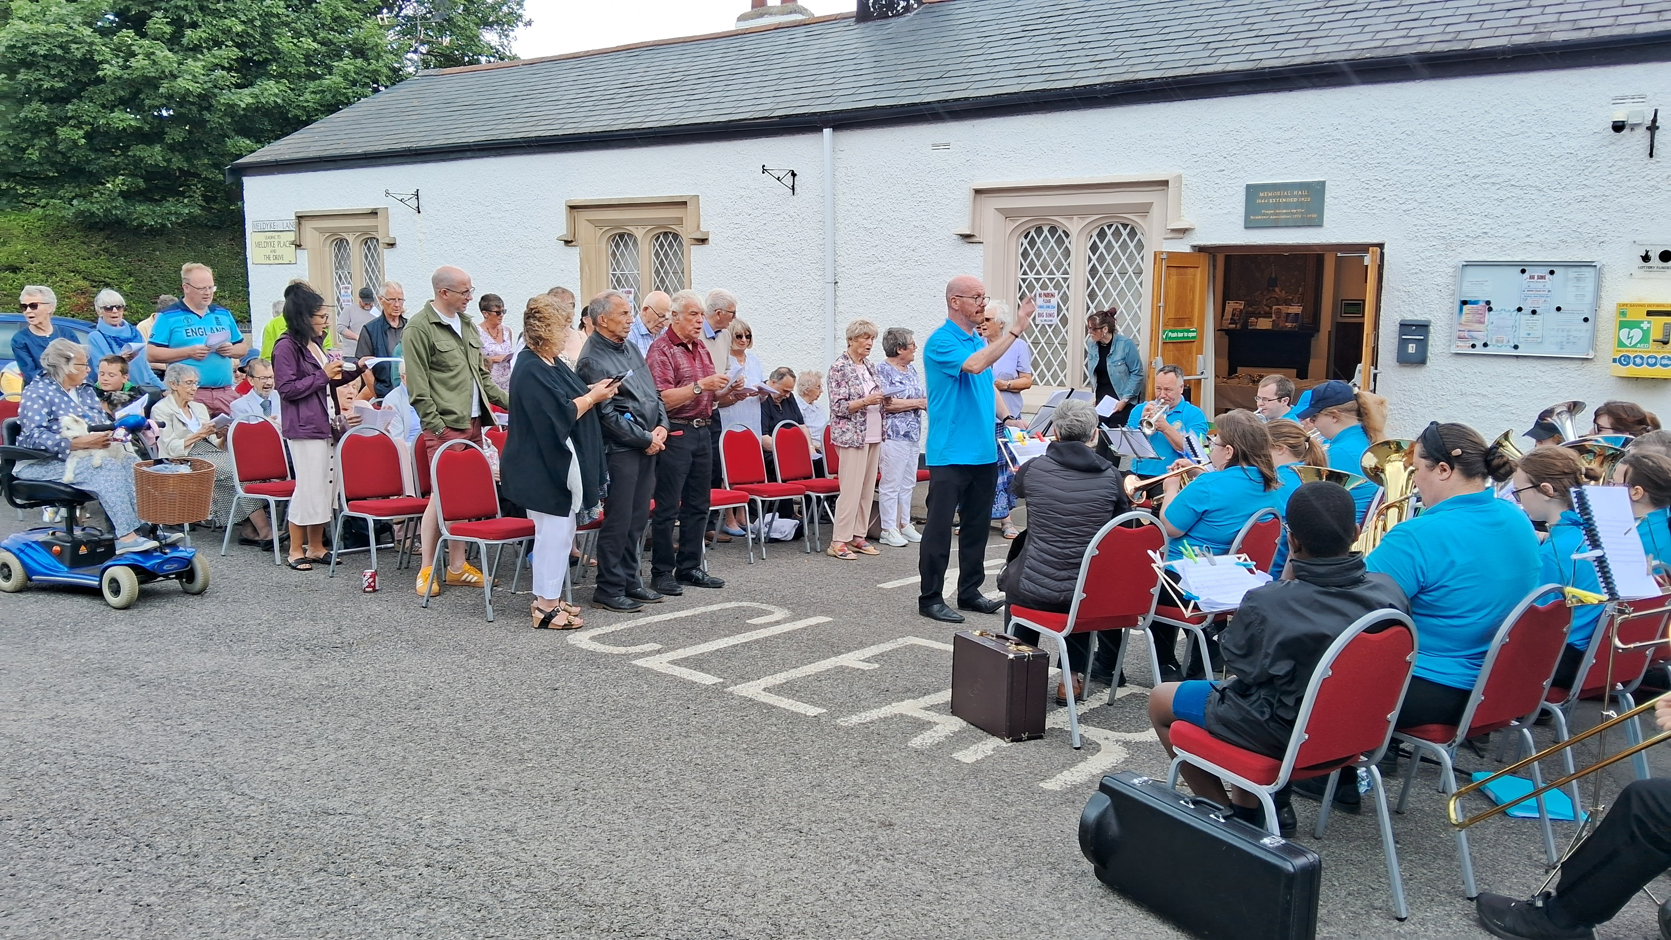
Picture credit: Bob Ardley
_____________________________________

For your diaries – Important Dates!

Important Date No 1 Sunday 29th June 2025

This is a fifth Sunday and so there will be a single 5th Sunday Special Plurality Service of Holy Communion at Brookfield Church at 10.30am; there will NOT be a service at Stainton Church or at Hilton Church on that day.

After the 10.30am Service there will be an extended time of Fellowship as all are invited to a Plurality BBQ in the Vicarage Garden at 89 Low Lane, courtesy of the Wild Family. Our Vicar, Revd Laura, says:

There will be room for two or three cars [to park at the Vicarage] so the hope is people will [park near St Margaret’s and] walk to the Vicarage from there. A folding chair may be helpful if people have one to hand.

If guests would like to bring a contribution, [perhaps] those who worship:
- At St Peter's Hilton might bring 'pop' or other soft drinks;
- At St Peter and St Paul’s Stainton might bring something sweet; and
- At St Margaret’s Brookfield might bring bread buns or something else savoury.

Do come and join in this happy time of fellowship!

Important Date No 2 Sunday 7th September 2025

On Sunday 7th September 2025 at 9.30am at St Margaret’s Church, Brookfield there will be a Confirmation Service at which our Bishop of Whitby, the Revd Barry Hill, will preside. Between now and then our Vicar, Revd Laura, is holding some Confirmation Preparation Classes. Please do be praying for the Confirmation Candidates as they prepare for this next step in their Christian Faith Journey.

_____________________________________

Plurality Bible Study Course

Our Vicar, Revd Laura Wild, is running a Bible Study course for people from each of the three Parishes in our Plurality. Everybody will be most welcome! The sessions will be held fortnightly in Brookfield Church Hall at 2.00pm for one hour.

The course follows on from the “Faith Pictures” Lent Study Course that Revd Laura led for us. This Study Course will look at the “Companions on our (Faith) Journey”. The fourth session will be on Monday 30th June 2025 when we will look at Gideon.


Picture credit: Church Army
_____________________________________

Services and Events in our Churches over the next two weeks
On Sunday 29th June 2025 – Trinity 2 and the Feast of St Peter and St Paul - there will be a single Joint Plurality service – one of our 5th Sunday Special Communion Service as at Brookfield Church at 10.30am [Editor’s note: There will NOT be a service at Stainton Church or Hilton Church on that day]. The service will be followed by a time of fellowship at a BBQ in the Vicarage Garden at 89 Low Lane, courtesy of the Wild Family.
The lessons set in the Lectionary for Trinity 2 (Proper 8) are:
- 1 Kings 19:5-16, 19-21
- Psalm 16
- Galatians 5:1,13-15
- Luke 9:51-62
The lessons set in the Lectionary for the Feast of St Peter and St Paul are:
- Zechariah 4:1-6a, 10b-14 or Acts 12:1-11
- Psalm 125
- Acts 12:1-11 or 2 Timothy 4:6-8, 17, 18
- Matthew 16:13-19
The Diocesan Reflection for the Trinity 2 is given by the Rt Revd Dr Flora Winfield, Bishop of Selby. Bishop Flora reflects on the Gospel set for the Feast of St Peter (Matthew 16.13-19) .You can find the Reflection at this link.

On Monday 30th June 2025 at 2.00pm at Brookfield Church (Hall) there is the fourth session of our fortnightly Plurality Bible Study “Companions on our Journey” when we shall be looking at Gideon. These study sessions are open to anyone from any of the three Churches in our Plurality, will last about one hour, and will be led by our Vicar, Revd Laura Wild.
On Tuesday 1st July 2025 at 9.30am at Stainton Church there will be a half-hour Plurality Prayer Gathering.
On Wednesday 2nd July 2025 at 10.00am at Brookfield Church there will be a service of Holy Communion at which our Vicar Revd Laura Wild, will preside. _____________________________________
On Sunday 6th July 2025 – Trinity 3 we shall be celebrating St Margaret’s Brookfield’s 65th Anniversary; there will be services as follows:
At 9.30am at Hilton Church a service of Holy Communion at which Revd Marie Edwrads, will preside.
At 11.00am at Stainton Church a “Café Church” service of informal worship with quizzes, discussions and simple refreshments, led by our Vicar, Revd Laura Wild [Editor’s note: There will NOT be Holy Communion at this service].
At 2.00pm to 4.00pm at Brookfield Church there will be a time of Family Fun and a Photography Exhibition
At 5.00pm at Brookfield Church there will be a Celebration Songs of Praise
The lessons set in the Lectionary for Trinity 3 (Proper 9 in the Common Lectionary) are:
- Isaiah 66:10-14
- Psalm 66:1-8
- Galatians 6: (1-6), 7-16
- Luke 10:1-11, 16-20
The Diocesan Reflection for the Trinity 3 will be available on the Diocesan website at this link by about the Thursday of the previous week.
On Tuesday 8th July 2025 at 9.30am at Stainton Church there will be a half-hour Plurality Prayer Gathering.
On Wednesday 9th July 2025 at 10.00am at Brookfield Church there will be a service of Holy Communion at which our Vicar Revd Laura Wild, will preside.
_____________________________________
Please continue to pray …..
… for Myanmar and neighbouring Thailand
Pray for all those affected by the recent massive earthquake that occurred in Myanmar on Friday 28th March 2025: for the Military Junta in Myanmar; the success of the DEC Myanmar Earthquake Appeal, and all the humanitarian aid agencies seeking to support those in great need.
Here is an update dated 24th June 2025 from the DEC on their Myanmar Earthquake Appeal:
Over £26 million has been raised for the DEC Myanmar Earthquake Appeal.
Nearly 3 months on from the earthquake, people are living without access to safe shelter, clean water, food and medical care.
Needs remain huge and aid delivery tricky in the context, but despite the challenges, DEC charities and their local partners are reaching some of the most vulnerable with lifesaving support.
In Myanmar currently:
- 17 million people affected by the earthquake – across 58 townships.
- 19.9 million people – a third of the population – already needed humanitarian support before the earthquake.
- 1.8 million people are being targeted by DEC charities for assistance in the worst earthquake affected areas.
Thank you for your help so far. DEC charities are responding in Myanmar now and your donations are key to supporting those affected by the earthquake.

… for Israel, Palestine and Lebanon
The situation in the Middle East has become catastrophic! We need as much specific prayer as possible. Please pray for;
- Hamas to release the remaining Israeli hostages as soon as possible
- A softening of Israel’s stance on Palestine and a willingness to negotiate constructively for an end to the war in Gaza and the West Bank.
- The opening up of the border crossings between Israel and Gaza, and for the resumption of humanitarian aid and relief to reach those who so desperately need it.
- An urgent ceasefire between Israel and Iran following the new war that has opened up between them just a week ago.
- For Iranian, Palestinian and Israeli Christians that they would be strong in their faithful as they trust God for their future.
Here is an update dated 19th June 2025 from the DEC on their Middle East Appeal:
Over £46 million has been raised for the DEC Middle East Humanitarian Appeal, but the humanitarian needs are huge, with the whole of Gaza at risk of famine.
With extremely limited supplies entering Gaza, DEC charities and their local partners are working tirelessly to meet some basic needs in the ways they are still able to.
During the first 6 months of the DEC funded response, between October 2024 and April 2025:
- More than 440 000 ready to eat meals were distributed
- Over 390 000 people benefitted from improved access to drinking water
- Over 109 000 people gained improved access to healthcare, including the distribution of medicine and provision of primary healthcare services
- More than 22 000 people were reached with cash assistance
Much of this work was made possible by the increase in aid delivered during the ceasefire agreement earlier this year.
…. and for Ukraine and Russia
For an early end to the war between Russia and Ukraine, giving thanks that talks are taking place and praying that there will be a satisfactory outcome to those talks which is acceptable to both sides.
Here is a prayer from the National Council of Churches [in the USA]:
Gracious and Merciful God,
We pray today for the Ukrainian people and ask for Your intervention in this senseless war levied against them by Russia. We pray, O God, for protection and that there would be peace. We pray for restoration and renewed hope.
We pray for the families, especially, the children living through the horrors of war and all the upheaval and tribulation it brings.
We also pray for those protesting in Russia against these violent acts by their government. We ask that You would protect, cover and keep these protesters as they put their bodies on the line in the name of what is just and righteous.
We pray for the entire world community, including the leaders in our own country. Give them wisdom and ingenuity to respond in ways that ends this war and moves us all to a world where Your peace abides.
Hear the cries of Your people, O God. Lord, have mercy. Christ, have mercy.
Amen.

_____________________________________

Please join us in praying for our Churches to Grow

Can we invite you to use our Revitalise "prayer for growth" in your personal quiet times with God?

Revitalise us Lord,
Enthuse in our congregations the desire for mission. Give
Vision to our planning and
Inspire our thoughts as we seek Your will.
Teach us to be more like You, Christ
Abiding in You and
Loving one another.
In growing healthy churches,
Sharing our faith, living Christ’s story
Every day, help us to be faithful disciples and bear much fruit. Amen.
_____________________________________

Pastoral Support - Here are the contact details for our Vicar, Revd Laura Wild:

Address: The Vicarage, 89 Low Lane, Brookfield, Middlesbrough TS5 9EF
Phone: 01642-598621
E-mail: rev.laura.wild@gmail.com

Laura's normal "day off" is Friday - if you need to contact her on that day, please leave a message on the answerphone.
______________________________________

Bob Ardley

Ashdale House,
26 Meldyke Lane,
Stainton,
Middlesbrough TS8 9AU

T: 01642-284525
E: bob.ardley@ntlworld.com

