Greetings to Stainton and Hemlington Church Members and Friends of Stainton Church

Welcome to the Stainton Church e-News for

Friday 21st March 2025

We hope you are well and keeping safe. If you need any
practical support, please do get in touch.

Worship God with a new song

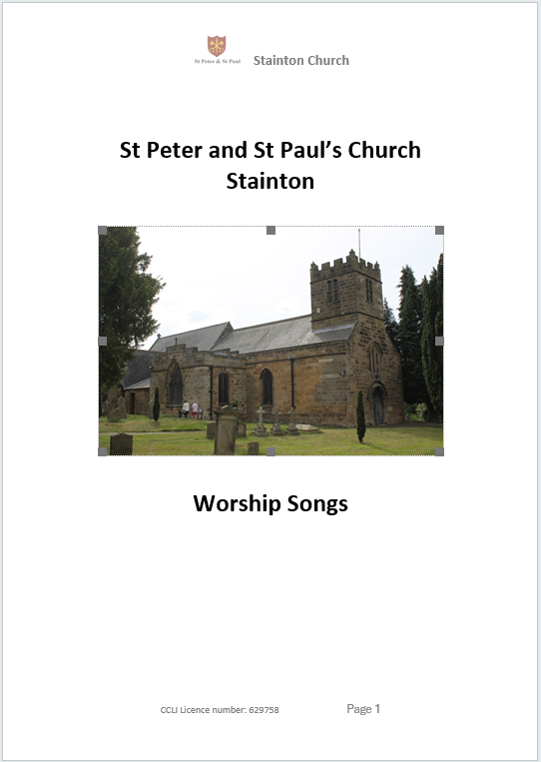

At Stainton Church we now have a new expanded edition of our songbook of 35 (mainly) contemporary worship songs and will be using these in some of our future services. Some of these songs will be unfamiliar to readers of the e-News so they might like to come to an informal “learn a new song” session in the Stainton Parish Room where we can listen to and learn some of the songs together.
If you would be interested in attending such a “learn a new song” session, or sessions, (at which there will be tea/coffee and biscuits) please click here to let your Editor know by e-mail or you can send a Text (SMS) message to 07910075752; please include your preferred day-of-the-week and time (morning, afternoon or evening). Further details of the first “learn a new song” session will be available shortly.

_____________________________________

Creation of the new 2025-2031 Church Electoral Roll
And 2025 Stainton Church Annual Meetings

The New 2025-2031 Stainton Church Electoral Roll will be compiled during the period starting on Saturday 22nd March and ending on Friday 18th April 2025. Please note that there is no automatic transfer of names from the Old Roll to the New Roll so even if your name was on the Old Roll you will need to fill in an application form to join the New 2025-2031 Roll.

Application forms to apply to join the new Roll are available in Stainton Church or can be downloaded and printed off from the Stainton 2025 Annual Meetings page of the Plurality website by clicking here. Completed application forms should be given to Bob Ardley, Stainton Electoral Roll (ER) Officer ASAP and by Friday 18th April 2025 at the absolute latest.

The Stainton with Hemlington 2025 Annual Meetings – the Meeting of Parishioners (to elect Churchwardens), and the Annual Parochial Church Meeting (APCM) will be held in Stainton Church at
12.00 noon on Sunday 11th May 2025 immediately after the 11.00am service that day.

Application forms to join the New Hilton Electoral Roll or the New Brookfield Electoral Roll are available from the respective ER Officers in those two Parishes. Note that the dates for submitting completed applications forms will be different to those stated above.

The Hilton 2025 Annual Meetings – the Meeting of Parishioners (to elect Churchwardens), and the Annual Parochial Church Meeting (APCM) will be held in Hilton Church at 2.00pm on Monday 12th May 2025.The closing date for receipt of applications to join the new Hilton Electoral Roll is Monday 31st March 2025

The Brookfield 2025 Annual Meetings – the Meeting of Parishioners (to elect Churchwardens), and the Annual Parochial Church Meeting (APCM) will be held in Brookfield Church Hall at 11.00am on Sunday 25th May 2025 immediately after the 9.30am service that day.

Lent - Preparing for Easter

On six Thursdays during Lent our Vicar, Revd Laura Wild, will be holding a Lent Study Course, using the “Faith Pictures” material from the Church Army. The dates of the sessions are:

Thursdays: 6th March, 13th March, 20th March, 27th March, 3rd April, and 10th April. On each of these Thursdays there will be two sessions:

- An afternoon session from 12.30pm to 1.30pm in Brookfield Church Hall; and
- An evening session from 7.00pm to 8.00pm in Stainton Church Parish Room.

_____________________________________

Services and Events in our Churches over the next two weeks
On Sunday 23rd March 2025 – the 3rd Sunday of Lent (Lent 3) – there will be services as follows:
At 9.30am at Brookfield Church a service of Holy Communion at which our Vicar, Revd Laura Wild, will preside.
At 11.00am at Stainton Church a service of Holy Communion at which our Vicar will also preside; and
At 4.00pm at Hilton Church a service of Evensong led by our Pioneer Minister, Revd Vanessa Kirby, and at which our Vicar will preach.
The lessons set in the Lectionary for Lent 3 are:
- Isaiah 55:1-9
- Psalm 63:1-9
- 1 Corinthians 10:1-13
- Luke 13:1-9
The Diocesan Reflection for Lent 3 is given by the Venerable Samantha Rushton, Archdeacon of York. Archdeacon Sam reflects on the Gospel reading (Luke 13:1-9) set for Lent 3; you can find the Reflection at this link.
This Is Archdeacon Sam’s last Diocesan Reflection before she and her family move to Lichfield Diocese where she will take up her new role as Diocesan Secretary and Chief Executive Officer (CEO). Sam leaves our Diocese on 31st March 2025 and takes up her new post at the end of April.
In her last Sunday Reflection for our Diocese Sam is seen sitting among a great pile of cardboard boxes supplied by her removal company. Having watched the Reflection your Editor can truly say that Archdeacon Sam’s thoughts have a powerful message for us all and he can recommend that you too watch the video, which you can do by clicking on the picture below.

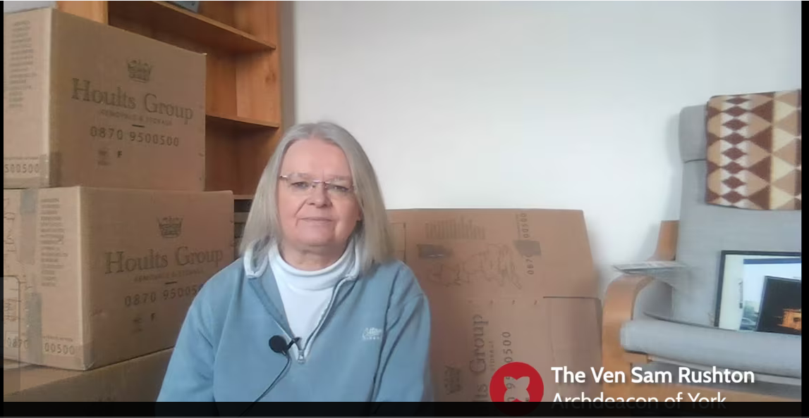
On Tuesday 25th March 2025 at 9.30am at Stainton Church there will be a half-hour Plurality Prayer Gathering.
On Wednesday 26th March 2025 at 10.00am at Brookfield Church; there will be a service of Holy Communion at which our Vicar, Revd Laura Wild, will preside.
On Thursday 27th March 2025 at 12.30pm – 1.30pm in Brookfield Church Hall there will be the fourth afternoon session of our “Faith Pictures” Lent Course.
On Thursday 27th March 2025 at 2.30pm – 4.30pm in Brookfield Church Hall St Margart’s Church is holding “Our Golden Girls Afternoon Tea”. This an outreach event for women in the week of Mothering Sunday. You are invited to take two invitations (which are available in the Churches), one for yourself and one for a guest you would like to take to the event.
On Thursday 27th March 2025 at 7.00pm – 8.00pm in Stainton Church Parish Room there will be the fourth evening session of our “Faith Pictures” Lent Course.

On Sunday 30th March 2025 – the 4th Sunday of Lent - Mothering Sunday – there will be a single Joint (Plurality) service as follows:
At 9.30am at Stainton Church – a 5th Sunday Special Holy Communion service on the theme of “Generosity” at which our Vicar, Revd Laura Wild, will preside. We will begin with a shared breakfast at 9.30am and the Communion service itself will start at 10.30am
[Editor’s note: there will NOT be a service at Hilton Church or at Brookfield Church on that day].
The lessons set in the Lectionary for the Lent 4 are:
- Joshua 5:9-12
- Psalm 32
- 2 Corinthians 5:16-21
- Luke 15:1-3,11b-32
The lessons set in the Lectionary for the Mothering Sunday are:
- Exodus 2:1-10 or 1 Samuel 1:20-28
- Psalm 34:1-10 or Psalm 127:1-4
- 2 Corinthians 1:3-7 or Colossians 3:12-17
- Luke 2:33-35 or John 19:25-27
The Diocesan Reflection for the Lent 4 will be available on the Diocesan website at this link from about the Thursday of the previous week.

On Tuesday 1st April 2025 at 9.30am at Stainton Church there will be a half-hour Plurality Prayer Gathering.
On Wednesday 2nd April 2025 at 10.00am at Brookfield Church there will be a service of Holy Communion
On Thursday 3rd April 2025 at 12.30pm – 1.30pm in Brookfield Church Hall there will be the fifth afternoon session of our “Faith Pictures” Lent Course.
On Thursday 3rd April 2025 at 7.00pm – 8.00pm in Stainton Church Parish Room there will be the fifth evening session of our “Faith Pictures” Lent Course.
_____________________________________

Please continue to pray

… for Israel, Palestine and Lebanon

Give thanks for the recent ceasefire agreed between Israel and Hezbollah in Southern Lebanon, and for the recent ceasefire between Israel and Hamas in Gaza. Pray that the first phase of the ceasefire will continue as the two side prepare for the second phase.

Please pray for a ceasefire between Israel and Hamas in the West Bank; and for Israeli, Palestinian and Lebanese Christians.

… and for Syria

Give thanks for the end of the rule by President Bashar al-Assad and pray for the Rebel Islamist militant group, Hayat Tahrir al-Sham (HTS), which has assumed power, that they keep the Syrian people’s interest as a first priority. The HTS Leader is Ahmed al-Sharaa.

…. and for Sudan

Pray for reconciliation between the warring factions in the civil war in Sudan and for a speedy end to the fighting.

…. and for Ukraine and Russia

For an early end to the war between Russia and Ukraine, giving thanks that talks are taking place and that there will be a satisfactory outcome to those talks which is acceptable to both sides.

_____________________________________

Please join us in praying for our Churches to Grow

Can we invite you to use our Revitalise "prayer for growth" in your personal quiet times with God?

Revitalise us Lord,
Enthuse in our congregations the desire for mission. Give
Vision to our planning and
Inspire our thoughts as we seek Your will.
Teach us to be more like You, Christ
Abiding in You and
Loving one another.
In growing healthy churches,
Sharing our faith, living Christ’s story
Every day, help us to be faithful disciples and bear much fruit. Amen.
_____________________________________

Pastoral Support - Here are the contact details for our Vicar, Revd Laura Wild:

Address: The Vicarage, 89 Low Lane, Brookfield, Middlesbrough TS5 9EF
Phone: 01642-598621
E-mail: rev.laura.wild@gmail.com

Laura's normal "day off" is Friday - if you need to contact her on that day please leave a message on the answerphone.
______________________________________

Bob Ardley

Ashdale House,
26 Meldyke Lane,
Stainton,
Middlesbrough TS8 9AU

T: 01642-284525;
E: bob.ardley@ntlworld.com

