Greetings to Stainton and Hemlington Church Members and Friends of Stainton Church

Welcome to the Stainton Church e-News for

Friday 28th February 2025

We hope you are well and keeping safe. If you need any
practical support, please do get in touch.

Is your name on the old 2019-2025 Church Electoral Roll?
Will your name be on the new 2025-2031 Church Electoral Roll?

Every six years the Church of England requires Parishes to compile a completely new Church Electoral Roll which is in effect a Membership List for the Church; this year is one of those years: the old 2019-2025 Roll is scrapped, and a completely new 2025-2031 Roll is compiled.

It is important that Church Members apply to join the new Roll so that the Church knows, at a National (Church of England), Regional (York Diocesan), Local (Stokesley Deanery) and Parish level, how many people are Members. The number of names on the Electoral Roll is used to determine:
- how many lay Parish Representatives are elected to the Deanery Synod,
- how many lay Deanery Representatives are elected to the Diocesan Synod, and
- how many lay Diocesan Representatives are elected to the General Synod.
Being on the Church Electoral Roll also entitles you to nominate and vote for the people you want to represent you on the Church Council (the PCC – the Parochial Church Council).

The formal notice announcing the creation of the New 2025-2031 Stainton Church Electoral Roll will be put up on the notice board in the Church Porch on Saturday 1st March and the New Roll will be compiled during the period starting on Saturday 22nd March and ending on Friday 18th April 2025.


Image credit: screen capture from this URL

Application forms to apply to join the new Roll are available in Stainton Church or can be downloaded and printed off from the Stainton 2025 Annual Meetings page of the Plurality website by clicking here. Completed application forms should be given to Bob Ardley, Stainton Electoral Roll (ER) Officer ASAP and by Friday 18th April 2025 at the absolute latest.

Please note that there is no automatic transfer of names from the Old Roll to the New Roll so if your name is on the Old Roll you will need to fill in an application form to join the New 2025-2032 Roll.

Application forms to join the New Hilton Electoral Roll or the New Brookfield Electoral Roll are available from the respective ER Officers in those two Parishes. Note that the dates for submitting completed applications forms will be different to those stated above.

Preparing for Lent and Easter
On Tuesday 4th March 2025, which is Shrove Tuesday, our Vicar, Revd Laura Wild and Pioneer Minister Revd Vanessa Kirby, are hosting a Church Family (Plurality) Pancake Party in St Margaret’s Church Hall, Brookfield from 3.30pm to 5.30pm. The Party is open to all so do bring your friends and neighbours along as we feast on good things before the start of Lent. This is a fundraising event to support the work of BiG KIDS, a local charity which works with children in Middlesbrough schools and Churches. Some members of the BiG KIDs Team will be at the Party.
(*) BiG KIDS is a creative-arts based children’s charity, working with 7-14 year olds in Middlesbrough.
[The BiG KIDs] team is vastly experienced in youth and children’s work, with particular specialties in art, music, sport and drama. You will find them to be friendly, energetic, enthusiastic and committed – that’s the hallmark of a BiG KID! Do have a look at their website.


Picture credit: Photo by M Draa on Unsplash Picture credit: Photo by Ahna Ziegler on Unsplash

On Wednesday 5th March 2025, which is Ash Wednesday, it is the beginning of Lent, the period of 40-days leading up to Easter. Our Vicar, Revd Laura Wild will be holding Holy Communion services with “Ashing” on Ash Wednesday as follows:
- At 10.00am at Brookfield Church;
- At 1.00pm at Hilton Church; and
- At 7.00pm at Stainton Church.

On six Thursdays during Lent our Vicar, Revd Laura Wild, will be holding a Lent Study Course, using the “Faith Pictures” material from the Church Army. The dates of the sessions are:

Thursdays: 6th March, 13th March, 20th March, 27th March, 3rd April, and 10th April. On each of these Thursdays there will be two sessions:

- An afternoon session from 12.30pm to 1.30pm in Brookfield Church Hall; and
- An evening session from 7.00pm to 8.00pm in Stainton Church Parish Room.

_____________________________________

Would you like to visit your Cathedral at no charge?
You can borrow a York Minster Parish Pass for 2025

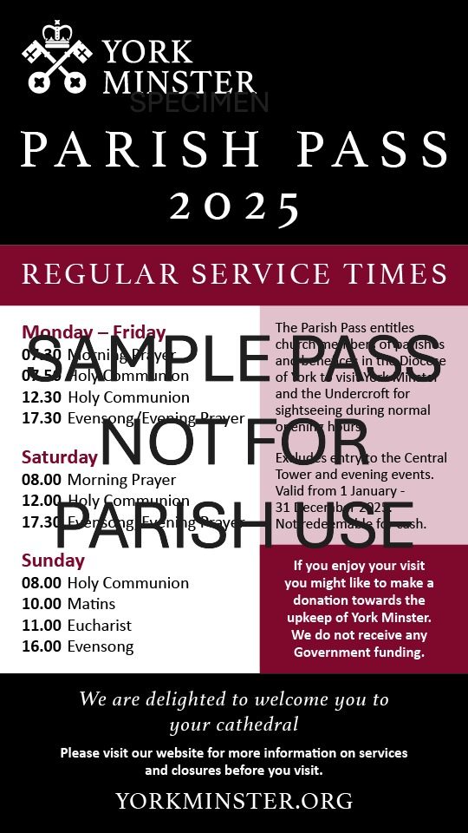
Picture credit: York Diocesan Website

Here is a message from the Very Reverend Dominic Barrington, Dean of York Minster, about the York Minster Parish Pass and how it works.

Dear Brothers and Sisters,

Above all else York Minster is a house of prayer, the seat of the Archbishop of York and the Mother church of the diocese of York. As such we want to make our cathedral as accessible as possible to all who are regular worshippers in the churches of the Diocese of York. To this end we have for many years issued Parish Passes to be used by regular worshippers in the Diocese to visit their Mother church.

Parish Passes are kindly sent by the Diocesan office on behalf of the Minster at the beginning of the year. These are issued to the PCC secretary to allow members of the Christian community across the Diocese to visit their Mother church free of charge.

Those who wish to visit no longer need to book online before coming to the Minster; when they visit the Minster members of your Christian community need to bring a copy of the Parish Pass for each visitor, join the “fast-track” queue at the Minster for advance bookings (at the West Door main entrance), and be prepared to say which parish they are part of.

As usual, parts of the Minster have to be closed from time to time, so we strongly recommend that visitors check the calendar on our website or call us prior to visiting in case there are any restrictions. Our hope is that these arrangements will enable many people who worship in churches within our Diocese to come and enjoy some time in their cathedral. We look forward to welcoming our sisters and brothers in Christ from all the corners of the Diocese to their cathedral church.

Parish Passes for the Minster are available from and should be returned to the PCC Secretary; for Stainton Church this is Bob Ardley.
_____________________________________

Services and Events in our Churches over the next two weeks
On Sunday 2nd March 2025 – Sunday next before Lent – there will be services as follows:
At 9.30am at Hilton Church – a service of Holy Communion at which our Vicar, Revd Laura Wild, will preside;
At 9.30am at Brookfield Church – a service of Holy Communion at which our Pioneer Minister, Revd Vanessa Kirby, will preside; and
At 11.00am at Stainton Church – a “Café Church” service of informal worship, discussions, quizzes and simple refreshments. The service will be led by our Vicar, Revd Laura Wild. [Editor’s note: There will NOT be Holy Communion at this service].
The lessons set in the Lectionary for the Sunday next before Lent are:
- Exodus 34:29-35
- Psalm 99
- 2 Corinthians 3:12 -4:2
- Luke 9:28-36 (37-43)
The Diocesan Reflection for the Sunday next before Lent is given by the Rt Revd Dr Flora Winfield, Bishop of Selby. Bishop Flora reflects on the Gospel reading (Luke 9:28-36) set for the Sunday next before Lent; you can find the Reflection at this link.
On Tuesday 4th March 2025 at 9.30am at Stainton Church there will be a half-hour Plurality Prayer Gathering.
On Tuesday 4th March 2025 at 3.30 – 5.30pm at Brookfield Church there will be a Pancake Party to celebrate Shrove Tuesday. This is a fundraising event to support the work of the local children’s charity Big KIDs and is open to all so do come along and join in the fun!
On Wednesday 5th March 2025 – Ash Wednesday, the first day of Lent 2025 - there will be services of Holy Communion as follows:
- At 10.00am at Brookfield Church;
- At 1.00pm at Hilton Church; and
- At 7.00pm at Stainton Church
On Thursday 6th March 2025 at 12.30pm – 1.30pm in Brookfield Church Hall there will be the first afternoon session of our “Faith Pictures” Lent Course.
On Thursday 6th March 2025 at 7.00pm – 8.00pm in Stainton Church Parish Room there will be the first evening session of our “Faith Pictures” Lent Course.
_____________________________________
On Sunday 9th March 2025 – the 1st Sunday of Lent (Lent 1) – there will be services as follows:
At 9.30am at Brookfield Church a service of Holy Communion at which our Vicar, Revd Laura Wild, will preside.
At 11.00am at Stainton Church a service of Holy Communion at which our Vicar will also preside; and
At 4.00pm at Hilton Church a service of Evensong led by our Vicar.
The lessons set in the Lectionary for Lent 1 are:
- Deuteronomy 26:28-36 (37-43)
- Psalm 91:1-2, 9-16
- Romans 10:8b-13
- Luke 4:1-13
The Diocesan Reflection for the Lent 1 will be available on the Diocesan website at this link from about the Thursday of the previous week.

On Tuesday 11th March 2025 at 9.30am at Stainton Church there will be a half-hour Plurality Prayer Gathering.
On Wednesday 12th March 2025 at 10.00am at Brookfield Church; there will be a service of Holy Communion at which our Vicar, Revd Laura Wild, will preside.
On Thursday 13th March 2025 at 12.30pm – 1.30pm in Brookfield Church Hall there will be the second afternoon session of our “Faith Pictures” Lent Course.
On Thursday 13th March 2025 at 7.00pm – 8.00pm in Stainton Church Parish Room there will be the second evening session of our “Faith Pictures” Lent Course.
_____________________________________

Please continue to pray

… for Israel, Palestine and Lebanon

Give thanks for the recent ceasefire agreed between Israel and Hezbollah in Southern Lebanon, and for the recent ceasefire between Israel and Hamas in Gaza. Pray that the first phase of the ceasefire will continue as the two side prepare for the second phase.

Please pray for a ceasefire between Israel and Hamas in the West Bank; and for Israeli, Palestinian and Lebanese Christians.

Here is a prayer from the Christian Charity Tearfund:

Dear God,

We cry out to you on behalf of the people seriously affected by the conflict in Gaza and the Middle East. Our hearts break at the devastation and suffering that we see, and we know it breaks yours, too.

We ask that you stretch out your mighty hand to bring lasting peace.

We cry out for people who have been injured or traumatised, who have lost loved ones or their homes. Please provide everything they need and be their comfort, their hope, their healer, and their safe refuge.

We pray for your peace to reign. We look to you as our Saviour and the hope of the world.

Amen.

… for Syria

Give thanks for the end of the rule by President Bashar al-Assad and pray for the Rebel Islamist militant group, Hayat Tahrir al-Sham (HTS), which has assumed power, that they keep the Syrian people’s interest as a first priority. The HTS Leader is Ahmed al-Sharaa (also known as Abu Mohammed al-Jolani).

Here is a prayer from the Christian Charity Embrace (the Middle East)

Lord God,

We pray for the people of Syria at this time of uncertainty and transition. Please be their refuge and protect them from further conflict.

May the transfer of power be peaceful, and may those in new positions of authority follow the paths of peace.

We pray against violence and disunity.

We lift our local [Embrace] partners before you. Please be their shield and their strength as they continue to serve those on the margins.

In Jesus’ name, Amen.

…. and for Ukraine and Russia

For an early end to the war between Russia and Ukraine, giving thanks that talks are taking place and that there will be a satisfactory outcome to those talks which is acceptable to both sides.

Here are some helpful ideas from the Christian Charity Tearfund which might inspire your prayers:

When faced with a crisis like the conflict in Ukraine, it can be hard to know how to pray. But the desire to pray itself is a great place to start. Here are suggestions about what to pray for:

What to pray for…
There are five areas we can focus our prayers on: for people affected by the conflict, for those in leadership positions, for God’s power and love to be revealed through the church, for the wider global impact, and for peace.

…. and for Sudan

Pray for reconciliation between the warring factions in the civil war in Sudan and for a speedy end to the fighting.

Here is a prayer from the Global South Fellowship of Anglican Churches (GSFA)

Heavenly Father, we come before You with hearts burdened by the on-going war and turmoil in Sudan, we earnestly seek Your divine intervention and mercy. We lift up our prayers for Sudan, a nation yearning for peace and healing. Lord, in Your mercy, hear our prayer:

Lord, we pray for Your peace to be granted to the people of Sudan. May Your presence be felt among them, guiding them away from conflict and towards reconciliation.

Lord, we pray You continue to touch the hearts of the warring leaders in Sudan. May their hearts be softened. Please allow peaceful negotiations to begin, leading to lasting peace for this nation of Sudan.

Lord, we pray for the countless displaced and refugees in Sudan. May You provide them with the means to return to their homes in safety and with dignity.

Lord, we pray and we lift up the children of Sudan who have been deprived of their education due to this on-going conflict. Open doors for them to return to school, where they can learn, grow, and build a better future for themselves and their nation.

Lord, we pray and bless all places of Christian worship. May Your peace prevail in these and all other spaces, allowing believers to worship without fear.

Lord, we pray for those who suffer from hunger and scarcity in Sudan. May You continue to bless and establish the efforts of humanitarian organizations and individuals who strive to provide food and sustenance to those in need.

Lord, Your word assures us of Your desire for peace and stability. "Blessed are the peacemakers, for they will be called children of God" (Matthew 5:9). We cling to this promise, trusting in your power to bring peace back to Sudan.

In Jesus' name, we pray. Amen.

_____________________________________

Please join us in praying for our Churches to Grow

Can we invite you to use our Revitalise "prayer for growth" in your personal quiet times with God?

Revitalise us Lord,
Enthuse in our congregations the desire for mission. Give
Vision to our planning and
Inspire our thoughts as we seek Your will.
Teach us to be more like You, Christ
Abiding in You and
Loving one another.
In growing healthy churches,
Sharing our faith, living Christ’s story
Every day, help us to be faithful disciples and bear much fruit. Amen.
_____________________________________

Pastoral Support - Here are the contact details for our Vicar, Revd Laura Wild:

Address: The Vicarage, 89 Low Lane, Brookfield, Middlesbrough TS5 9EF
Phone: 01642-598621
E-mail: rev.laura.wild@gmail.com

Laura's normal "day off" is Friday - if you need to contact her on that day please leave a message on the answerphone.
______________________________________

Bob Ardley

Ashdale House,
26 Meldyke Lane,
Stainton,
Middlesbrough TS8 9AU

T: 01642-284525;
E: bob.ardley@ntlworld.com

