Greetings to Stainton and Hemlington Church Members and Friends of Stainton Church

Welcome to the Stainton Church e-News for

Friday 14th February 2025

We hope you are well and keeping safe. If you need any
practical support, please do get in touch.

Like a tree that is planted by the waters

On 16 February, the Third Sunday Before Lent, two of our Lectionary readings feature trees: Psalm 1 and Jeremiah 17:5-10.

This set me thinking about trees in the bible. There are many mentions, not only of trees in general, but of particular species including oak, cedar and cypress – not forgetting the mighty Mustard Tree of Jesus’ parable (Matthew 13) which shelters many creatures. The bible points us to other kinds of tree too. Matthew’s gospel begins with Jesus’ genealogy while Isaiah 11:1 refers to ‘a shoot coming up from the stump of Jesse’ (Jesse was the father of King David). This reference inspired medieval artists to make paintings of the ‘Jesse Tree’, a visual interpretation of Jesus’ ancestry and possible origin of the term ‘family tree’. Finally, in the very last chapter of the whole bible, we find the Tree of Life, to which everyone whose name is written in the Lamb’s Book of Life ‘has the right’ (Rev. 21:27; 22:14).

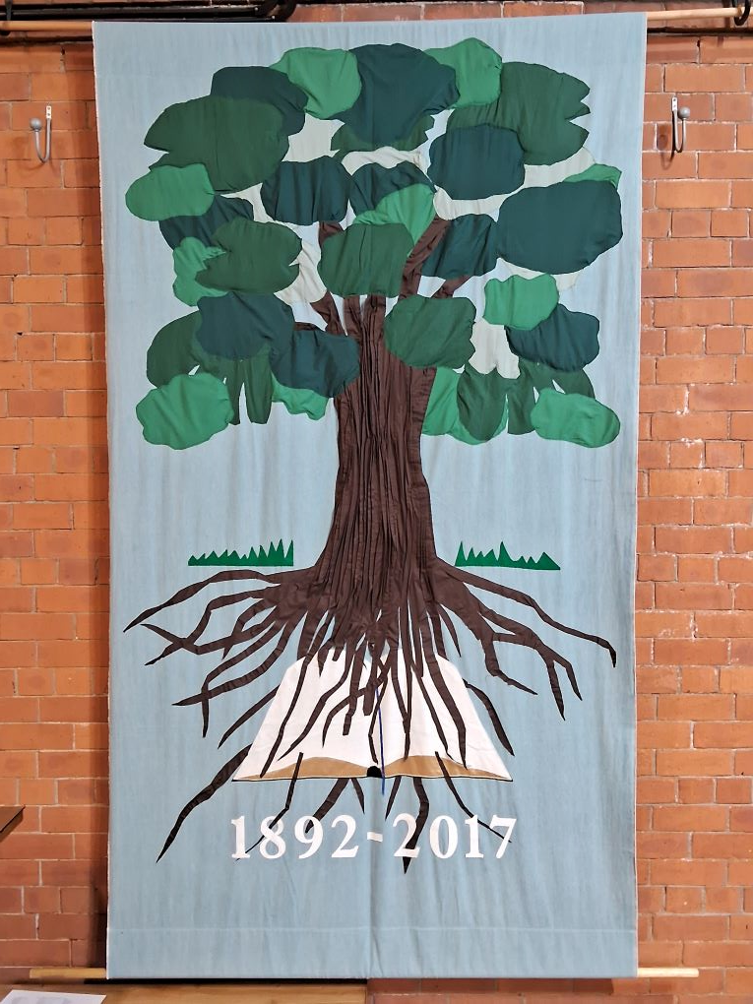

In 1930s America Psalm 1:3 and Jeremiah 17:8-9 provided the foundation for the words of the protest song ‘We shall not be moved’ (*): an anthem sung by workers in a variety of industries to strengthen them in their struggles against oppressive employers, low wages and dangerous working conditions. In the 1950s and 60s civil rights activists sang the same song as they united for racial justice around the conviction that ‘the Lord watches over the way of the righteous, but the way of the wicked will perish’ (Psalm 1:6).

The vivid pictures of trees found in Psalm 1 and Jeremiah 17 make the point that trying to live without the water of life is like struggling to survive in a desert. Psalm 1 says that those who stand tall for righteousness in this world also draw strength and blessing from God’s law (or word), which is as essential for life as water.

The photo above shows a banner which was made to celebrate the 125th anniversary of St Barnabas’ Church in Linthorpe. It’s a lovely reminder of our need both as individual followers of Jesus and as Christian churches to be rooted in the Word of God as we drink from the water of life and seek to grow strong and tall in our faith.

The water of life, the word of life, and the tree(s) of life: thank God for his inestimable gifts.

Julia Ardley

(*) reference: https://balladofamerica.org/we-shall-not-be-moved/

_____________________________________

Services and Events in our Churches over the next two weeks

On Sunday 16th February 2025 – 3rd Sunday before Lent – there will be services as follows:

At 9.30am at Hilton Church – a service of Morning Praise led by Julia Ardley, Authorised Lay MInister.

At 9.30am at Brookfield Church – a “Breakfast Church” service of informal worship, discussions, quizzes and simple refreshments. The service will be led by our Vicar, Revd Laura Wild. [Editor’s note: There will NOT be Holy Communion at this service].

At 11.00am at Stainton Church – a service of Holy Communion at which Revd Laura will preside.

The lessons set in the Lectionary for the 3rd Sunday before Lent are:
- Jeremiah 17:5-10
- Psalm 1
- 1 Corinthians 15:12-20
- Luke 6:17-26
The Diocesan Reflection for 3rd Sunday before Lent is given by the Revd Dr Jenny Wright, Chaplain to the Archbishop of York. Jenny reflects on the Gospel reading (Luke 6:17-26) set for 3rd Sunday before Lent; you can find the Reflection at this link.

On Tuesday 18th February 2025 at 9.30am at Stainton Church there will be a half-hour Plurality Prayer Gathering.

On Wednesday 19th February 2025 at 10.00am at Brookfield Church there will be a service of Holy Communion at which our Vicar, Revd Laura Wild, will preside.
_____________________________________

On Sunday 23rd February 2025 – 2nd Sunday before Lent – there will be services as follows:

At 9.30am at Brookfield Church a service of Holy Communion at which our Vicar, Revd Laura Wild, will preside;

At 11.00am at Stainton Church a service of Holy Communion at which Revd Laura will also preside, will preside; and

At 4.00pm at Hilton Church a service of Evensong led by our Pioneer Minister, Revd Vanessa Kirby.

The lessons set in the Lectionary for 2nd Sunday before Lent are:
- Genesis 2:4b-9, 15-end
- Psalm 65
- Revelation 4
- Luke 8:22-25
The Diocesan Reflection for the 2nd Sunday before Lent will be available on the Diocesan website at this link from about the Thursday of the previous week.

On Tuesday 11th February 2025 at 9.30am at Stainton Church there will be a half-hour Plurality Prayer Gathering.
On Wednesday 12th February 2025 at 10.00am at Brookfield Church there will be a service of Holy Communion at which our Vicar, Revd Laura Wild, will preside.

_____________________________________

Please continue to pray

… for Israel, Palestine and Lebanon

Give thanks for the recent ceasefire agreed between Israel and Hezbollah in Southern Lebanon, and for the recent ceasefire between Israel and Hamas in Gaza.

Please pray for a ceasefire between Israel and Hamas in the West Bank; and for Israeli, Palestinian and Lebanese Christians.

… for Syria

Give thanks for the end of the rule by President Bashar al-Assad and pray for the Rebel Islamist militant group, Hayat Tahrir al-Sham (HTS), which has assumed power, that they keep the Syrian people’s interest as a first priority. The HTS Leader is Ahmed al-Sharaa (also known as Abu Mohammed al-Jolani).

…. and for Ukraine and Russia

For an early end to the war between Russia and Ukraine.

…. and for Sudan

Pray for reconciliation between the warring factions in the civil war in Sudan and for a speedy end to the fighting.

_____________________________________

Please join us in praying for our Churches to Grow

Can we invite you to use our Revitalise "prayer for growth" in your personal quiet times with God?

Revitalise us Lord,
Enthuse in our congregations the desire for mission. Give
Vision to our planning and
Inspire our thoughts as we seek Your will.
Teach us to be more like You, Christ
Abiding in You and
Loving one another.
In growing healthy churches,
Sharing our faith, living Christ’s story
Every day, help us to be faithful disciples and bear much fruit. Amen.
_____________________________________

Pastoral Support - Here are the contact details for our Vicar, Revd Laura Wild:

Address: The Vicarage, 89 Low Lane, Brookfield, Middlesbrough TS5 9EF
Phone: 01642-598621
E-mail: rev.laura.wild@gmail.com

Laura's normal "day off" is Friday - if you need to contact her on that day please leave a message on the answerphone.
______________________________________

Bob Ardley

Ashdale House,
26 Meldyke Lane,
Stainton,
Middlesbrough TS8 9AU

T: 01642-284525;
E: bob.ardley@ntlworld.com

