Greetings to Stainton and Hemlington Church Members and Friends of Stainton Church

Welcome to the Stainton Church e-News for

Friday 24th January 2025

We hope you are well and keeping safe. If you need any
practical support, please do get in touch.

Growing our Churches

Your Editor came across this cartoon on Facebook today and wondered – tongue-in-cheek? - if it would help us to increase the sizes of our congregations? If you have any good ideas how to do this please do let our Vicar, Revd Laura know.

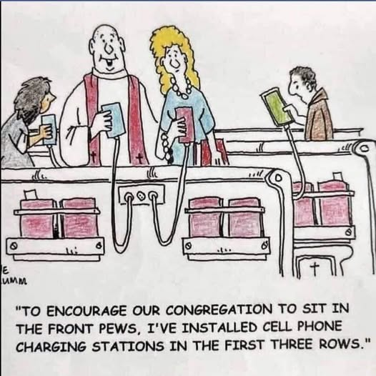

_____________________________________

Services and Events in our Churches over the next two weeks

On Sunday 26th January 2025 – Epiphany 3 – there will be services as follows:

At 9.30am at Brookfield Church a service of Holy Communion at which our Pioneer Minister, Revd Vanessa Kirby, will preside;

At 11.00am at Stainton Church a service of Holy Communion at which our Vicar, Revd Laura Wild, will preside; and

At 4.00pm at Hilton Church a service of Evensong led by Revd Laura.

The lessons set in the Lectionary for Epiphany 3 are:
- Nehemiah 8:1-3, 5-6, 8-10
- Psalm 19
- 1 Corinthians 12:12-31a
- Luke 4::14-21
The Diocesan Reflection for Epiphany 3 is given by our own Bishop of Whitby, the Rt Revd Barry Hill. Bishop Barry reflects on the Gospel reading (Luke 4:14-21) set for Epiphany 3 as the Church prepares to remember Holocaust Memorial Day (HMD) on Monday 27th January 2025; you can find the Reflection at this link. Bishop Barry gives a very powerful message, and your Editor commends Barry’s Reflection to you.



This Holocaust Memorial Day (HMD) 2025 marks the 80th anniversary of the liberation of Auschwitz-Birkenau, the largest Nazi concentration camp complex, and the 30th anniversary of the genocide in Bosnia.

The Holocaust Memorial Day Trust (the HDMT) says: 80 years after the liberation of Auschwitz-Birkenau, we must become the generations who carry forward the legacy of the witnesses, remember those who were murdered and challenge those who would distort or deny the past, or who discriminate and persecute today. We can all mark Holocaust Memorial Day 2025 and commit to making a better future for us all.

You can find out more about what Holocaust Memorial Day is by watching this short video produced by the HMDT – just CTRL+click on the image below or on this YouTube link: https://youtu.be/wCYAFWiZfRg



In addition, the Trust has a short video about the liberation by British Army troops of the camp at Bergen-Belsen on 15th April 1945 –just CTRL+click on the image below or on this YouTube link: https://youtu.be/Qu3_Oytc5Qk

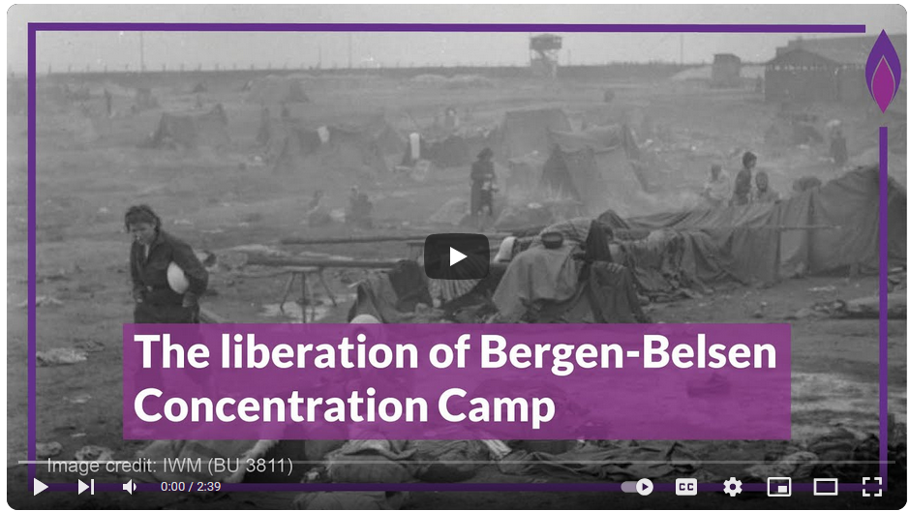

Both videos contain archive material from the Imperial War Museum (IWM).

On Tuesday 28th January 2025 at 9.30am at Stainton Church there will be a half-hour Plurality Prayer Gathering.
On Wednesday 29th January 2025 at 10.00am at Brookfield Church there will be a service of Holy Communion at which our Vicar, Revd Laura Wild, will preside.

_____________________________________

On Sunday 2nd February 2025 – Candlemas – there will be services as follows:

At 9.30am at Brookfield Church – a service of Holy Communion at which our Vicar, Revd Laura Wild, will preside;

At 11.00am at Stainton Church – a “Café Church” service of informal worship, discussions, quizzes and simple refreshments. The service will be led by Revd Laura. [Editor’s note: There will NOT be Holy Communion at this service].

At 4.00pm at Hilton Church – a service of Holy Communion by Candlelight for Candlemas at which Revd Laura will preside.

The lessons set in the Lectionary for Candlemas are:
- Malachi 3:1-5
- Psalm 24:7-10
- Hebrews 2:14-18
- Luke 2:22-40
The Diocesan Reflection for Candlemas will be available on the Diocesan website at this link from about the Thursday of the previous week.

On Tuesday 4th February 2025 at 9.30am at Stainton Church there will be a half-hour Plurality Prayer Gathering.

On Wednesday 5th February 2025 at 10.00am at Brookfield Church there will be a service of Holy Communion at which our Vicar, Revd Laura Wild, will preside.

_____________________________________

Please continue to pray


… for Israel and Palestine and now also for Lebanon

Give thanks for the recent ceasefire agreed between Israel and Hezbollah in Southern Lebanon.

Continue to pray for an end to the conflict between Israel and Hamas in Gaza and in the West Bank; and for Israeli, Palestinian and Lebanese Christians.

_____________________________________


… for Syria

Give thanks for the end of the rule by President Bashar al-Assad and pray for the Rebel Islamist militant group, Hayat Tahrir al-Sham (HTS), which has assumed power, that they keep the Syrian people’s interest as a first priority. The HTS Leader is Ahmed al-Sharaa (also known as Abu Mohammed al-Jolani).

_____________________________________


…. and for Ukraine and Russia

For an early end to the war between Russia and Ukraine.

_____________________________________


…. and for Sudan

Pray for reconciliation between the warring factions in the civil war in Sudan and for a speedy end to the fighting.

_____________________________________

Please join us in praying for our Churches to Grow

Can we invite you to use our Revitalise "prayer for growth" in your personal quiet times with God?

Revitalise us Lord,
Enthuse in our congregations the desire for mission. Give
Vision to our planning and
Inspire our thoughts as we seek Your will.
Teach us to be more like You, Christ
Abiding in You and
Loving one another.
In growing healthy churches,
Sharing our faith, living Christ’s story
Every day, help us to be faithful disciples and bear much fruit. Amen.
_____________________________________

Pastoral Support - Here are the contact details for our Vicar, Revd Laura Wild:

Address: The Vicarage, 89 Low Lane, Brookfield, Middlesbrough TS5 9EF
Phone: 01642-598621
E-mail: rev.laura.wild@gmail.com

Laura's normal "day off" is Friday - if you need to contact her on that day please leave a message on the answerphone.
______________________________________

Bob Ardley

Ashdale House,
26 Meldyke Lane,
Stainton,
Middlesbrough TS8 9AU

T: 01642-284525;
E: bob.ardley@ntlworld.com

