Greetings to Stainton and Hemlington Church Members and Friends of Stainton Church

Welcome to the Stainton Church e-News for

Friday 17th January 2025

We hope you are well and keeping safe. If you need any
practical support, please do get in touch.

Praise God for the Israel-Gaza interim/temporary ceasefire-hostage agreement!

At the time of writing an agreement has been reached between the Israelis and Hamas for a interim or temporary ceasefire in Gaza. The agreement was brokered by Qatar, Egypt and the USA and has been approved by Hamas, and approval by the Israeli Government has been recommended by the Israeli Security Cabinet. Once all sides have approved the proposal it should come into force on Sunday 19th Jan 2025. Here is what has been said about it:

Archbishop Stephen Cottrell, Archbishop of York writes on 16th Jan 2025:

The ceasefire-hostage deal between Israel and Hamas has been far too long in the making, but it is welcome news for those caught up in this devastating violence.

My prayers are with all the families being reunited over the coming days, and for those who are still held in captivity. My prayers too are with the people of Gaza who have suffered such immense destruction, deprivation and displacement. Now must be the time – again, so long overdue – for unfettered aid to reach the people of Gaza, and for the indispensable role of UNRWA to be respected and protected by all parties. May this deal be a precursor to a wider, more durable and just settlement in the region: it must not be a false dawn.

Please pray for Archbishop Hosam and our Anglican sisters and brothers in Palestine and Israel, and for all the Christians of the Holy Land as they bear the light of Christ in such dark times. Pray too for the courageous staff of the Anglican Al-Ahli Hospital in Gaza, and those in their care. Across the West Bank, this war is being felt not just in the daily grievous news from Gaza, but through widespread intensification of the occupation. I pray this deal acts as a catalyst to bring freedom, justice and dignity to the Palestinian people as well as being a small step towards the long term security of both Palestinians and Israelis.

We lift before God the peoples of the Holy Land, and for His justice, mercy and peace to be known by all.

Stephen Cottrell, Archbishop of York
--- * ---

The Christian Charity Embrace the Middle East said in an e-mail on 17th Jan 2025:

Dear Friends,
Situation in Gaza

We rejoice in the news of a ceasefire agreement in Gaza - offering a glimmer of hope amid the devastation. Please join us in praying that this is the start to a just and lasting peace.

Our partner Caritas Jerusalem have been providing medical care on the ground in Gaza throughout the war. Anton Asfa, their General Secretary, told us:
At Caritas Jerusalem, we see this day as a new beginning, but we know that the road to achieving real and lasting peace is long ... we will continue to work tirelessly in the reconstruction of Gaza. And here, I do not mean only rebuilding buildings but also rebuilding the human being, preserving their dignity, and giving them the chance to live the life they deserve.

You can watch a [very powerful (Editor’s emphasis)] short three-minute video of Anton's full update by CTRL+clicking on the play button on this YouTube video:

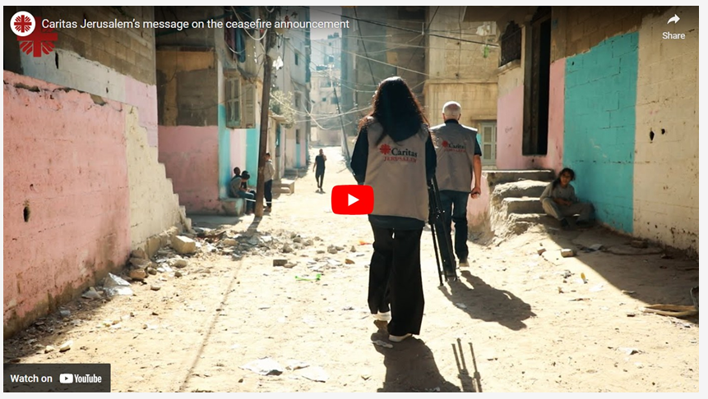

The temporary ceasefire is good news, but it is only the beginning, not the end. We [Embrace] remember all those who have been left dead or wounded, who have lost loved ones and all their possessions. We are deeply grateful for the courage and strength of our church partners who have carried on serving others in the most awful of circumstances, providing healthcare, psychological support and emergency provisions. We continue to call for lasting peace and an end to the violence. We call for the recognition of all Palestinians’ rights, an end to the illegal occupation of Palestinian territories, and full accountability for all violations of international law since 7 October 2023.

Embrace the Middle East has joined with 17 other charities and NGOs in issuing a joint statement calling on the UK Government to ensure that this pause turns rapidly into a permanent ceasefire and that it is the impetus to bring to an end the Israeli authorities’ occupation and oppression of Palestinians. You can READ THE STATEMENT HERE

Situation in the West Bank

Our [Embrace] colleague David is currently in the West Bank, meeting with some of our partners there. He sent us this update:
In the West Bank, [Embrace] partners welcomed the news of the ceasefire with joy. They are relieved that the killing will end and are actively planning how they will respond to help the injured, displaced and traumatised population.
But along with the joy there is also mourning for all the loss of life and concern about what the future holds for the West Bank. The West Bank remains in crisis and the ceasefire in Gaza will not change the situation here [Editor’s emphasis]. There is concern that military actions may increase and continue the pattern of escalation that has been seen for the past 16 months in the West Bank. The intensity of the occupation continues to increase and the ceasefire needs to be just one step on the path towards a just peace.

--- * ---
The organisation of Messianic Jews and Arabs called “One for Israel” is working towards a time when Jews and Arabs come to know Yeshua (Jesus) as Lord; they have an interesting take on the ceasefire-hostage agreement which your Editor shares without further comment. In an e-mail today One for Israel said:

Shalom Bob,

It’s official: 33 of the hostages will at last be coming home soon, some even this weekend. The deal was reached after Israelis paid a dear and heavy price in blood over the past 15 months with over 2,000 murdered and fallen in action. The hostage deal takes place just one day after the funeral of a Messianic Jewish soldier here in Israel.
Redeeming captives is a subject well known and written about in Jewish literature. Starting from the exodus from Egypt, through the first and second diasporas, and unfortunately throughout church history. Jewish communities have always redeemed their captives. This hostage deal is therefore but a chain in the history of Israel.

As followers of Messiah, the release of captives is very dear to the heart of us all, and part of the message that Jesus Himself came to bring.
The ceasefire has been agreed for 42 days during which just a third of the remaining hostages, some of which will be alive and others are already dead, will be returned at last to their families. The first three hostages will come home on Sunday.
Those hostages on the list to be set free are women, children, adults over the age of 50, and severely sick and wounded civilians. Starting with the women and children, around three to four additional hostages will be released every week over a course of six weeks.
The famous red-headed Bibas children taken captive from Nir Oz are on the list to be released, but their mother, Shiri, is not. We have no idea which of the hostages is still alive and who is dead. Families are getting ready either to embrace their loved ones, or bury them.
In exchange, up to 1,650 Palestinian prisoners will be released, 30 for each civilian and 50 for each female soldier. These are not political or even usual criminal prisoners – they include arch-terrorists with a lot of blood on their hands, convicted and some sentenced with life imprisonment, and Gazan terrorists arrested in connection to the atrocities of October 7. There are no civilians nor innocent people among them.
Here in Israel, emotions are very high. We are overjoyed at the thought of hostages finally coming home to their families, but we are paying a very heavy price. Some Israeli families whose relatives were brutally murdered by the terrorists about to be released in the hostage deal are trying to apply pressure not to release them, and thus not sign the deal. The situation poses yet another moral dilemma.

Some of the prisoners will be deported to Qatar and Turkey, but there is great concern about so many dangerous terrorists who are determined to destroy Israel walking free. One of the conditions of the agreement is that Israel will not be allowed to rearrest them.
During this first six-week phase, Israel and Hamas will discuss the details regarding a second phase, with the goal being a final end to the war in Gaza.
Please pray with us all at this time: Pray for our leaders here in Israel, and the other nations in the mediation process, who have to navigate these waters. Our God is a God of peace, life, and of freedom. Join us in prayer for His will to be done.

One for Israel has produced a worship video of the passage in John 3;16 in several languages which your Editor commends to you. Just CTRL+click on the YouTube image below to watch and listen.

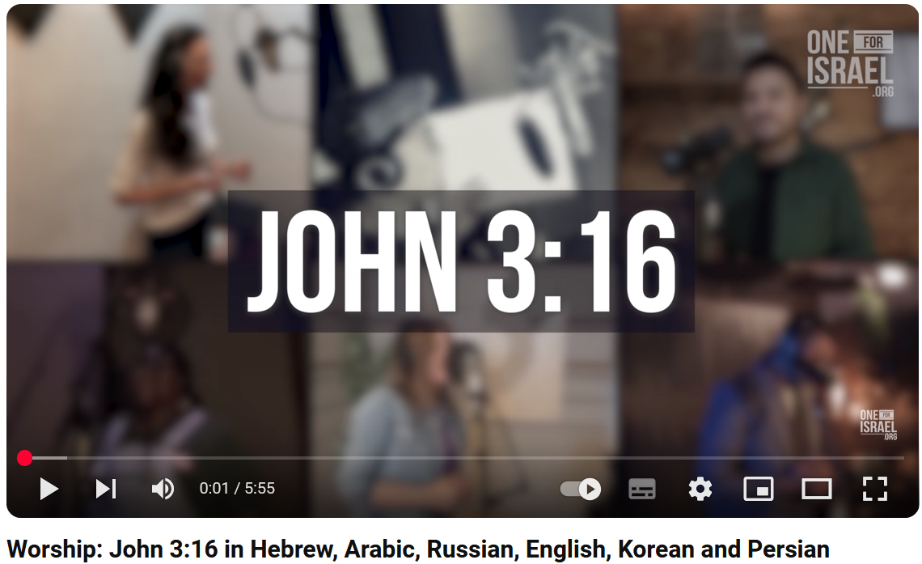
_____________________________________

Services and Events in our Churches over the next two weeks

On Sunday 19th January 2025 – Epiphany 3 – we begin the Week of Prayer for Christian Unity: there will be services as follows:

At 9.30am at Hilton Church – a service of Morning Praise led by Juia Ardley, Authorised Lay Minister;

At 9.30am at Brookfield Church – a “Breakfast Church service” of informal worship with discussions, quizzes and tea/coffee and cakes, led by our Vicar, Revd Laura Wild [Editor’s note: there will NOT be Holy Communion at this service]. And

At 11.00am at Stainton Church – a service of Holy Communion at which Revd Laura will preside and at which our Pioneer Minister, Revd Vanessa Kirby, will preach. The service will be followed at 1.00pm with a “Soup Lunch”.

The lessons set in the Lectionary for Epiphany 2 are:
- Isaiah 62:1-5
- Psalm 36:5-10
- 1 Corinthians 12:1-11
- John 2:1-11
The Diocesan Reflection for Epiphany 2 is given by the Revd Dr Ian McIntosh, Diocesan Director of Mission and Ministry. Ian reflects on the Gospel reading (John 2:1-11) set for Epiphany 2; you can find the Reflection at this link.

On Tuesday 21st January 2025 at 9.30am at Stainton Church there will be a half-hour Plurality Prayer Gathering.

On Tuesday 21st January 2025 at 7.00pm at Brookfield Church there will be a Revitalise/Alpha Reunion for discussion and review of where our three Churches are with Growing Health Churches in our locality. You are invited to gather to reflect on God's goodness in the revitalisation of our Churches! Everyone's insight is valuable so please do come along. You can enjoy some delicious puddings!

On Wednesday 22nd January 2025 at 10.00am at Brookfield Church there will be a service of Holy Communion at which our Vicar, Revd Laura Wild, will preside.

On Thursday 23rd January 2025 at 4.00pm at Brookfield Church there will be a service of Evening Prayer for the Week of Prayer for Christian Unity led by our Vicar, Revd Laura Wild

_____________________________________

On Sunday 26th January 2025 – Epiphany 3 – there will be services as follows:

At 9.30am at Brookfield Church a service of Holy Communion at which our Pioneer Minister, Revd Vanessa Kirby, will preside;

At 11.00am at Stainton Church a service of Holy Communion at which our Vicar, Revd Laura Wild, will preside; and

At 4.00pm at Hilton Church a service of Evensong led by Revd Laura.

The lessons set in the Lectionary for Epiphany 3 are:
- Nehemiah 8:1-3, 5-6, 8-10
- Psalm 19
- 1 Corinthians 12:12-31a
- Luke 4::14-21
The Diocesan Reflection for Epiphany 3 will be available on the Diocesan website at this link from about the Thursday of the previous week.

On Tuesday 28th January 2025 at 9.30am at Stainton Church there will be a half-hour Plurality Prayer Gathering.
On Wednesday 29th January 2025 at 10.00am at Brookfield Church there will be a service of Holy Communion at which our Vicar, Revd Laura Wild, will preside.

_____________________________________

Please continue to pray


… for Israel and Palestine and now also for Lebanon

Give thanks for the recent ceasefire agreed between Israel and Hezbollah in Southern Lebanon.

Continue to pray for an end to the conflict between Israel and Hamas in Gaza and in the West Bank; and for Israeli, Palestinian and Lebanese Christians.

_____________________________________


… for Syria

Give thanks for the end of the rule by President Bashar al-Assad and pray for the Rebel Islamist militant group, Hayat Tahrir al-Sham (HTS), which has assumed power, that they keep the Syrian people’s interest as a first priority. The HTS Leader is Ahmed al-Sharaa (also known as Abu Mohammed al-Jolani).

_____________________________________


…. and for Ukraine and Russia

For an early end to the war between Russia and Ukraine.

_____________________________________


…. and for Sudan

Pray for reconciliation between the warring factions in the civil war in Sudan and for a speedy end to the fighting.

_____________________________________

Please join us in praying for our Churches to Grow

Can we invite you to use our Revitalise "prayer for growth" in your personal quiet times with God?

Revitalise us Lord,
Enthuse in our congregations the desire for mission. Give
Vision to our planning and
Inspire our thoughts as we seek Your will.
Teach us to be more like You, Christ
Abiding in You and
Loving one another.
In growing healthy churches,
Sharing our faith, living Christ’s story
Every day, help us to be faithful disciples and bear much fruit. Amen.
_____________________________________

Pastoral Support - Here are the contact details for our Vicar, Revd Laura Wild:

Address: The Vicarage, 89 Low Lane, Brookfield, Middlesbrough TS5 9EF
Phone: 01642-598621
E-mail: rev.laura.wild@gmail.com

Laura's normal "day off" is Friday - if you need to contact her on that day please leave a message on the answerphone.
______________________________________

Bob Ardley

Ashdale House,
26 Meldyke Lane,
Stainton,
Middlesbrough TS8 9AU

T: 01642-284525;
E: bob.ardley@ntlworld.com

