Greetings to Stainton and Hemlington Church Members and Friends of Stainton Church

Welcome to the two-week edition of the Stainton Church e-News for

Friday 20th December 2024

We hope you are well and keeping safe. If you need any
practical support, please do get in touch.

Two Christmas Reflections

Here is a Christmas Reflection from the Revd Su McClellan, Associate Minister at Coventry Cathedral and Church Engagement Lead at the Christian Charity Embrace the Middle East.

I’ve always loved the Advent season. As a child it was filled with expectation as I’d open the window on my Advent calendar each day. I could feel the excitement growing as we got nearer to Christmas. As an adult I’ve valued the chance to reflect on the coming of the baby of Bethlehem, and what that means for our lives today as each day I light the Advent candle that sits on our kitchen table.

This year has been no exception. As war has continued to rage in the Middle East, Embrace has been privileged to hold three Advent vigils. During our reflections and prayers for our friends and partners in the region, we have listened to the experience of three different women, each one a representative of one of the Abrahamic faiths. We asked each of them the same question, ‘in these dark times, where do you find hope?’. It will probably come as no surprise to discover that light featured in their answers. As Bernadette Farrell’s well known hymn, Longing for Light acknowledges, we all yearn for light.

Light weaves its way through our Christian understanding of the world. “Let there be light” is recorded in Genesis as God’s first creative act. God’s light continues to be reflected in the words of the Psalmist and the prophets, and ultimately God’s light is revealed in Jesus, the Light of the World.

There are, however, times when the world feels very dark indeed and we may be wondering where the light has gone. Has God abandoned us?

In answering that question, I often think of the people of Svalbard, right up there in the Artic Circle. Their living environment is extreme, and at this time of year they are in the middle of the Polar Night that stretches from November to the beginning of February. The darkness is absolute. But that doesn’t mean that the sun has disappeared from the centre of our solar system, it’s simply that we can’t see it from that position on our planet.

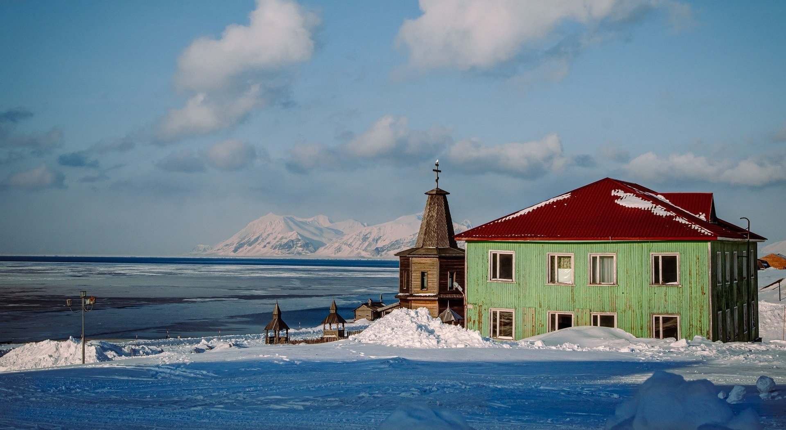
Svalbard, Arctic Circle. (Credit: Simona Ricci, Pixabay)

There are times when our lives and experience bask in the warmth of God’s light. There are other times when we feel as if we are on a lifeless, cold and dark rock, deprived of all warmth and light. It doesn’t mean that God has gone, it just means that our position has shifted and for now we are in the equivalent of a Polar Night.

The problem with Christmas as we celebrate it in the West today, is that it generates all sorts of expectations. TV images suggest cosy homes warmed with log fires and twinkling lights. Families gathering with no trace of pain or cross words. Unlimited amounts of money to spend on extravagant gifts. This is not reality. Christmas can be extraordinarily painful for people. For those of us living in the Northern Hemisphere, there is deep poignancy in Christmas coming at the darkest time of the year, as the baby of Bethlehem was born in dark times.

The shepherds and the angels, the manger and the wise men have all retained their places in the countless retellings of the Christmas story. We conveniently leave out the story’s most brutal episode, when the vasal King Herod orders the slaughter of every baby boy in Bethlehem and the Holy Family are forced to flee for their lives to Egypt. Whilst before the current war, pilgrims and tourists would flock to the Church of the Nativity in Bethlehem, few would visit the little chapel that sits outside its south transept. The Chapel of the Holy Innocents is placed over a first century burial ground containing the remains of babies. It’s a stark reminder of the consequences of greed, corruption and hunger for power.

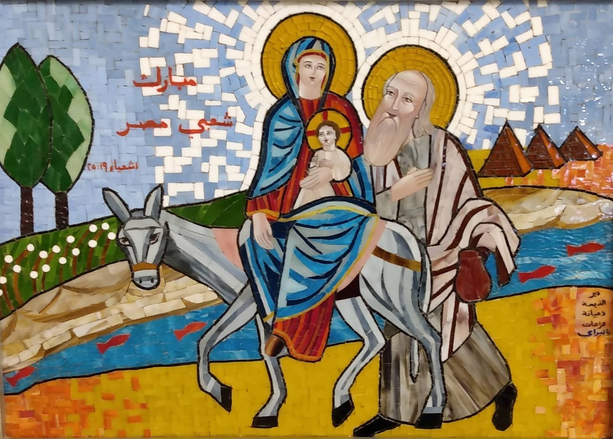
The Holy Family fled into Egypt to escape the massacre of the innocents.
Mosaic at the Coptic Papal Residence in Cairo.

The tragedy surrounding the first Christmas is a reminder to us all of Emmanuel, God with us. God does not come as a conquering hero. God comes as a baby, born in an occupied land, under the rule of a wicked vasal king and forced to become a refugee. The fractures of our broken world are eventually imprinted onto Jesus’ body as he dies on the cross. Those wounds carry the pain of all humanity. God is with us. God walks with us.

As we enter another Christmas season with the unimaginable suffering of the people of the land we call holy ongoing, we trust in the God who continues to walk alongside us in our fractured world. As I draw this reflection to a close, I am reminded of the Leonard Cohen lyric that says, “There’s a crack in everything. That’s how the light gets in”.

--- * ---

During this last week your Editor received a further Christmas Devotional e-mail from the Elevation Church in the USA and he is pleased to share this with you now.

Elevation Worship Advent Devotional Tuesday 17th Dec 2024.

“Echo the Angels”.

The Angel of the Lord appeared to the shepherds announcing the humble arrival of the son of God on earth. Jesus made His entry into our world in the lowliest fashion. He wasn't wrapped in the finest silks; rather, He was held tightly in strips of cloth. There was no silver spoon at a grand table; instead, He spent his first night in a manger filled with hay. Yet even though He experienced none of the trappings ordinarily held by other kings, Jesus was the King of kings at the moment of his birth.

Before performing a single miracle on earth, before giving sight to the blind and calming the swirling seas, the baby of whom the Angel spoke was fully God in infant form. Those who could see this - the angels, the shepherds, the wise men, Mary, and Joseph - responded out of this revelation. They adorned Him with gifts, sang over Him with gladness, and worshipped Him as the King sent to save.

Christ Jesus, the anointed one, is worthy of all our affection and devotion. The Creator of the world chose to be born into the world that He created. He experienced human existence and now walks in compassion over us. And this great King invites us to share in the song of all creation and crown Him with glory as the only one who deserves it.

“Glory to the newborn king”

_____________________________________

Services and Events in our Churches over the next three weeks

On Sunday 22nd December 2024 – Advent 4 – there will be services as follows:

At 9.30am at Brookfield Church a service of Holy Communion at which our Vicar, Revd Laura Wild, will preside;

At 11.00am at Stainton Church a service of “Carols and Coffee” led by our Pioneer Minister, Revd Vanessa Kirby. Come to the service dressed in a Christmas Jumper or other Christmas Outfit (maybe a “Onesie” even?) – Revd Vanessa has promised a prize for the best-dressed person in the congregation. [Editor’s note: There will NOT be Holy Communion at this service]; and

At 4.00pm at Hilton Church a Christingle Service led by Revd Laura.

The lessons set in the Lectionary for Advent 4 are:
- Micah 5:2-5a
- Psalm 80:1-8 or Canticle: Magnificat
- Hebrews 10:5-10
- Luke 1:39-45
The Diocesan Reflection for Advent 4 is given by the Rt Revd Dr Flora Winfield, the recently-appointed Bishop of Selby. Bishop Flora reflects on the Gospel reading (Luke 1:39-55) set for Advent 4; you can find the Reflection at this link.

On Tuesday 24th December 2024 at 9.30am at Stainton Church there will be a half-hour Plurality Prayer Gathering.
On Tuesday 24th December 2024 at 2.00pm at Brookfield Church there will be a Pop-up Nativity service led by the Ministry Team.

On Tuesday 24th December 2024 at 4.00pm at Stainton Church there will be a Nativity/Crib service led by the Ministry Team.
On Tuesday 24th December 2024 at 8.00pm at Stainton Church there will be a service of The First Holy Communion of Christmas [Editor’s note: aka “Midnight Mass”] at which our Vicar, the Revd Laura Wild, will preside.
On Wednesday 25th December 2024 at 9.30am at Hilton Church there will be a service of Holy Communion for Christmas Day at which our Pioneer Minister, Revd Vanessa Kirby, will preside.

On Wednesday 25th December 2024 at 10.00am at Brookfield Church there will be a service of Holy Communion for Christmas Day at which Revd Laura will preside.

_____________________________________

On Sunday 29th December 2024 – the First Sunday of Christmas (Christmas 1) - at 10.30am at Hilton Church there will be our “5th Sunday Special” Joint (Plurality) Service of Holy Communion for the 1st Sunday of Christmas at which our Vicar, Revd Laura Wild, will preside [Editor’s note: there will NOT be a service at Stainton Church or at Brookfield Church on that day].

The lessons set in the Lectionary for Christmas 1 are:
- 1 Samuel 2:18-20, 26
- Psalm 148
- Colossians 3:12-17
- Luke 2:41-52
The Diocesan Reflection for Christmas 1 is given by the Venerable Dr Amanda Bloor, Archdeacon of Cleveland. Archdeacon Amanda reflects on the Gospel reading (Luke 2:41-52) set for Christmas 1; you can find the Reflection at this link.

On Tuesday 31st December 2024 at 9.30am at Stainton Church there will be a half-hour Plurality Prayer Gathering.

On Wednesday 1st January 2025 the usual weekly mid-week service at 10.00am at Brookfield Church is cancelled.

_____________________________________

On Sunday 5th January 2025 – The Feast of the Epiphany (transferred from 6th January) – there will be services as follows:

At 9.30am at Hilton Church – a service of Holy Communion, at which Revd Maris Edwards will preside;

At 9.30am at Brookfield Church – a service of Holy Communion at which our Vicar, Revd Laura Wild, will preside; and

At 11.00am at Stainton Church – a “Café Church service” of informal worship to celebrate Epiphany with discussions, quizzes and tea/coffee and cakes, led by our Vicar, Revd Laura Wild [Editor’s note: there will NOT be Holy Communion at this service].

The lessons set in the Lectionary for the Feast of the Epiphany are:
- Isaiah 60:1-6
- Psalm 72 1-15
- Ephesians 3:1-12
- Matthew 2:1-12
The Diocesan Reflection for Epiphany will be available on the Diocesan website at this link from about the Thursday of the previous week.

On Tuesday 7th January 2025 at 9.30am at Stainton Church there will be a half-hour Plurality Prayer Gathering.

On Wednesday 8th January 2025 at 10.00am at Brookfield Church there will be a service of Holy Communion at which our Vicar, Revd Laura Wild, will preside.

_____________________________________

Please continue to pray


… for Israel and Palestine and now also for Lebanon

Give thanks for the recent ceasefire agreed between Israel and Hezbollah in Southern Lebanon.

Continue to pray for an end to the conflict between Israel and Hamas in Gaza and the West Bank; and for Israeli, Palestinian and Lebanese Christians.

_____________________________________


… for Syria

Give thanks for the end of the rule by President Bashar al-Assad and pray for the Rebel Islamist militant group, Hayat Tahrir al-Sham (HTS), which has assumed power, that they keep the Syrian people’s interest as a first priority. The HTS Leader is Ahmed al-Sharaa (also known as Abu Mohammed al-Jolani).

_____________________________________


…. and for Ukraine and Russia

For an early end to the war between Russia and Ukraine.

_____________________________________


…. and for Sudan

Pray for reconciliation between the warring factions in the civil war in Sudan and for a speedy end to the fighting.

_____________________________________

Please join us in praying for our Churches to Grow

Can we invite you to use our Revitalise "prayer for growth" in your personal quiet times with God?

Revitalise us Lord,
Enthuse in our congregations the desire for mission. Give
Vision to our planning and
Inspire our thoughts as we seek Your will.
Teach us to be more like You, Christ
Abiding in You and
Loving one another.
In growing healthy churches,
Sharing our faith, living Christ’s story
Every day, help us to be faithful disciples and bear much fruit. Amen.
_____________________________________

Pastoral Support - Here are the contact details for our Vicar, Revd Laura Wild:

Address: The Vicarage, 89 Low Lane, Brookfield, Middlesbrough TS5 9EF
Phone: 01642-598621
E-mail: rev.laura.wild@gmail.com

Laura's normal "day off" is Friday - if you need to contact her on that day please leave a message on the answerphone.
______________________________________

Bob Ardley

Ashdale House, 26 Meldyke Lane, Stainton, Middlesbrough TS8 9AU T: 01642-284525; E: bob.ardley@ntlworld.com

