Greetings to Stainton and Hemlington Church Members and Friends of Stainton Church

Welcome to the Stainton Church e-News for

Friday 13th December 2024

We hope you are well and keeping safe. If you need any
practical support, please do get in touch.

A Christmas Reflection

On Wednesday, at Coffee and Kids this week, we had the story of Mary and Joseph journeying from Nazareth in Gallilee to Bethlehem in Judea to take part in the Census decreed by the Roman Emperor Caesar Augustus. Although there is no mention of Mary “riding on a donkey” in the Gospel accounts of the first Christmas we can be reasonably confident that she did – Google Maps tells us that it is a 146km (90 miles) trip taking 35 hours of non-stop walking, an impossible task for a heavily-pregnant woman. It must have taken Mary and Joseph quite a long time – many days, even – with Mary riding on their trusted beast of burden.

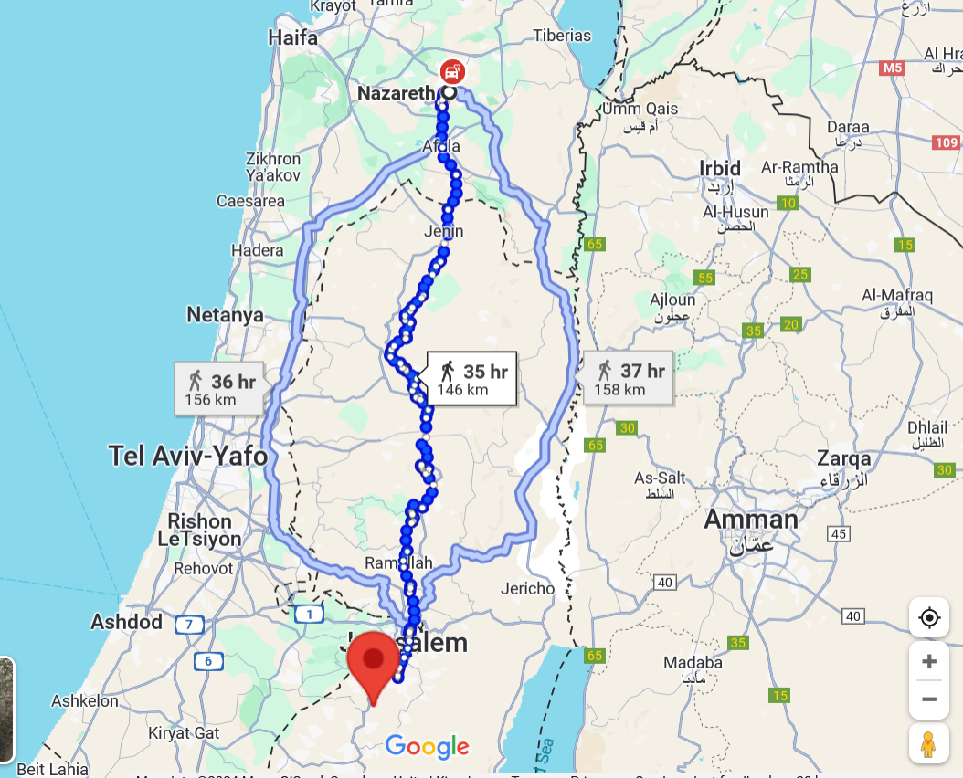

Imagine arriving in a packed Bethlehem to find that all the hotels and inns were full to overflowing with no room available without a reservation. Fortunately, one Inn had a “Stable free if Mary and Joseph did not mind sleeping with the animals” …

…. and that would be the night that Mary goes into labour!

And the rest is History.

I wonder what was going through Mary’s mind?

During this last week your Editor received a Christmas Devotional e-mail from the Elevation Church in the USA and he is pleased to share this with you now.

Elevation Worship Advent Devotional Tuesday 10th Dec 2024.

“I am waiting in silent prayer”.

There were certainly moments of clamour and chaos surrounding the events of the birth of Jesus. His entry into our world would have been accompanied by the sounds of childbirth pains and the cries of a newborn baby. Nights were interrupted with screams, signalling it was time to nurse and nurture an infant child.

Likely, there were nervous conversations between Mary and Joseph as they processed the implications of a brand-new reality setting in. There was worship from the shepherds, praise from the wise men, choruses sung by angels, and a constant rustling of the animals that surrounded them on the night when Jesus was born. Yet, in the quiet moments, Mary sought solitude and peace amid the swirling emotions and uncertainties as she “… treasured up all these things, and pondered them in her heart”.

This Christmas season today echoes a different kind of chaos. We rush to decorate our homes with lights and ornaments, gather with friends and family, and hunt for the perfect gifts. In this whirlwind, the essence of the season can easily slip away, leaving us caught in the hustle without connecting to the heart of it all. Like Mary, we can learn to cultivate moments of stillness and reflection amid the festive frenzy. It's not that these activities are wrong - they’re part of the joy of Christmas - but when they consume us, they can overshadow the true purpose of our celebrations.

Let's learn from Mary's example. Let's deliberately seek moments of serenity and engaging contemplative prayer during these bustling December days. When we make space for quiet reflection, we can deepen our connection to the profound meaning behind Christmas. Embrace stillness amid the rush and find yourself drawn closer to the heart of this joyous season, discovering again the wonder of the birth of Christ, and all that His coming means for you.

You can watch and listen to Amy Grant singing her song “Breath of Heaven (Mary’s Song)” by clicking on this YouTube link: https://youtu.be/FWo3qlqyW1c . This song was the inspiration for the title of this Advent Devotion – “I am waiting in silent prayer”.

_____________________________________

Services and Events in our Churches over the next two weeks

On Sunday 15th December 2024 – Advent 3 – there will be services as follows:

At 9.30am at Hilton Church – Morning Praise led by Julia Ardley, Authorised Lay Minister;

At 9.30am at Brookfield Church – a “Christingle Breakfast Church” service of informal worship, quizzes, discussions and good simple refreshments [Editor’s note: the Christingles will be made during the service. Please note that there will NOT be Holy Communion at this service]; and

At 11.00am at Stainton Church – a service of Holy Communion at which our Pioneer Minister, Revd Vanessa Kirby, will preside; and

At 4.00pm at Brookfield Church – a Christingle Service with Carols supported by Acklam Whin Primary School Choir - this will be a family-friendly service suitable for all ages.

The lessons set in the Lectionary for Advent 3 are:
- Zephaniah 3:14-20
- Canticle: Isaiah 12:2-6
- Philippians 4:4-7
- Luke 3:7-18
The Diocesan Reflection for Advent 2 is given by the Very Revd Dominic Barrington, Dean od York Minster. Dean Dominic reflects on the Gospel reading (Luke 3:7-18) set for Advent 3; you can find the Reflection at this link.

On Tuesday 17th December 2024 at 9.30am at Stainton Church there will be a half-hour Plurality Prayer Gathering.

On Tuesday 17th December 2024 at 7.00pm at Stainton Memorial Hall there will be the Stainton Village Carol Service which is a joint venture between Stainton Parish Church and Stainton Methodist Chapel.

On Wednesday 18th December 2024 at 10.00am at Brookfield Church there will be a service of Holy Communion at which our Vicar, Revd Laura Wild, will preside.

On Wednesday 18th December 2024 at 5.00pm at Hemlington Viewley Centre (outside the Hemlington Library) there will be Open Air Carol Singing, led by our Vicar Revd Laura Wild.
_____________________________________

On Sunday 22nd December 2024 – Advent 4 – there will be services as follows:

At 9.30am at Brookfield Church a service of Holy Communion at which our Vicar, Revd Laura Wild, will preside;

At 11.00am at Stainton Church a service of “Carols and Coffee” led by our Pioneer Minister, Revd Vanessa Kirby. Come to the service dressed in a Christmas Jumper or other Christmas Outfit (maybe a “Onesie” even?) – Revd Vanessa has promised a prize for the best-dressed person in the congregation. [Editor’s note: There will NOT be Holy Communion at this service]; and

At 4.00pm at Hilton Church a Christingle Service led by Revd Laura.

The lessons set in the Lectionary for Advent 4 are:
- Micah 5:2-5a
- Psalm 50:1-8
- Hebrews 10:5-10
- Luke 1:39-45
The Diocesan Reflection for Advent 4 will be available on the Diocesan website at this link from about the Thursday of the previous week.

On Tuesday 24th December 2024 at 9.30am at Stainton Church there will be a half-hour Plurality Prayer Gathering.
On Tuesday 24th December 2024 at 2.00pm at Brookfield Church there will be a Pop-up Nativity service led by the Ministry Team.

On Tuesday 24th December 2024 at 4.00pm at Stainton Church there will be a Nativity/Crib service led by the Ministry Team.
On Tuesday 24th December 2024 at 8.00pm at Stainton Church there will be a service of The First Holy Communion of Christmas [Editor’s note: aka “Midnight Mass”] at which our Vicar, the Revd Laura Wild, will preside.
On Wednesday 25th December 2024 at 9.30am at Hilton Church there will be a service of Holy Communion for Christmas Day at which our Pioneer Minister, Revd Vanessa Kirby, will preside.

On Wednesday 25th December 2024 at 10.00am at Brookfield Church there will be a service of Holy Communion for Christmas Day at which Revd Laura will preside.

_____________________________________

On Sunday 29th December 2024 at 10.30am at Hilton Church there will be our “5th Sunday Special” Joint (Plurality) Service of Holy Communion for the 1st Sunday of Christmas at which our Vicar, Revd Laura Wild, will preside [Editor’s note: there will NOT be a service at Stainton Church or at Brookfield Church on that day].

_____________________________________

Please continue to pray


… for Israel and Palestine and now also for Lebanon

Give thanks for the recent ceasefire agreed between Israel and Hezbollah in Southern Lebanon.

Continue to pray for an end to the conflict between Israel and Hamas in Gaza and the West Bank; and for Israeli, Palestinian and Lebanese Christians.
_____________________________________


… for Syria

Give thanks for the end of the rule by President Bashar al-Assad and pray for the Rebel Islamist militant group, Hayat Tahrir al-Sham (HTS), which has assumed power, that they keep the Syrian people’s interest as a first priority (The HTS Leader is Ahmed al-Sharaa, also known as Abu Mohammed al-Jolani).

Here are some prayers from the Church of England.

How long oh Lord? How long?

We have been crying to you for peace in Syria; for an end to killing and despair, an end to hostilities on all sides. We thank you for the current cessation of hostilities and pray it may turn into a long lasting peace.

We cry to you for humanitarian aid to reach those most in need.

We beseech you for the rebuilding of ruined homes, businesses and communities.

We long for the repairing of the breach and the restoration of streets where your children may dwell in harmony.

We cry out that justice, truth and love may prevail for all the people of Syria.

We pray in the name of the Prince of Peace, Jesus Christ our Lord.

Amen.
---*---

Lord of the church, we pray for your blessing on our sisters and brothers in Jesus Christ in the churches of Syria. Uphold and sustain them.

Keep them faithful to Jesus in the face of persecution, opposition, tragedy and turmoil.

May they know the power of your Holy Spirit to be your people in, and for, their land and nation.

We pray in the name of Jesus Christ the foundation and cornerstone of your holy church.

Amen.

_____________________________________


…. and for Ukraine and Russia

For an early end to the war between Russia and Ukraine.
_____________________________________


…. and for Sudan

Pray for reconciliation between the warring factions in the civil war in Sudan and for a speedy end to the fighting.

_____________________________________

Please join us in praying for our Churches to Grow

Can we invite you to use our Revitalise "prayer for growth" in your personal quiet times with God?

Revitalise us Lord,
Enthuse in our congregations the desire for mission. Give
Vision to our planning and
Inspire our thoughts as we seek Your will.
Teach us to be more like You, Christ
Abiding in You and
Loving one another.
In growing healthy churches,
Sharing our faith, living Christ’s story
Every day, help us to be faithful disciples and bear much fruit. Amen.
_____________________________________

Pastoral Support - Here are the contact details for our Vicar, Revd Laura Wild:

Address: The Vicarage, 89 Low Lane, Brookfield, Middlesbrough TS5 9EF
Phone: 01642-598621
E-mail: rev.laura.wild@gmail.com

Laura's normal "day off" is Friday - if you need to contact her on that day please leave a message on the answerphone.
______________________________________

Bob Ardley

Ashdale House, 26 Meldyke Lane, Stainton, Middlesbrough TS8 9AU T: 01642-284525; E: bob.ardley@ntlworld.com

