Greetings to Stainton and Hemlington Church Members and Friends of Stainton Church

Welcome to the Stainton Church e-News for

Friday 29th November 2024

We hope you are well and keeping safe. If you need any
practical support, please do get in touch.

It’s on NOW – Don’t miss it!
Stainton Church Angel Festival
Friday 29th November to Sunday 1st December 2024



The Festival opening times are:
Friday 29th November 2024 3.30pm – 6.00pm
Saturday 30th November 2024 2.00pm – 4.30pm
Sunday 1st December 2024 3.00pm – 4.00pm followed by
4.00pm – 5.00pm a Celebration Advent Carol Service at which our guest speaker will be the Rt Revd Barry Hill, Bishop of Whitby

Revd Vanessa writes:

The Angel Festival is now on. We hope to welcome people of all ages from the local community and the wider area to see the canopy of 1,000 paper angels that has been raised in the nave of Stainton Church, as well as a Memorial Tree on and around which we will place the knitted and crocheted angels in memory of a loved one.

The Angel Festival is going to be such a special time and even more special because it is a whole community project. A big THANK YOU to all who have taken part.

Vanessa x
_____________________________________
A date for your diaries

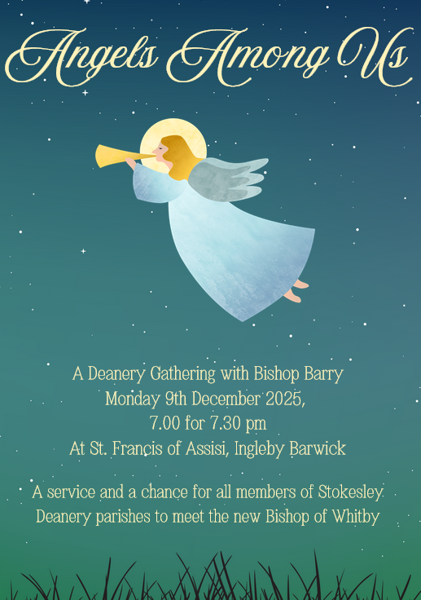

On Monday 9th December 2024 at 7.00pm for 7.30pm at St Francis of Assisi Church, Ingleby Barwick there will be a Deanery Gathering with Bishop Barry. This service provides an opportunity for all members of Stokesley Deanery Parishes – including those from Stainton with Hemlington, Hilton and Brookfield - to meet the new Bishop of Whitby, the Rt Revd Barry Hill.

The evening will include a Q&A session with Bishop Barry. If you have a question that you would like to ask the Bishop please submit it ahead of time (this allows time to be allocated appropriately to each question). Please send your question to Liz Taylorson, Deanery Secretary at this e-mail address stokeselydeanery@outlook.com before 1.00 pm on Thursday 5th December.

_____________________________________

Safeguarding and the Church – what do you think?
The Diocesan Safeguarding Team say: “a huge thank you to all those who have supported and took part in the Diocesan Safeguarding Week 2024 (18th to 24th November 2024). During the week we enjoyed a wide range of talks and presentations on a wide variety of subjects. Feedback so far has been extremely positive. We will share more information and insights over the next few weeks”.

Safeguarding and the Church – what do you think? Worshippers, parishioners and church members throughout the Church of England are invited to take part in an independent Safeguarding Audit commissioned by the national church, to ensure that every diocese and church is doing all it can to create an environment where everyone feels safe, valued and respected.

Editor’s comment: The Safeguarding Team at the Diocese have asked that information about the Audit be circulated widely in our Parishes. As the Parish Safeguarding Officer (PSO) for all three Churches in our Group can I please, please, please encourage you to take part in this important Survey.
How to take part?
There is an online survey which invites individuals to comment on any safeguarding matters within the Audit's focus. The survey is anonymous and confidential - you won't be asked who you are, so that you can be open and honest in your responses.
You can access the online survey at this link: https://ineqe.com/churchofengland/york. The Survey is open now, and will continue until 11.30pm on Friday 3rd January 2025.
What happens to the answers you give?
The responses you give will be received directly by the Safeguarding Audit Team at INEQE Safeguarding Group, the independent organisation conducting the audit on behalf of the Church of England.
Thank you for taking part in this piece of work to help the church in its journey to becoming a safer place for all. INEQE looks forward to hearing from you; everyone is welcome to share your views and experiences with them through the survey.
_____________________________________

Services and Events in our Churches over the next two weeks

On Friday 29th November 2024 at 3.30pm to 6.00pm at Stainton Church our Angel Festival will be open to visitors.

On Saturday 30th November 2024 at 2.00pm to 4.30pm at Stainton Church our Angel Festival will be open to visitors.

_____________________________________

On Sunday 1st December 2024 – Advent Sunday – we begin a new liturgical year in the life of the Church; much of our liturgy will be taken from Year C in the Common Worship books.

On this Advent Sunday 2024 there will be services as follows:

At 9.30am at Hilton Church – Holy Communion at which Revd Marie Edwards will preside;

At 9.30am at Brookfield Church – Holy Communion with a Christmas Toy/Gift Service at which our Vicar, Revd Laura Wild, will preside. UNWRAPPED GIFTS of toys received at the Brookfield Gift Service will be passed on to a local charity Christmas appeal;

At 11.00am at Stainton Church – a Christingle “Café Church” service of informal worship, quizzes, discussions and good simple refreshments [Editor’s note: and lots of Christingles, of course!] led by Revd Laura Wild;

At 3.00pm at Stainton Church - our Angel Festival will be open to visitors; and

At 4.00pm at Stainton Church – an Angel Festival Celebration Carol Service led by our Pioneer Minister, Revd Vanessa Kirby, and at which we shall be pleased to welcome the Rt Revd Barry Hill, Bishop of Whitby, as guest speaker.

The lessons set in the Lectionary for Advent Sunday are:
- Jeremiah 33:14-16
- Psalm 25:1-9
- 1 Thessalonians 3:9-13
- Luke 21:25-36
The Diocesan Reflection for Advent Sunday is given by the Venerable Andy Broom, Archdeacon of the East Riding. Archdeacon Andy reflects on the Gospel reading (Luke 21:25-36) set for Advent Sunday; you can find the Reflection at this link.

On Tuesday 3rd December 2024 at 9.30am at Stainton Church there will be a half-hour Plurality Prayer Gathering.

On Wednesday 4th December 2024 at 10.00am at Brookfield Church there will be a service of Holy Communion at which our Vicar, Revd Laura Wild, will preside.

_____________________________________

On Sunday 8th December 2024 – Advent 2 – there will be services of Holy Communion as follows:

At 9.30am at Brookfield Church at which our Vicar, Revd Laura Wild, will preside;

At 11.00am at Stainton Church at which our Pioneer Minister, Revd Vanessa Kirby, will preside; and

At 4.00pm at Hilton Church at which Revd Laura will preside.

The lessons set in the Lectionary for Advent 2 are:
- Malachi 3:1-4
- Psalm/Canticle Benedictus
- Philippians 1:3-11
- Luke 3:1-6
The Diocesan Reflection for Advent 2 will be available on the Diocesan website at this link from about the Thursday of the previous week.

On Tuesday 10th December 2024 at 9.30am at Stainton Church there will be a half-hour Plurality Prayer Gathering.
On Wednesday 11th December 2024 at 10.00am at Brookfield Church there will be a service of Holy Communion at which our Vicar, Revd Laura Wild, will preside.

On Friday 13th December 2024 at 7.00pm at Hilton Church there will be the Hilton Village Carol Service supported by the Cleveland Police Community Band, followed at 8.00pm by refreshments service in Hilton Village Hall.

_____________________________________

Please continue to pray


… for Israel and Palestine and now also for Lebanon

Give thanks for the recent ceasefire agreed between Israel and Hezbollah in Southern Lebanon.

Continue to pray for an end to the conflict between Israel and Hamas in Gaza and the West Bank.

Continue to pray for Israeli, Palestinian and Lebanese Christians.

_____________________________________


…. and for Ukraine and Russia

For an early end to the war between Russia and Ukraine.

_____________________________________


…. and for Sudan

Pray for reconciliation between the warring factions in the civil war in Sudan and for a speedy end to the fighting. There is a crisis in Sudan with more than 10 million displaced people.

Famine has already been declared in one area - many others subsist on the brink of starvation not knowing where their next meal will come from. "It’s an invisible crisis," emphasises the UN’s new humanitarian chief Tom Fletcher. "Twenty-five million Sudanese, more than half the country, need help now," he adds.

As well as the two main warring parties in Sudan - the army and the paramilitary Rapid Support Forces (RSF) - there are many smaller "ethnic armies" looting and going "berserk" on civilians, Jan Egeland, head of the Norwegian Refugee Council (NRC), said. "The parties are tearing down their own houses, they are massacring their own people," he said. For 19 months, there has been a brutal power struggle between the army and the RSF, that has forced more than 10 million people to flee their homes and pushed the country to the brink of starvation.

"All that I saw confirms that this is indeed the biggest humanitarian emergency on our watch, the biggest hunger crisis, the biggest displacement crisis," Mr Egeland said, following a trip to Sudan.

"Most of Sudan is starving, it's starving," he said, adding that starvation has been used as a method of warfare. Some food security specialists fear that as many as 2.5 million people could die from hunger by the end of this year.

You can read very recent reports on this by the BBC by clicking here and here.

_____________________________________

Please join us in praying for our Churches to Grow

Revitalise (*) is the Diocesan “Growing Health Churches” programme which seeks to help us be a viable flourishing presence into the future.
Can we invite you to use our Revitalise "prayer for growth" in your personal quiet times with God?

Revitalise us Lord,
Enthuse in our congregations the desire for mission. Give
Vision to our planning and
Inspire our thoughts as we seek Your will.
Teach us to be more like You, Christ
Abiding in You and
Loving one another.
In growing healthy churches,
Sharing our faith, living Christ’s story
Every day, help us to be faithful disciples and bear much fruit. Amen.

_____________________________________

Pastoral Support - Here are the contact details for our Vicar, Revd Laura Wild:

Address: The Vicarage, 89 Low Lane, Brookfield, Middlesbrough TS5 9EF
Phone: 01642-598621
E-mail: rev.laura.wild@gmail.com

Laura's normal "day off" is Friday - if you need to contact her on that day please leave a message on the answerphone.
______________________________________

With all good wishes to you

Bob Ardley

Ashdale House,
26 Meldyke Lane,
Stainton,
Middlesbrough TS8 9AU

T: 01642-284525;
E: bob.ardley@ntlworld.com

