Greetings to Stainton and Hemlington Church Members and Friends of Stainton Church

Welcome to the Stainton Church e-News for

Friday 25th October 2024

We hope you are well and keeping safe. If you need any
practical support, please do get in touch.

Important messages

Please would e-News Readers check their e-mail address book list for Revd Vanessa Kirby, our Pioneer Priest. An incorrect e-mail address has been in circulation.

Vanessa’s correct address is: rev.vanessakirby@gmail.com (NOT vanessakirby@gmail.com)

The clocks need to be put back one hour on Saturday – don’t forget and be late for this Sunday’s services!

[Editor’s note: pedantically, the clocks go back one hour at 02.00hrs on Sunday]


_____________________________________

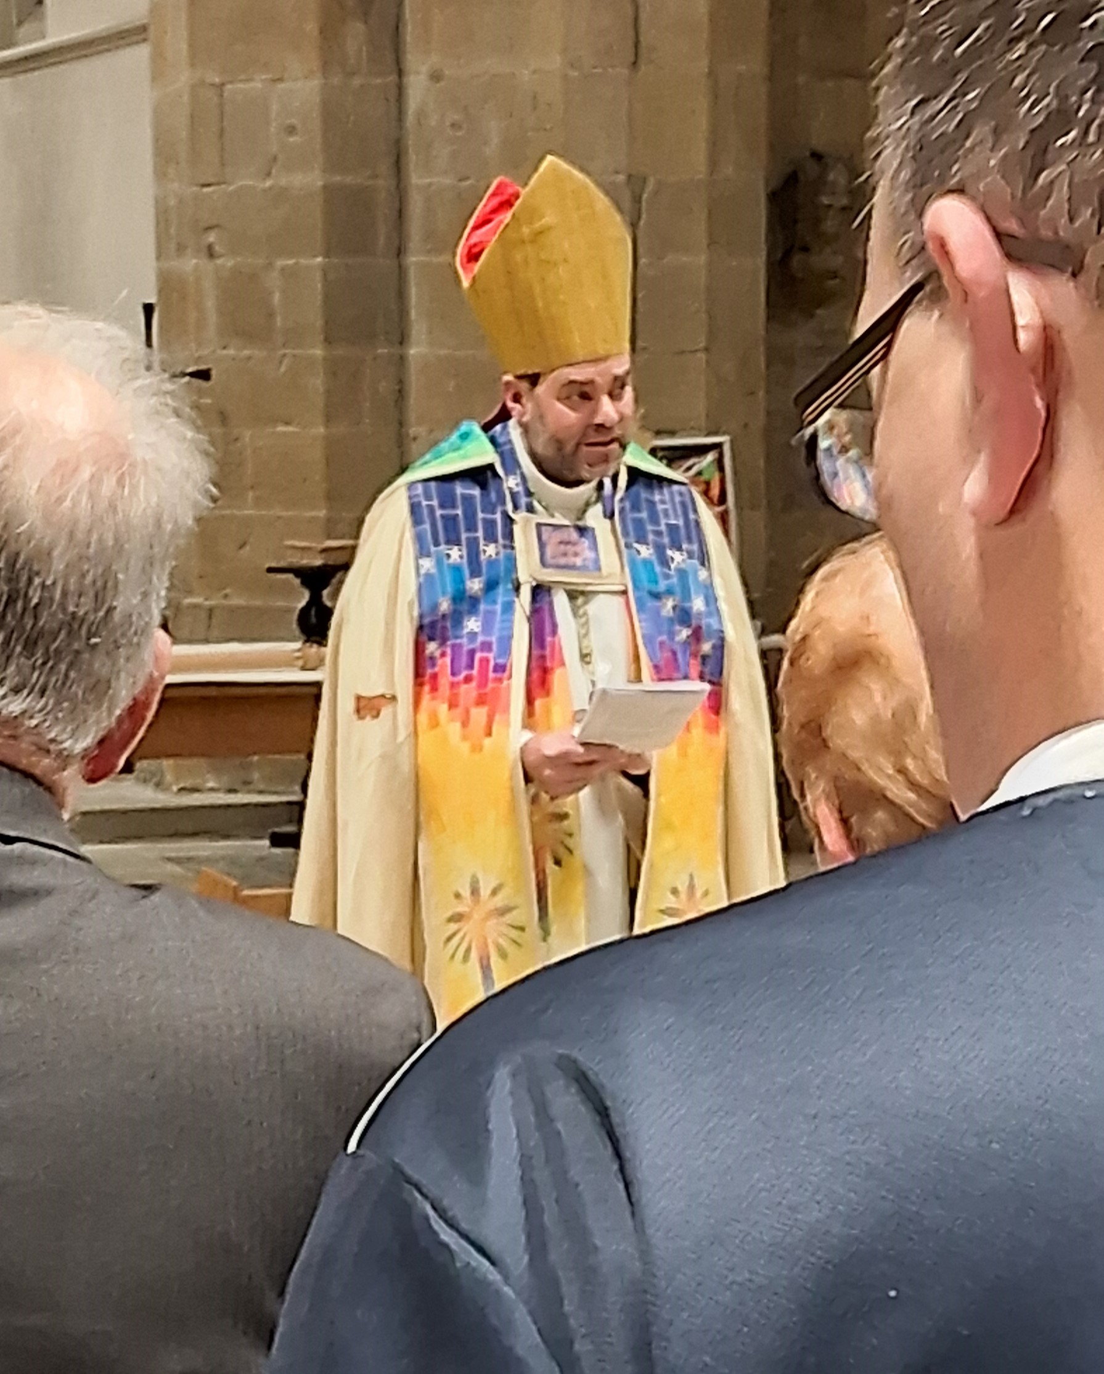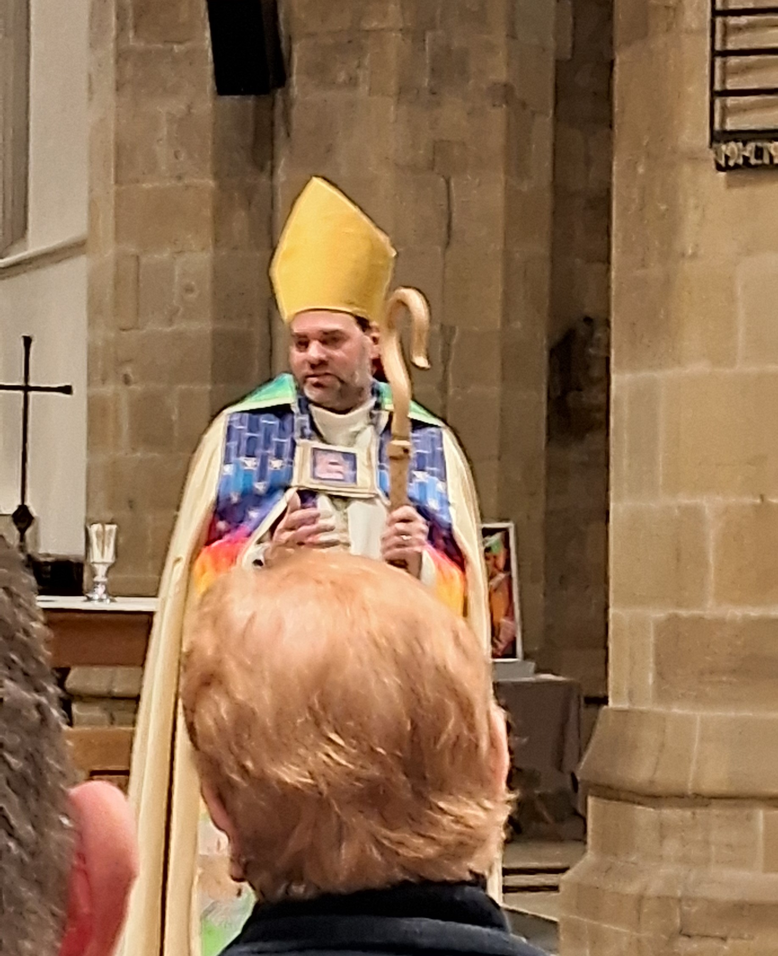

Your editor, Judith and Vernon Clare, Revd Laura and Revd Vanessa gathered with many others from across the Archdeaconry to welcome the Rt Revd Barry Hill, to his public ministry as Bishop of Whitby. The service was held at All Saints’ Church, Northallerton, on Wed 23rd October 2024

_____________________________________

Angel Craft Workshops
Come and help create angels for our Christmas Angel Festival. We have crafting for all ages.
With free refreshments

Saturday 19th October: Brookfield Church Hall: 10am - 12noon
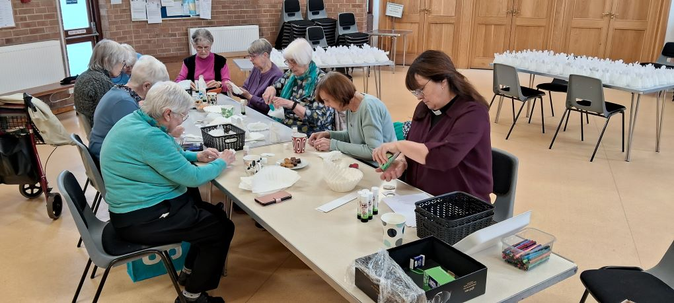
A very busy session at Brookfield – look at the concentration!
And look at all the “coffee filter angels” on the two tables.

Here are the dates for the next two Workshops:
Sat 26th Oct: Hemlington Community Hub & Library: 10am - 12noon
Saturday 16th November: Hemlington Community Hub & Library: 10am - 12noon

For more information please contact Revd Vanessa Kirby on: 07804-234388
_____________________________________

Services and Events in our Churches over the next two weeks

On Saturday 26th October 2024 at Hemlington Community Hub and Library from 10.00am to 12.00noon there will be an Angel Making Workshop with crafting activities for all ages.

_____________________________________

On Sunday 27th October 2024 – The Last Sunday after Trinity – there will be services as follows:

At 9.30am at Brookfield Church a service of Holy Communion at which our Pioneer Priest, Revd Vanessa Kirby, will preside; and

At 11.00am at Stainton Church a service of Holy Communion at which our Vicar, Revd Laura Wild, will preside; and

At 4.00pm at Hilton Church a service of Hope and Remembrance led by Revd Laura.

The lessons set in the Lectionary for Trinity 22 are:
- Jeremiah 31:7-9
- Psalm 126
- Hebrews 7:23-end
- Mark 10:46-52
The Diocesan Reflection for the Last Sunday after Trinity is given by the Very Revd Dominic Barrington, Dean of York (Minster). Dean Dominic reflects on the Gospel lesson set for the Last Sunday after Trinity (Mark 10:35-45); you can find the Reflection at this link.

On Tuesday 29th October 2024 at 9.30am at Stainton Church there will be a half-hour Plurality Prayer Gathering.
On Wednesday 30th October 2024 at 10.00am at Brookfield Church there will be a service of Holy Communion at which our Vicar, Revd Laura Wild, will preside.

[Editor’s note: On Thursday 31st October 2024 there will NOT be Alpha Course sessions at 12.00 noon at Brookfield Church or at 7.00pm at Stainton Church – Alpha is having a week off for the school half-term break.]

On Saturday 2nd November 2024 at Tees Valley Community Church at The Oakwood Centre, Cleasby Way, Eaglescliffe, Stockton-on-Tees TS16 0RD from 10.00am to 4.00pm there will be an “Alpha away-day” for everyone in the Tees Valley area who has been attending one of the Alpha Courses run by local Churches.

_____________________________________

On Sunday 3rd November 2024 – it is the 4th Sunday before Advent. We shall be celebrating All Saints’ Day (transferred from 1st Nov) when we remember all saints and martyrs in Christian history, and All Souls’ Day (transferred from 2nd Nov) when we remember the faithful departed. There will be services of Remembrance as follows:

At 9.30am at Hilton Church - a service of Holy Communion at which our Pioneer Minister, Revd Vanessa Kirby, will preside;

At 9.30am at Brookfield Church – a service of Holy Communion informal at which Revd Marie Edwards will preside; and

At 11.00am at Stainton Church – a “Café Church” service of informal worship and activities for all ages with discussions and refreshments, led by our Vicar, Revd Laura Wild.

The lessons set in the Lectionary for All Saints are:
- Isaiah 25:6-9
- Psalm 24:1-6
- Revelation 21:1-6a
- John 11:32-44
The Diocesan Reflection for the third Sunday before Advent will be available on the Diocesan website at this link from about the Thursday of the previous week.

On Tuesday 5th November 2024 at 9.30am at Stainton Church there will be a half-hour Plurality Prayer Gathering.

On Wednesday 6th November 2024 at 10.00am at Brookfield Church there will be a service of Holy Communion at which our Vicar, Revd Laura Wild, will preside.

On Thursday 7th November 2024 at 12.00 noon at Brookfield Church there will be session seven of our lunch-time “Stay Curious – Alpha Course”, accompanied by a light lunch.

On Thursday 7th November 2024 at 7.00pm at Stainton Church there will be session seven of our evening “Stay Curious – Alpha Course”, accompanied by a puddings/desserts.

_____________________________________

Please continue to pray



… for Israel and Palestine and now also for Lebanon For an end to the war which is causing so much loss of life and destruction, and especially that there would not be an escalation into a wider regional conflict.



The Disasters Emergency Committee (DEC) in the UK has launched a "Middle East Humanitarian Appeal" saying:

[The] conflict in the Middle East is devastating lives. Right now, millions of people across Gaza, Lebanon and the wider region are in urgent need of food, shelter, basic supplies and medical care.

In Gaza, people are dying of hunger and disease, as well as injuries caused by the conflict. Food and clean water are desperately scarce. Ninety percent of the population are displaced, and more than 42,000 people have been killed.

In Lebanon, more than a million people have had to leave their homes in recent weeks. Shelters are overwhelmed, and hospitals are struggling to treat the thousands of people injured.

DEC charities are ready to do more, and respond across the region, wherever the needs are greatest. But they urgently need more funds.

Click here to find out how you can donate to this DEC Appeal.
_____________________________________



…. and for Ukraine and Russia For an early end to the war between Russia and Ukraine.

Here is a prayer from the Christian Charity Worldvision:

Heavenly Father, hear our prayers for our brothers and sisters in Ukraine.

Lord, we ask for peace for those who need peace, reconciliation for those who need reconciliation and comfort for all who don’t know what tomorrow will bring. Lord, may your Kingdom come, and Your will be done.

Lord God, we ask for you to be with all – especially children who are suffering as the crisis in Ukraine deteriorates. Lord for those who are anxious and fearful. For those who are bereaved, injured or who have lost their lives. And for those who have lost loved ones. Lord, hear our prayers.
Lord, we ask that decisions makers hear Your voice. Parents protecting their families. Church leaders as they support and comfort people. And Lord, we ask for wise actions from global leaders - who have the power not only to start wars, but to stop them too.

And Father God we cry out for an end to this crisis. For mercy, peace, and truth – because You are light, hope, power, and love.
Amen.

_____________________________________

Please join us in praying for our Churches to Grow

Revitalise (*) is the Diocesan “Growing Health Churches” programme which seeks to help us be a viable flourishing presence into the future.
Can we invite you to use our Revitalise "prayer for growth" in your personal quiet times with God?

Revitalise us Lord,
Enthuse in our congregations the desire for mission. Give
Vision to our planning and
Inspire our thoughts as we seek Your will.
Teach us to be more like You, Christ
Abiding in You and
Loving one another.
In growing healthy churches,
Sharing our faith, living Christ’s story
Every day, help us to be faithful disciples and bear much fruit. Amen.

_____________________________________

Pastoral Support - Here are the contact details for our Vicar, Revd Laura Wild:

Address: The Vicarage, 89 Low Lane, Brookfield, Middlesbrough TS5 9EF
Phone: 01642-598621
E-mail: rev.laura.wild@gmail.com

Laura's normal "day off" is Friday - if you need to contact her on that day please leave a message on the answerphone.
______________________________________

With all good wishes to you

Bob Ardley

Ashdale House,
26 Meldyke Lane,
Stainton,
Middlesbrough
TS8 9AU

T: 01642-284525;
E: bob.ardley@ntlworld.com

