Greetings to Stainton and Hemlington Church Members and Friends of Stainton Church

Welcome to the Stainton Church e-News for

Friday 11th October 2024

We hope you are well and keeping safe. If you need any
practical support, please do get in touch.

Bishop Barry Hill, Bishop of Whitby

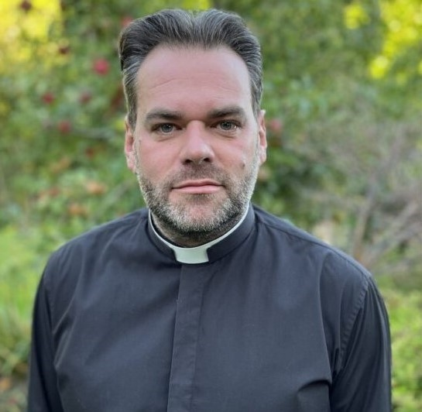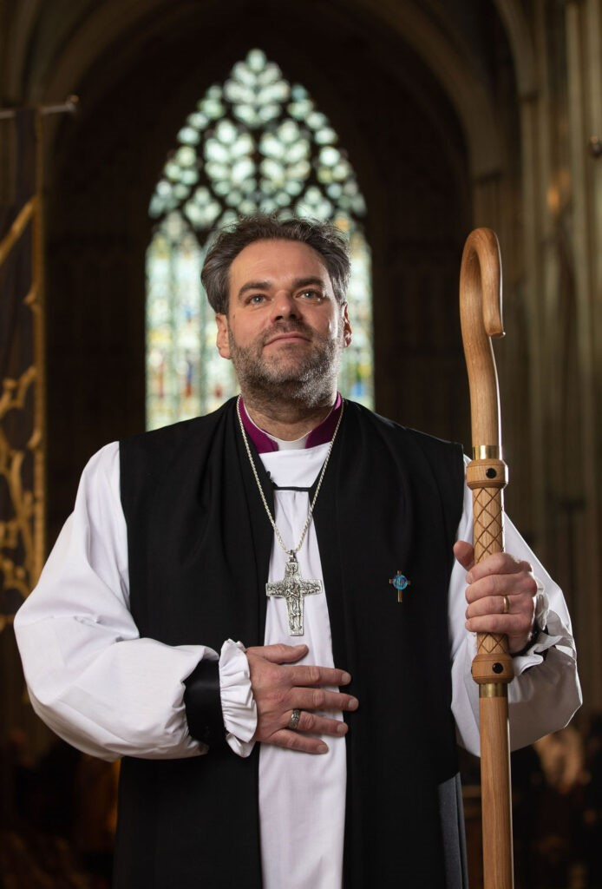

Yesterday, 10th October 2024, Revd Barry Hill was consecrated as Bishop of Whitby by the Most Revd and Rt Hon Stephen Cottrell, Archbishop of York at a service in York Minster. The photo of Bishop Barry in his episcopal robes (© Duncan Lomax / Ravage Productions) is from the Diocesan website at this link where you will find many more pictures of the happy event.

Bishop Barry begins his public ministry as Bishop of Whitby on Wednesday 23rd October 2024 when there will be an Archdeaconry Welcome Service for him at All Saints’ Parish Church in Northallerton starting at 7.00pm and to which all readers of the e-News are invited for this informal time of worship and to stay for tea/coffee and cake afterwards.

_____________________________________

A big “Thank You”!

Firstly, for all the donations of food, toiletries and household items given at the Harvest Festival “Café Church” service at Stainton last Sunday. Here are some photos of all that was given (before it was collected by Tees Valley Together for the Eco Shop at Hemlington) and of the beautiful Harvest flower arrangement created by Angela Russell.

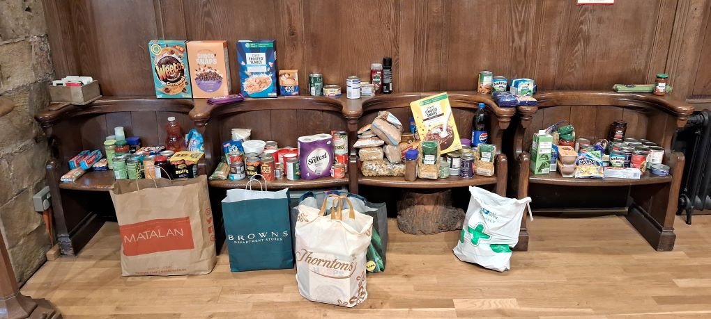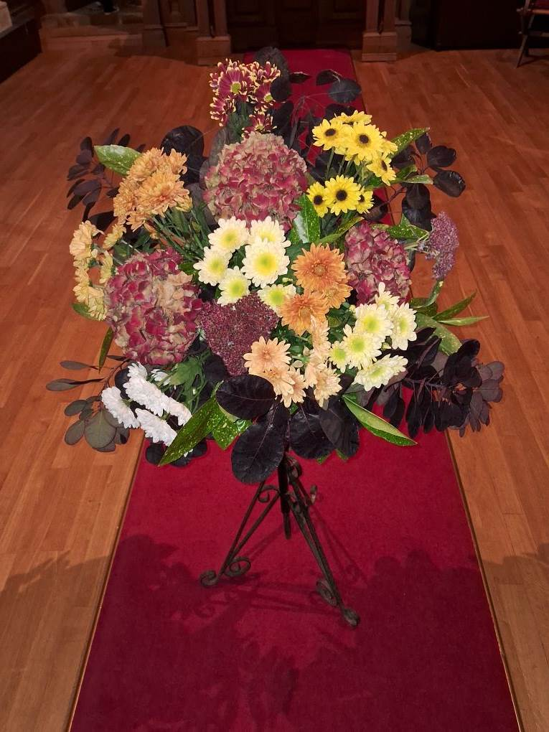

Secondly, for all the financial donations made to Stainton Church at the Annual “Gift Day” held last Saturday – at the time of writing the total donated is a tremendous £1,335 (£883 in cash on the day and £452 by bank transfer directly into the PCC account)

Angel Craft Workshops
Come and help create angels for our Christmas Angel Festival. We have crafting for all ages.
With free refreshments

Saturday 28th September: Stainton Church: 10am - 12noon

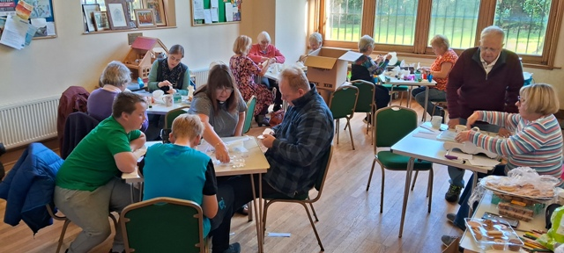

A great time was had by all who attended the Workshop at Stainton last Saturday.

Here are the dates for the next three Workshops:

Saturday 19th October: Brookfield Church Hall: 10am - 12noon
Saturday 26th October: Hemlington Community Hub & Library: 10am - 12noon
Saturday 16th November: Hemlington Community Hub & Library: 10am - 12noon

For more information please contact Revd Vanessa Kirby on: 07804-234388
_____________________________________

Services and Events in our Churches over the next two weeks

On Sunday 13th October 2024 – Trinity 20 there will be services of Holy Communion at which our Vicar, Revd Laura Wild will preside, as follows:

At 9.30am at Brookfield Church;

At 11.00am at Stainton Church; and

At 4.00pm at Hilton Church

The lessons set in the Lectionary for Trinity 20 are:
- Amos 5:6-7, 10-15
- Psalm 90:12-17
- Hebrews 4:12-16
- Mark 10:17-31
The Diocesan Reflection for Trinity 20 is given by the Rt Revd Dr Eleanor Sanderson, Bishop of Hull. Bishop Eleanor reflects on the Gospel lesson set for Trinity 20 (Mark 10:17-31), when, during this season of Harvest, we give thanks to the God of creation for the fruits that we enjoy. You can find the Reflection at this link.

On Tuesday 15th October 2024 at 9.30am at Stainton Church there will be a half-hour Plurality Prayer Gathering.

On Wednesday 16th October 2024 at 10.00am at Brookfield Church there will be a service of Holy Communion at which our Vicar, Revd Laura Wild, will preside.

On Thursday 17th October 2024 at 12.00 noon at Brookfield Church there will be session five of our lunch-time “Stay Curious – Alpha Course”, accompanied by a light lunch.

On Thursday 17th October 2024 at 7.00pm at Stainton Church there will be session five of our evening “Stay Curious – Alpha Course”, accompanied by a puddings/desserts.

On Saturday 19th October 2024 at 10.00am to 12.00noon at Brookfield Church there will be an Angel Making Workshop with crafting activities for people of all ages.

_____________________________________

On Sunday 20th October 2024 – Trinity 21 – there will be services as follows:

At 9.30am at Hilton Church a service of Morning Praise led by Julia Ardley, Lay Minister at Stainton;

At 9.30am at Brookfield Church a “Breakfast Church” service of informal worship for all ages including simple refreshments, led by our Vicar, Revd Laura Wild (Editor’s note: there will not be Holy Communion at this service); and

At 11.00am at Stainton Church a service of Holy Communion at which Revd Laura Wild will preside.

The lessons set in the Lectionary for Trinity 21 are:
- Isaiah 53:4-end
- Psalm 91:9-16
- Hebrews 5:1-10
- Mark 10:35-45

The Diocesan Reflection for Trinity 21 will be available on the Diocesan website at this link from about the Thursday of the previous week.

On Tuesday 22nd October 2024 at 9.30am at Stainton Church there will be a half-hour Plurality Prayer Gathering.
On Wednesday 23rd October 2024 at 10.00am at Brookfield Church there will be a service of Holy Communion at which our Vicar, Revd Laura Wild, will preside.

On Thursday 24th October 2024 at 12.00 noon at Brookfield Church there will be session six of our lunch-time “Stay Curious – Alpha Course”, accompanied by a light lunch.

On Thursday 24th October 2024 at 7.00pm at Stainton Church there will be session six of our evening “Stay Curious – Alpha Course”, accompanied by a puddings/desserts.

_____________________________________

Please continue to pray



… for Israel and Palestine and now also for Lebanon For an end to the war which is causing so much loss of life and destruction, and especially that there would not be an escalation into a wider regional conflict.

Here is a prayer from the Christian Charity Embrace to mourn one year of violence.

On the one-year anniversary of the of appalling attacks in Israel and the start of the devastating war in Gaza, we cry out to God:

Out of the depths I cry to you, O Lord. Lord hear my voice! (Psalm 130:1)
Compassionate and loving God, we stand with those who cry in anguish in Israel, Palestine and Lebanon. With those who have lost their lives to violence, those who mourn, those who have been displaced, those who are held unjustly against their will, those who have lost their homes and livelihoods. We stand with the traumatized, the injured, the children, the elderly and the frail.
Lord, move our hearts
Give us eyes to see as you see.
If you, O Lord, should mark iniquities, Lord, who could stand? (Psalm 130:3)
We come to you in sorrow for the violence and hatred that we are each capable of carrying in our hearts. Forgive our inability to see your image in others.
Lord, move our hearts
Give us eyes to see as you see.
Have mercy on us, O Lord have mercy upon us for we have had more than enough of contempt. (Psalm 123:3)
We pray for an end to the fighting and violence. We pray for those who are without shelter, clean water, food, electricity, medical care and safety. God of justice and peace, may the world’s leaders have the imagination to envision a future of creativity and human flourishing, rather than destruction and death.
Lord, move our hearts
Give us eyes to see as you see.
I am for peace; but when I speak, they are for war. (Psalm120:7)
We pray for the courage to speak up for peace, to challenge the hatred in our own hearts and minds, and to do all that we can to make for the peace that builds our common life as the nations of your world.
Lord, move our hearts
Give us eyes to see as you see.
AMEN



…. and for Ukraine and Russia For an early end to the war between Russia and Ukraine.

_____________________________________

Please join us in praying for our Churches to Grow

Revitalise (*) is the Diocesan “Growing Health Churches” programme which seeks to help us be a viable flourishing presence into the future.
Can we invite you to use our Revitalise "prayer for growth" in your personal quiet times with God?

Revitalise us Lord,
Enthuse in our congregations the desire for mission. Give
Vision to our planning and
Inspire our thoughts as we seek Your will.
Teach us to be more like You, Christ
Abiding in You and
Loving one another.
In growing healthy churches,
Sharing our faith, living Christ’s story
Every day, help us to be faithful disciples and bear much fruit. Amen.

_____________________________________

Pastoral Support - Here are the contact details for our Vicar, Revd Laura Wild:

Address: The Vicarage, 89 Low Lane, Brookfield, Middlesbrough TS5 9EF
Phone: 01642-598621
E-mail: rev.laura.wild@gmail.com

Laura's normal "day off" is Friday - if you need to contact her on that day please leave a message on the answerphone.
______________________________________

With all good wishes to you

Bob Ardley

Ashdale House,
26 Meldyke Lane,
Stainton,
Middlesbrough
TS8 9AU

T: 01642-284525;
E: bob.ardley@ntlworld.com

