Greetings to Stainton and Hemlington Church Members and Friends of Stainton Church

Welcome to the Stainton Church e-News for

Friday 16th August 2024

We hope you are well and keeping safe. If you need any
practical support, please do get in touch.

Our new Bishop-designate of Whitby

On 31st July 2024 [Number] 10 Downing Street announced that His Majesty the King has approved the appointments in the Diocese of York of the Reverend Canon Doctor Flora Winfield as Suffragan Bishop of Selby, and of the Reverend Barry Hill as the Suffragan Bishop of Whitby. This follows the retirement of the Right Reverend Doctor John Thomson and Right Reverend Paul Ferguson. The consecrations of the Bishops of Selby and Whitby will take place on 10th October 2024 at York Minster; further details will be published when confirmed.

Here are two photos and some information about Bishop-designate Barry and his family. We look forward to welcoming Barry, his wife Stephanie (Pep) and their two children Greg and Katy, to their Parish Church of St Peter and St Paul, Stainton in due course.

Barry, Pep and Katy will be moving into the house at 21 Thornton Road, Stainton, in the very near future, in time for Katy to start at her new school at the beginning of September.

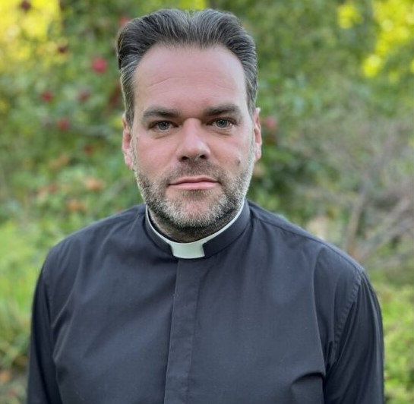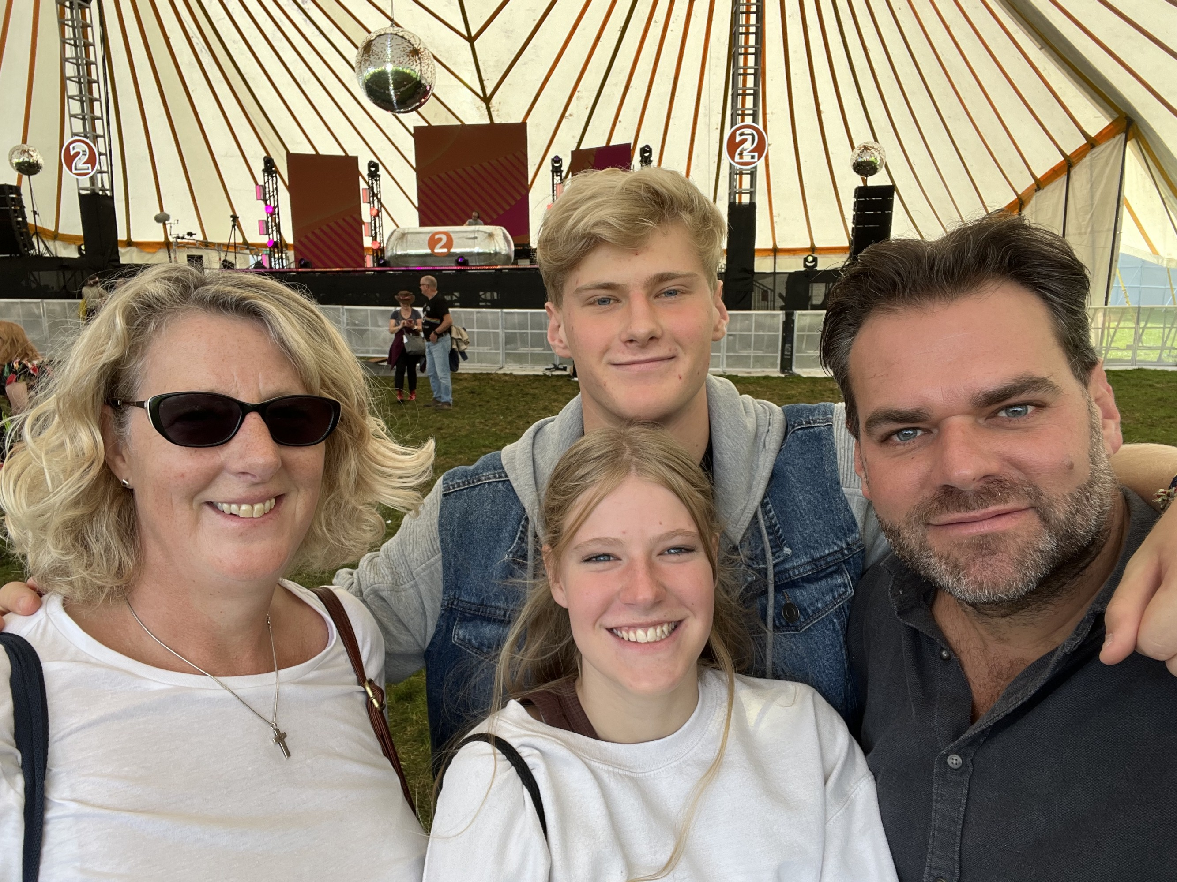
Picture credit: York Diocesan website Picture credit: Leicester Diocesan website

The Bishop of Whitby holds a particular responsibility for the care of the people, parishes, and clergy in the Archdeaconry of Cleveland, which stretches from Thirsk north to Middlesbrough, along the coast to Whitby, and south to Pickering. Additionally, the Bishop of Whitby will lead the Diocese of York’s priority of Growing Younger and More Diverse, ensuring this is understood and woven into the whole diocesan mission and ministry, and will serve as Chair of the Board of Education with a particular care for the 121 Church of England schools in the Diocese.

Bishop-designate of Whitby, Barry Hill’s ministry to date has been within the Diocese of Leicester; he was ordained in 2005 and currently serves as the Leicester Diocese’s “Strategy Development Enabler”. Previously, he has been Team Rector of Harborough Anglican Team, alongside roles leading mission, fresh expressions of Church and church planting across the diocese. Barry is married to Stephanie (Pep), who is also ordained, and is father to [teenage children] Greg and Katy. Their dog, Tilly, is considered the “fifth member of the household.”

Reflecting on his appointment, Barry said, “I’m excited, if a little daunted to be taking on the role! I am conscious of following someone of great faith, wisdom, and generosity of spirit in Bishop Paul and am looking forward to serving parishes and working with colleagues in helping us see more of how God is at work across our communities. After twenty years, it will be hard leaving the parishes and people of Leicester Diocese whom I have grown to love very deeply, but I am excited by what God no doubt has in store across the beautiful diversity of the Archdeaconry of Cleveland and the wider diocese, especially as we seek to grow younger and more diverse.”
Born in 1979, Barry grew up in Sussex and came to faith as a teenager. After leaving school at 18, Barry spent a year on the diocesan year out scheme, which led to voluntary roles in youth work. He then worked in the flight simulation industry prior to beginning ordination training at Wycliffe Hall, Oxford, in 2002.
At college, Barry met his wife Pep. He served his curacy in Loughborough, focusing on youth and student ministry and leadership development. In 2009, Barry was appointed Diocesan Mission Enabler, supporting clergy and lay leaders in the Diocese of Leicester’s over 300 city, town, and village churches in areas of parish renewal and mission, vocations, discipleship, and training. Barry then took up the dual roles in 2017 of Team Rector of a large and diverse benefice in Market Harborough, and of Diocesan Resourcing Church Enabler. Most recently, Barry has worked as Diocesan Strategy Development Enabler leading the discernment and drafting of the Diocese of Leicester’s strategy, with a focus on growing younger and more diverse.
Additionally, Barry is a trustee of a large multi-academy trust with a particular passion around support for those with Special Education Needs and Disabilities, part of the Archbishops’ College of Evangelists, a member of General Synod, and as member of the Mothers’ Union has worked with the national team on various projects.
Reflecting on his faith journey, Barry said, “Over the years we have known God’s faithfulness through good times – like seeing people coming to faith and churches grow in serving their communities, and through challenges – such as facing miscarriages, long covid and cancer. Throughout all, God’s faithful love in Jesus Christ has been clear; woven through all, making life whole.” Barry is a passionate supporter of Brighton and Hove Albion football team, he enjoys cooking and musical theatre, and is learning to roller skate.
_____________________________________

Are you curious about the Christian faith? Would you like to understand it better? Stay curious! – join our Autumn Alpha Group.



Alpha is a brilliant video-based discussion group to explore - or be refreshed - in the Christian faith. Here in the Plurality we will have a daytime Alpha group on Thursday lunchtimes at St. Margaret's, Brookfield and a Thursday evening group at St Peter and St Paul, Stainton.

Do be praying for the courses, which begin on 18th September 2024, and be thinking about who you would like to bring along.

_____________________________________

Services and Events in our Churches over the next two weeks

On Sunday 18th August 2024 – Trinity 12 – there will be services as follows:

At 9.30am at Hilton Church a service of Morning Praise led by Julia Ardley, Lay Minister at Stainton;

At 9.30am at Brookfield Church a “Breakfast Church” service of informal worship and fellowship on the theme “Jesus – Living Bread”, led by our Vicar, Revd Laura Wild [Editor’s note: there will not be Holy Communion at this service]; and

At 11.00am at Stainton Church a service Holy Communion at which our Vicar, Revd Laura Wild, will preside, and at which the sermon will be given by Julia Ardley.

The lessons set for Trinity 12 are:
- Proverbs 9:1-6
- Psalm 34:9-14
- Ephesians 5:15-20
- John 6:51-58

The Diocesan Reflection for Trinity 11 is given by the Rt Revd Dr Eleanor Sanderson, Bishop of Hull. Bishop Eleanor reflects on the Gospel set for Trinity 12 (John 6:51-58); you can find the Reflection at this link.

On Tuesday 20th August 2024 at 9.30am at Stainton Church there will be a half-hour Plurality Prayer Gathering.

On Wednesday 21st August 2024 at 10.00am at Brookfield Church there will be a service of Holy Communion at which our Vicar, Revd Laura Wild, will preside.

_____________________________________

On Sunday 25th August 2024 – Trinity 13 – there will be a single Joint (Plurality) service of Holy Communion at 10.30am at Stainton Church at which Revd Vanessa Kirby and Revd Marie Edwards will preside.

Please note: there will NOT be a service at Brookfield Church or at Hilton Church on that day.

The lessons set in the Lectionary for Trinity 13 are:
- Joshua 24:1-2a, 14-18
- Psalm 34:15-22
- Ephesians 6:10-20
- John 6:59-69
The Diocesan Reflection for Trinity 13 will be available on the Diocesan website at this link from about the Thursday of the previous week.

On Tuesday 27th August 2024 at 9.30am at Stainton Church there will be a half-hour Plurality Prayer Gathering.
On Wednesday 28th August 2024 at 10.00am at Brookfield Church there will be a service of Holy Communion at which our Vicar, Revd Laura Wild, will preside.

_____________________________________

“Café Church” at Stainton

Here is reminder that on the first Sunday of the month at Stainton Church we hold a “Café Church” Service (without Holy Communion) providing an opportunity for informal, relaxed worship and fellowship with lots of games, puzzles and discussion, and lots of simple refreshments.

Our next “Café Church” will be at 11.00am on Sunday 1st September 2024. As a new school year will begin, please do bring your school bag, work bag or project bag to the Service as we 'bless the backpacks' and seek God's best in the new season.

_____________________________________

Please continue to pray

… for Israel and Palestine

For an end to the war which is causing so much loss of life and destruction, and especially that there would not be an escalation into a wider regional conflict.

…. and for Ukraine

Pray for an early end to the war between Russia and Ukraine.
_____________________________________

Please join us in praying for our Churches to Grow

Revitalise (*) is the Diocesan “Growing Health Churches” programme which seeks to help us be a viable flourishing presence into the future.
Can we invite you to use our Revitalise "prayer for growth" in your personal quiet times with God?

Revitalise us Lord,
Enthuse in our congregations the desire for mission. Give
Vision to our planning and
Inspire our thoughts as we seek Your will.
Teach us to be more like You, Christ
Abiding in You and
Loving one another.
In growing healthy churches,
Sharing our faith, living Christ’s story
Every day, help us to be faithful disciples and bear much fruit. Amen.
_____________________________________

Pastoral Support - Here are the contact details for our Vicar, Revd Laura Wild:

Address: The Vicarage, 89 Low Lane, Brookfield, Middlesbrough TS5 9EF
Phone: 01642-598621
E-mail: rev.laura.wild@gmail.com

Laura's normal "day off" is Friday - if you need to contact her on that day please leave a message on the answerphone.
______________________________________

Bob Ardley

Ashdale House,
26 Meldyke Lane,
Stainton,
Middlesbrough
TS8 9AU

T: 01642-284525;
E: bob.ardley@ntlworld.com

