Greetings to Stainton and Hemlington Church Members and Friends of Stainton Church

Welcome to the Stainton Church e-News for

Friday 9th August 2024

We hope you are well and keeping safe. If you need any
practical support, please do get in touch.

Laura’s Lines

Our Vicar, Revd Laura Wild, writes about: the recent civil unrest, rioting, protests and counter-protests; and our forthcoming Alpha course.

Love your neighbour - look out for your neighbour

As we met in freedom for “Café Church” at St Peter and St Paul Stainton last Sunday morning we sought to pray into the troubling protest seen in other cities the night before and the threat of a demonstration in Middlesbrough centre later that day. We recalled that "the prayers of the righteous are powerful and effective" (James 5:16b) as we brought our prayers together.

Thanks be to God that no police officers were injured in Sunday's thuggery.

Thanks be to God that further demonstrations threatened on Wednesday this week did not materialise.

Let us pray without ceasing that peace be restored and that each individual may feel safe in their own town.

Let us pray in thanks for our near neighbours - Cleveland Police - and let us check on our own neighbours too; we are people of peace who follow the Prince of Peace.

Are you curious about the Christian faith? Would you like to understand it better? Stay curious! – join our Autumn Alpha Group.

Alpha is a brilliant video-based discussion group to explore - or be refreshed - in the Christian faith. Here in the Plurality we will have a daytime Alpha group on Thursday lunchtimes at St. Margaret's, Brookfield and a Thursday evening group at St Peter and St Paul, Stainton.

Do be praying for the courses, which begin on 18th September 2024, and be thinking about who you would like to bring along.

St Margaret's “Feast of Fun” family activities.

A marvellous team hosted nearly 40 families over 4 mornings of crafts, stories, games and food at St Margaret's “Feast of Fun” family activities. I want to say a big “Thank You” to Revd Vanessa for organising the funding and all the resources for this amazing time, and to all those who came to help and support the work at any time over the four-day period. Pray in thanks for all that was shared and for the families finding a home and welcome within the church."

Here are a few of pictures from the “Feast of Fun” sessions; you can see the whole set of photos on the “St Margaret of Scotland, Brookfield” Facebook Page - just click on this link.

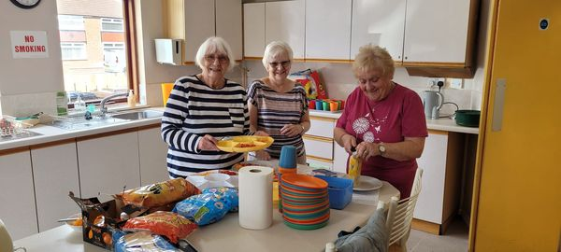

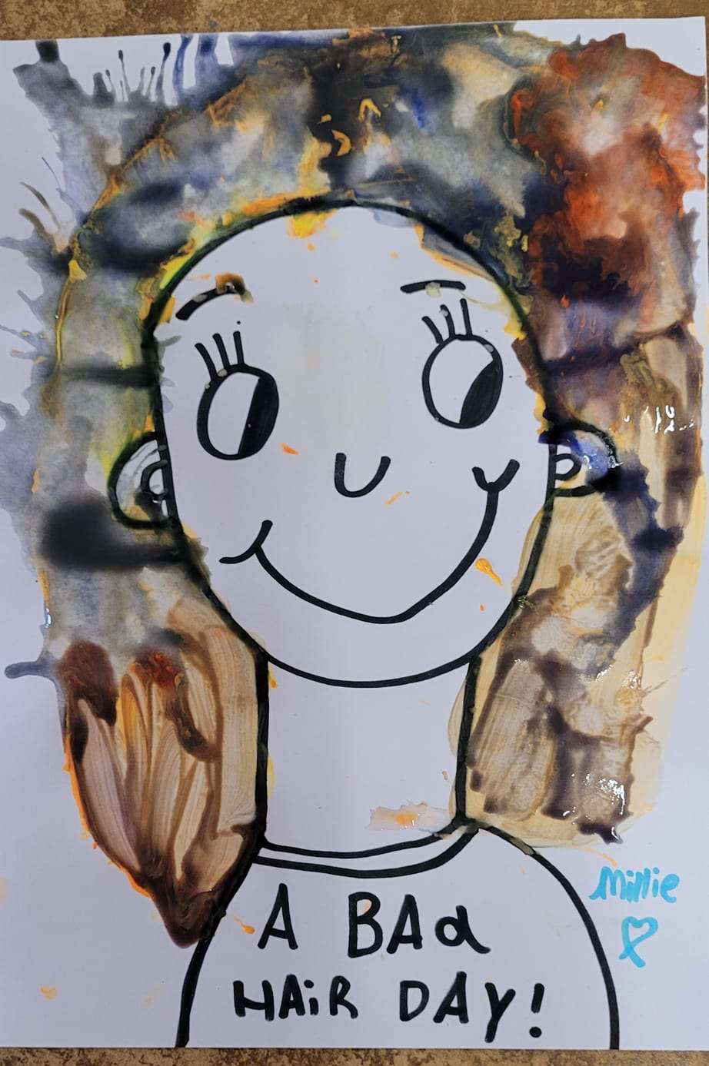

Laura

_____________________________________

Services and Events in our Churches over the next two weeks

On Sunday 11th August 2024 – Trinity 11 – there will be services of Holy Communion in our Churches as follows:

At 9.30am at Brookfield Church a service at which our Vicar, Revd Laura Wild, will preside;

At 11.00am at Stainton Church a service at which our Pioneer Minister, Revd Vanessa Kirby, will preside; and

At 4.00pm at Hilton Church a service at which Revd Marie Edwards will preside.

The lessons set in the Lectionary for Trinity 11 are:
- 1 Kings 19:4-8
- Psalm 34:1-8
- Ephesians 4:25-5:2
- John 6:35, 41-51
The Diocesan Reflection for Trinity 11 is given by our Archbishop of York, the Most Revd Stephen Cottrell. Archbishop Stephen reflects on the Gospel set for Trinity 11 (John 6:35, 41-51); you can find the Reflection at this link.

On Tuesday 13th August 2024 at 9.30am at Stainton Church there will be a half-hour Plurality Prayer Gathering.
On Wednesday 14th August 2024 at 10.00am at Brookfield Church there will be a service of Holy Communion at which our Vicar, Revd Laura Wild, will preside.

_____________________________________

On Sunday 18th August 2024 – Trinity 12 – there will be services as follows:

At 9.30am at Hilton Church a service of Morning Praise led by Julia Ardley, Lay Minister at Stainton;

At 9.30am at Brookfield Church a “Breakfast Church” service of informal worship and fellowship on the theme “Jesus – Living Bread”, led by our Vicar, Revd Laura Wild [Editor’s note: there will not be Holy Communion at this service]; and

At 11.00am at Stainton Church a service Holy Communion at which our Vicar, Revd Laura Wild, will preside, and at which the sermon will be given by Julia Ardley.

The lessons set for Trinity 12 are:
- Proverbs 9:1-6
- Psalm 34:9-14
- Ephesians 5:15-20
- John 6:51-58

The Diocesan Reflection for Trinity 12 will be available on the Diocesan website at this link from about the Thursday of the previous week.

On Tuesday 20th August 2024 at 9.30am at Stainton Church there will be a half-hour Plurality Prayer Gathering.

On Wednesday 21st August 2024 at 10.00am at Brookfield Church there will be a service of Holy Communion at which our Vicar, Revd Laura Wild, will preside.

_____________________________________

“Café Church” at Stainton

Here is reminder that on the first Sunday of the month at Stainton Church we hold a “Café Church” Service (without Holy Communion) providing an opportunity for informal, relaxed worship and fellowship with lots of games, puzzles and discussion, and lots of simple refreshments.

Our next “Café Church” will be at 11.00am on Sunday 7th September 2024 - as a new school year begins, please do bring your school bag, work bag or project bag to the Service as we 'bless the backpacks' and seek God's best in the new season.

_____________________________________

Please continue to pray

… for Israel and Palestine

For an end to the war which is causing so much loss of life and destruction, and especially that there would not be an escalation into a wider regional conflict.

…. and for Ukraine

Pray for an early end to the war between Russia and Ukraine.
_____________________________________

Please join us in praying for our Churches to Grow

Revitalise (*) is the Diocesan “Growing Health Churches” programme which seeks to help us be a viable flourishing presence into the future.
Can we invite you to use our Revitalise "prayer for growth" in your personal quiet times with God?

Revitalise us Lord,
Enthuse in our congregations the desire for mission. Give
Vision to our planning and
Inspire our thoughts as we seek Your will.
Teach us to be more like You, Christ
Abiding in You and
Loving one another.
In growing healthy churches,
Sharing our faith, living Christ’s story
Every day, help us to be faithful disciples and bear much fruit. Amen.
_____________________________________

Pastoral Support - Here are the contact details for our Vicar, Revd Laura Wild:

Address: The Vicarage, 89 Low Lane, Brookfield, Middlesbrough TS5 9EF
Phone: 01642-598621
E-mail: rev.laura.wild@gmail.com

Laura's normal "day off" is Friday - if you need to contact her on that day please leave a message on the answerphone.
______________________________________

Bob Ardley

Ashdale House,
26 Meldyke Lane,
Stainton,
Middlesbrough
TS8 9AU

T: 01642-284525;
E: bob.ardley@ntlworld.com

