Greetings to Stainton and Hemlington Church Members and Friends of Stainton Church

Welcome to the Stainton Church e-News for
Friday 10th November 2023
We hope you are well and keeping safe. If you need any
practical support please do get in touch.

Services in our Churches over the next two weeks



On Sunday 12th November 2023 – Third Sunday before Advent and Remembrance Sunday – there will be services as follows (Please note the service times):

at 8.00am at Hilton Church a service of Holy Communion at which the Vicar, Revd Laura Wild will preside, followed at 9.00am by a Commemoration for Remembrance Sunday at the Hilton War Memorial;

at 10.00am at Brookfield Church a service of Holy Communion at which the Revd Marie Edwards will preside and which will include at 11.00am a Commemoration for Remembrance Sunday; and

at 10.45am at Stainton Church a non-Eucharistic Community Service for Remembrance Sunday which will be led by the Vicar, Revd Laura Wild.

The Diocesan Reflection for Remembrance Sunday is given by our Bishop of Whitby, the Rt Revd Paul Ferguson. Bishop Paul begins his Reflection by showing the viewers the medals his father was given during the Second World War and remembering his father’s contribution to bringing some semblance of normality back to life in heavily-bombed Berlin after the end of the War. The Reflection can be found at this link.
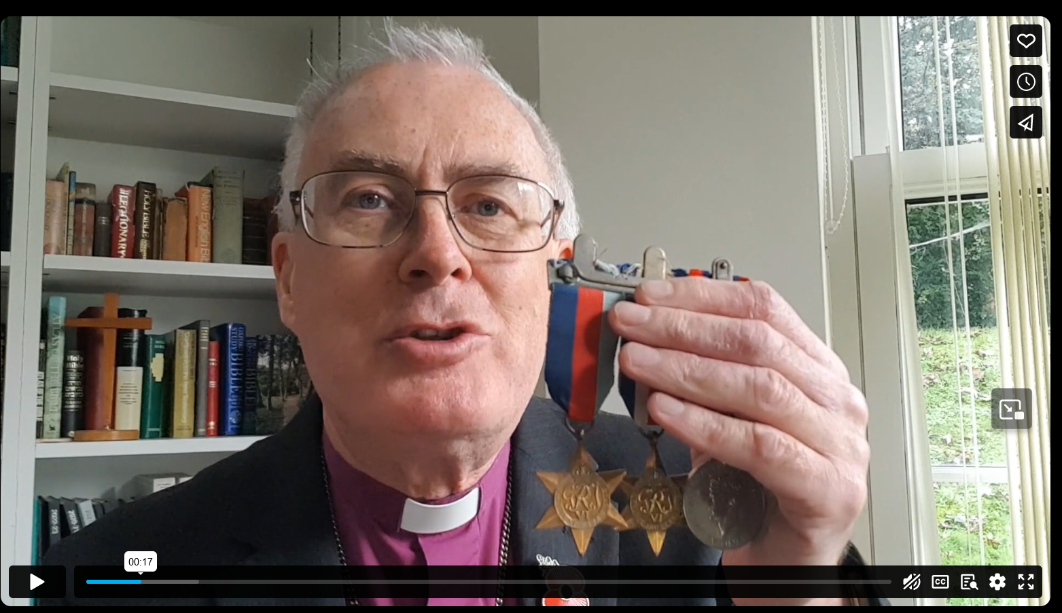

The lessons set for the Third Sunday before Advent that Revd Laura and Revd Marie will be using on Sunday morning will be taken from the following:
- Amos 5:18-24;
- Psalm 70
- 1 Thessalonians 4:13-19;
- Matthew 25:1-13

On Tuesday 14th November 2023 at 9.30am at Stainton Church there will be a half-hour Prayer Gathering.

On Wednesday 15th November 2023 at 10.00am at Brookfield Church there will be a service of Holy Communion at which the Vicar, Revd Laura Wild, will preside.

____________________________________

On Sunday 19th November 2023 – the Second Sunday before Advent – there will services as follows:

at 9.30am at Hilton Church - a service of Morning Praise, led by Julia Ardley, Lay Minister at Stainton;

at 9.30am at Brookfield Church - a Patronal Festival service of Holy Communion to celebrate St Margaret of Scotland at which the Vicar, Revd Laura Wild will preside; and

at 11.00am at Stainton Church - a service of Holy Communion at which the Vicar, Revd Laura Wild, will also preside.

The lessons set for the Second Sunday before Advent are:
- Zephaniah 1:7, 12-18;
- Psalm 90:1-12
- 1 Thessalonians 5:1-11
- Matthew 25:14-30

The Diocesan Reflection for the Second Sunday before Advent will be available at this link in due course, from about the Thursday of the preceding week

On Tuesday 21st November 2023 at 9.30am at Stainton Church there will be a half-hour Prayer Gathering.

On Wednesday 22nd November 2023 at 10.00am at Brookfield Church there will be a service of Holy Communion at which the Vicar, Revd Laura Wild, will preside.

_____________________________________

Advance Notice of Toy/Gift Services in our Churches

On Sunday 26th November 2023 the services in each of our three Churches will include an opportunity for those attending to bring donations of unwrapped toys/gifts; these will be donated to a Teesside Christmas Gift Appeal which will provide Christmas presents to those Children who, because of their family circumstances, would not be receiving a Christmas gift this year.
____________________________________
Please continue to pray …..

… for Israel and Palestine  

For the war which is causing so much loss of life and destruction. Here is prayer from the Christian Charity Open Doors UK

Sovereign God,

I pray for peace in Israel and Gaza – for an end to hostilities and for peacemakers on both sides.

Comfort all who mourn and all who are waiting to hear news of missing loved ones.

Give boldness and compassion to Christians on both sides to shine the light of Christ in their communities, and equip national and international leaders with wisdom.

May Your will be done, and may Your loving kindness be evident to all.

Amen.

…. and for Ukraine 

Pray for an end to the war between Russia and Ukraine. Here is prayer from the Chairs of the London District of the Methodist Church, quoted on the United Reform Church website.

We pray for the people of the Ukraine and the people of Russia, for their countries and their leaders.
We pray for all those who are afraid; that your everlasting arms hold them in this time of great fear.
We pray for all those who have the power over life and death; that they will choose for all people life, and life in all its fullness.
We pray for those who choose war; that they will remember that you direct your people to turn swords into ploughshares, and to seek peace.
We pray for leaders on the world stage; that they are inspired by the wisdom and courage of Christ.
Above all, Lord, we today pray for peace in Ukraine.
And we ask this in the name of your blessed Son. Lord have mercy.
Amen
__________________________________
Leading Your Church into Growth
Can we remind you that it would be really good to use the LYCiG "prayer for growth" in your personal quiet times with God?

God of mission, Who alone brings growth to your Church, send your Holy Spirit to give:
- Vision to our planning,
- Wisdom to our actions,
- Joy to our worship, and
- Power to our witness.

Help our church to grow in numbers, in spiritual commitment to You and in service to our local community, through Jesus Christ our Lord. Amen
______________________________________

Pastoral Support

Here are the contact details for our Vicar, Revd Laura Wild

Address: The Vicarage, 89 Low Lane, Brookfield, Middlesbrough TS5 9EF
Phone: 01642-598621
E-mail: rev.laura.wild@gmail.com

Laura's normal "day off" is Friday - if you need to contact her on that day please leave a message on the answerphone.
______________________________________

With all good wishes to you

Bob Ardley

Ashdale House,
26 Meldyke Lane,
Stainton,
Middlesbrough TS8 9AU

Tel: 01642-284525
E-mail: bob.ardley@ntlworld.com

