Greetings to Stainton and Hemlington Church Members and Friends of Stainton Church

Welcome to the Stainton Church e-News for
Friday 20th October 2023
We hope you are well and keeping safe. If you need any
practical support please do get in touch.

 Praying for Israel and Palestine 

Here is a short video message from Nashat Filmon, Director of the Palestinian Bible Society

Click on the image or click on the link below to watch the video – a transcript is included below

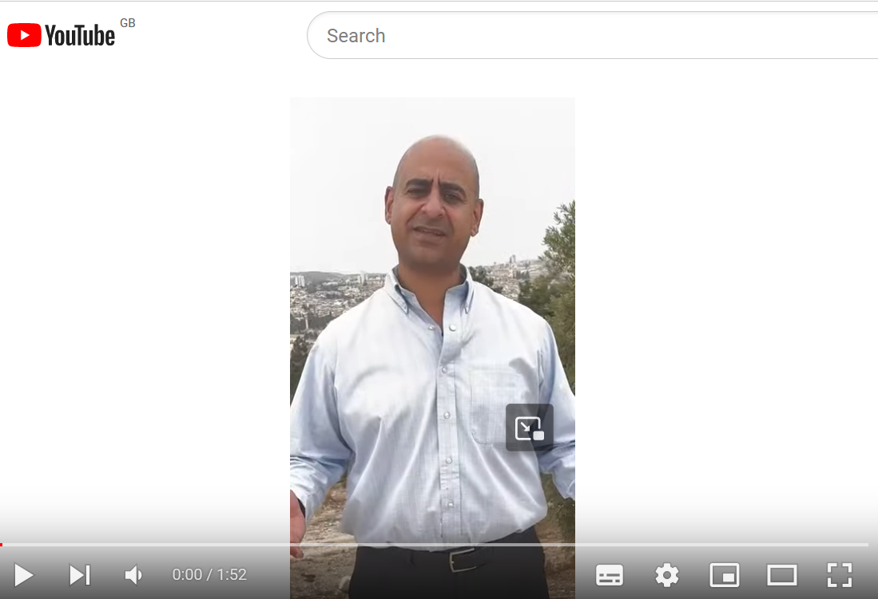

https://www.youtube.com/watch?v=RKJSWDam-Ug

[On 9th October 2023] Greetings from Jerusalem! My name is Nashat Filmon. I am the Director of the Palestinian Bible Society and in these tough days and hours, in the midst of turmoil, things we don't understand (the) sudden shock to all of us what's happening, we look up to God and we seek His Mercy; we seek His Justice; we seek His Peace. We pray for the Peace of Jerusalem, the city behind me, the city of Our Lord, this land that Jesus visited. He lived here, He performed miracles here, He died and He also resurrected.

This is our prayer that as we go through the Via Dolorosa, as we go through the difficulties and hardships, we look forward for the resurrection. Therefore I encourage you these days not just to side with one part over the other, with one nation over the other. No, pray for both nations; pray for the Gazan people; pray for this people who have been suffering for the past 20 years; pray for the peace of this country and this land. Trust that God is a just God and hope that He will restore His peace in a miraculous way.

We look up to You God, we trust in You and we also trust in the church all over the world to stand with us in prayers for the Palestinians, for the Israelis, for the restoration of peace, for His peace that fills our heart and mind and souls and overflows to all the world.

Thank you and remember us in your prayers every day .

____________________________________

The Archbishop of Canterbury was joined by Muslim and Jewish leaders at Lambeth Palace [on 17th October 2023] to condemn the sharp rise in antisemitic incidents over the past 10 days, and to call for unity between British faith communities against the backdrop of war between Israel and Hamas.

Archbishop Justin Welby, Sheikh Ibrahim Mogra and Rabbi Jonathan Wittenberg stood together outside Lambeth Palace and delivered statements calling for solidarity and unity between communities in the UK, and rejecting any form of hatred or discrimination.
Ctrl-Click on the image or click the link below to watch the video – a transcript is included below
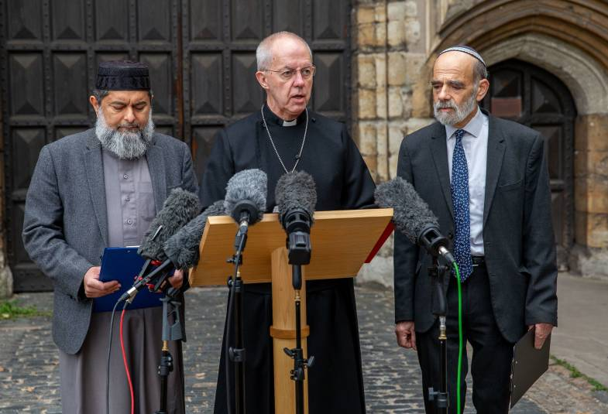

https://youtu.be/VqbsWk49nvM

Read the transcript of their remarks as delivered:

Archbishop Justin Welby:
Thank you all for being here this morning. I know that all of us are profoundly concerned by what is happening in Israel and Gaza – and here at Lambeth Palace we are praying constantly for all those who are caught up in this war that has already brought so much suffering to so many people.
But today we have come together out of shared concern for our communities and neighbourhoods here in the UK, and to stand together against any form of hatred or violence against Jewish people or any other community.
I want to introduce to you two religious leaders and I welcome their solidarity on this matter: Sheikh Ibrahim Mogra, a scholar and imam from Leicester, and a former Assistant Secretary-General of the Muslim Council of Britain, and Rabbi Jonathan Wittenberg, the Senior Rabbi of Masorti Judaism UK and Rabbi of the New North London Synagogue. They speak for their own communities and networks, and not for any others, but they speak out of their particular friendship, as a Muslim, and as a Jew.

Sheikh Ibrahim Mogra:
I stand before you in my capacity as an imam alongside my dear friend Rabbi Jonathan Wittenberg. We are all deeply pained by what is happening in Palestine and Israel. We have found some comfort and a lot of hope in our friendships that have been built over many years. We stand together to express our shared commitment to protecting the relationship between our communities. British Muslims and Jews have much in common and there are many personal ties between us. We have celebrated happy times together, and stood together in solidarity during difficult and challenging times. We have, and will sometimes be on opposite sides, but we live together as neighbours in peace and harmony, disagreeing with each other respectfully, without resorting to hate or violence.
At this critical time, we share deep concern for the welfare of everyone. We are determined to do our utmost to prevent violence and intimidation across our country, whether on the streets, in places of worship, in schools, in universities, or in any other institutions.
It is deplorable and wrong that our Jewish community here has been the target of hate crimes. It is unacceptable that synagogues and Jewish centres have been targeted. There has been a 500% rise in antisemitism. I condemn these attacks and call on all fellow citizens to stand up and speak out against all and every form of hate.
I pray for an end to this war and all wars, I pray for the innocent caught up in the carnage, I pray for the safety of everyone, wherever they are, āmīn [Arabic for Amen].

Rabbi Jonathan Wittenberg:
Thank you, my friend, Shaikh Ibrahim Mogra, for your important statement.
As you have said, over the last week there has been a five-fold rise in incidents of antisemitism. Your solidarity in standing up and speaking out clearly against all forms of antisemitism and antisemitic intimidation at this most deeply painful time means a great deal.
The Jewish community, led by the Board of Deputies, the Jewish Leadership Council and the Community Security Trust has long condemned and continues to condemn all racism directed against Muslims, from whatever source.
As leaders in the British Jewish and Muslim communities we affirm the importance of maintaining our relationships even, and especially, in troubled times.
We have so much in common; there are many friendships between us, and we have stood together through both peaceful and challenging days. As you say, we will sometimes have different loyalties, yet it is essential that we live together across the United Kingdom as neighbours and fellow citizens in peace and with respect.
I share your prayers for an ultimate end to war. My prayers, too, are with all the innocent people caught up in this horror, for all those who are hurt and grieve, and all who long for the safety and wellbeing of their loved ones.
We are both on the side of life. We share deep concern for the welfare of everyone and pray for a better future for all.
Archbishop Justin Welby:
Thank you both for this important sign of friendship and solidarity. I want to echo what you’ve both said about the importance of maintaining our relationships, even in this time of deep crisis. We cannot allow the seeds of hatred and prejudice to be sown afresh in our communities. And at this time especially, we cannot allow the cancer of antisemitism to spread in our nation. I pray that we remain united against all forms of discrimination, and for our Jewish neighbours and all our communities to know that they are an essential part of our country.
I add my own prayers to yours for the welfare of all our communities. And I offer my prayers, as the whole of the Anglican world is doing today, for all the people of the Holy Land.
Amen.

____________________________________

Archbishop of Canterbury appeals for end to bloodshed after ‘atrocious’ attack on Gaza hospital
Today [18th October] I join my Anglican brothers and sisters in Gaza, Israel and the West Bank in their profound mourning after the atrocious attack on the Anglican-run Al Ahli Hospital yesterday, which follows so closely on from an attack on the same hospital on Friday evening. This is a hospital I have visited, and whose staff I have prayed with.
This atrocity violates the sanctity and dignity of human life. It is a violation of humanitarian law, which is clear that hospitals, doctors and patients must be protected. For this reason, it’s essential that we exercise restraint in apportioning responsibility before all the facts are clear.
The evil and heinous terror attacks by Hamas on people in Israel were crimes against God and humanity. Israel has a legitimate right and duty to defend itself, and to pursue a proportionate and discriminate response to establish its security. The rules of war are there to safeguard civilians and the value of every human life. They must be upheld to the highest degree possible amidst the chaos of conflict, otherwise the cycle of violence will continue for generations to come.
Israel’s bombing campaign on the heavily populated Gaza Strip is causing massive civilian casualties and suffering. The people of Gaza are running out of water, food, medical supplies and places of refuge. Families in Israel and around the world still wait for news of their loved ones. It is unconscionable that aid is being prevented from reaching children and adults who are not combatants in this war. It is indefensible that hospitals, schools and refugee camps are being struck. It is an outrage that hostages are being held by Hamas. The bloodshed, slaughter and suffering of innocent people on all sides must stop.
The fundamental question is this: what kind of society can be envisaged both for a secure Israeli state and a secure neighbouring Palestinian state. That path is not clear, but it must be imagined – and that imagining must start again now. What we know for certain is that this violence will not secure for the people of the Holy Land the future they deserve.
I appeal again for hostages to be released and for civilians to be protected. I join the international call for all parties to grant immediate, safe humanitarian access into Gaza to prevent further loss of life. I pray again for the peace of Jerusalem, in solidarity with the Church in the Holy Land. I grieve with Israelis and Palestinians still mourning and in fear.
In the name of Jesus Christ, I urge a different path – one that spares innocent lives and pursues justice, security and lasting peace for all.

____________________________________

Recruiting a Pioneer Priest

Could God be calling you to serve as our new Pioneer Priest?

The parishes of Stainton with Hemlington, Hilton and Brookfield are looking for a Pioneer Priest to help us see Jesus transform lives.
This post is a fixed term post of 3 years initially with the possibility of an extension for a further 3 years.
For further information including our Parish Profile and Role Description, and to apply for this post, please click HERE
You can download the "Parish Profile" for the Plurality here; and the Role Description here.
For an informal chat please contact:
Our Vicar, Revd Laura Wild (tel 01642 598 621)
The Archdeacon of Cleveland, Venerable Dr Amanda Bloor (tel: 01642 706 095) and her PA Jacqui Gunter
The Bishop of Whitby, Rt Revd Paul Ferguson (tel: 01642 593 273) and his PA Mandy Robinson

Closing Date: 09:00am Thursday 23rd November 2023
Interviews: Thursday 7th December 2023

____________________________________

Services in our Churches over the next two weeks

On Sunday 22nd October 2023 – Trinity 20 – there will be services at which the Vicar, Revd Laura Wild will preside, as follows:

at 9.30am at Brookfield Church a service of Holy Communion;
at 11.00am at Stainton Church a service of Holy Communion; and
at 4.00pm at Hilton Church a service of Evensong.

The lessons set for Trinity 20 are:
- Isaiah 45:1-7
- Psalm 96:1-13
- 1 Thess 1:1-10
- Matthew 22:15-22

The Diocesan Reflection for Trinity 20 is given by Sam(antha) Nicol, Diocesan Director of Strategic Transformation. Sam reflects on the Gospel set for Trinity 20 (Matthew 22:15-22). The Reflection can be found at this link.

On Tuesday 24th October 2023 at 9.30am at Stainton Church there will be a half-hour Prayer Gathering.

On Wednesday 25th October 2023 at 10.00am at Brookfield Church there will be a service of Holy Communion at which the Vicar Revd Laura Wild will preside.
____________________________________

On Sunday 29th October 2023 – Last Sunday after Trinity – there will be services as follows:

at 9.30am at Brookfield Church a service of Holy Communion at which the Vicar, Revd Laura Wild will preside;
at 11.00am at Stainton Church a service of Holy Communion at which the Vicar will also preside; and
at 4.00pm at Hilton Church a special service for All Souls Day, led by Revd Lisa Opala, Assistant Curate at St Mary the Virgin, Nunthorpe.

The lessons set for the Last Sunday after Trinity are:
- Leviticus 19:1-2, 15-18
- Psalm 1
- 1 Thessaalonians 2:1-8
- Matthew 22:24-end

The Diocesan Reflection for the Last Sunday after Trinity will be available at this link in due course, from about the Thursday of the preceding week.

On Tuesday 31st October 2023 at 9.30am at Stainton Church there will be a half-hour Prayer Gathering.

On Wednesday 1st November 2023 at 10.00am at Brookfield Church there will be a service of Holy Communion at which the Vicar Revd Laura Wild will preside.

Thank you from Middlesbrough Foodbank for our Harvest Gifts
On Monday 16th October your Editor took the 64kg of Stainton Harvest Gifts to the Foodbank Collection Point at St Barnabas Church, Linthorpe – Thank You so much!

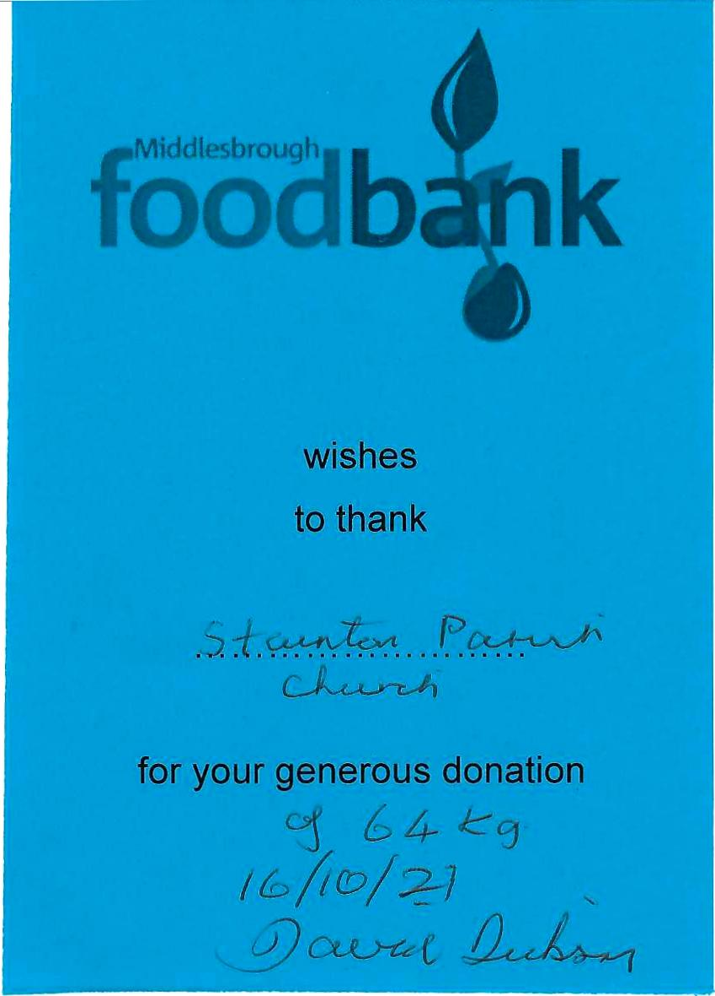


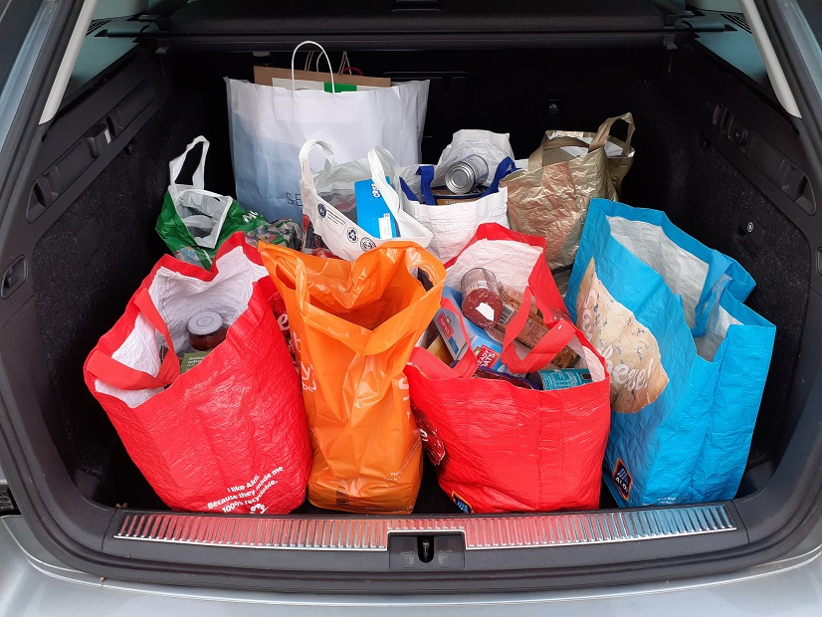

_____________________________________
Please (continue to) pray for …..

Israel and Palestine

For the war between Israel and Hamas.

**********

…. and for Ukraine 

For Russia’s war against Ukraine, that the fighting would cease, that peace will come and lives can be re-built.

**********

…. and for Morocco 

Following the earthquake in the Atlas mountains on Friday 8th September 2023.

**********

…. And Libya 
For those caught up in the devastating flood on Sunday 10 September, (when) Storm Daniel hit Libya.
__________________________________
Leading Your Church into Growth
Can we remind you that it would be really good to use the LYCiG "prayer for growth" in your personal quiet times with God?

God of mission, Who alone brings growth to your Church, send your Holy Spirit to give:
- Vision to our planning,
- Wisdom to our actions,
- Joy to our worship, and
- Power to our witness.

Help our church to grow in numbers, in spiritual commitment to You and in service to our local community, through Jesus Christ our Lord. Amen
______________________________________

Pastoral Support

Here are the contact details for our Vicar, Revd Laura Wild

The Vicarage, 89 Low Lane, Brookfield, Middlesbrough TS5 9EF
Phone: 01642-598621
E-mail: rev.laura.wild@gmail.com

Laura's normal "day off" is Friday - if you need to contact her on that day please leave a message on the answerphone.

______________________________________

With all good wishes to you

Bob Ardley

Ashdale House, 26 Meldyke Lane, Stainton, Middlesbrough TS8 9AU
Tel: 01642-284525
E-mail: bob.ardley@ntlworld.com

