Dear Stainton Church Members and Friends of Stainton Church

Important!!!!
Please do not forget that British Summer Time (BST) ends this weekend and we revert to GMT; the clocks go back one hour on Saturday evening
(pedantically, the time changes at 2.00am on Sunday morning!).

Revd Claire Todd - an update
Claire's Licensing and Installation as Priest-in-Charge of the Brookfield and Stainton-with-Hilton Church Family (Plurality) took place on Tuesday 20th October 2020 at St Margaret's Church, Brookfield. The service can be watched online via the new "St Margaret of Scotland, Brookfield" Facebook page which you can find at this link.
At her Licensing Service Claire announced that the services for
Bible Sunday on 25th October 2020, will be as follows:
9.30am(*) Brookfield: Holy Communion
11.00am Stainton: Holy Communion
Both services will be led by Claire.
If you are unable to attend one of these services please do use the sheet for "Worship at Home" that we will send out by separate e-mail.
(*) Please note the change of time from the recent habitual 10.00am start.

Clergy Support
If you need the support of a Priest please do contact Claire Todd:
Phone: 01642-294582
E-mail: revtoddy@gmail.com

Is there room for me at Stainton Church?
Here are the attendance figures for the last four Sunday services at Stainton:
27th September - 14 people (this was the day Brookfield Church re-opened)
4th October - 20 people
11th October - 14 people
18th October - 13 people
Back in July the Stainton PCC risk assessment for re-opening the Church allowed for 25-30 people to attend safely, so you can see that there is plenty of room for more people to attend. If you would like to come to the Services on Sunday you will be most welcome.

From Claire’s Licensing Service

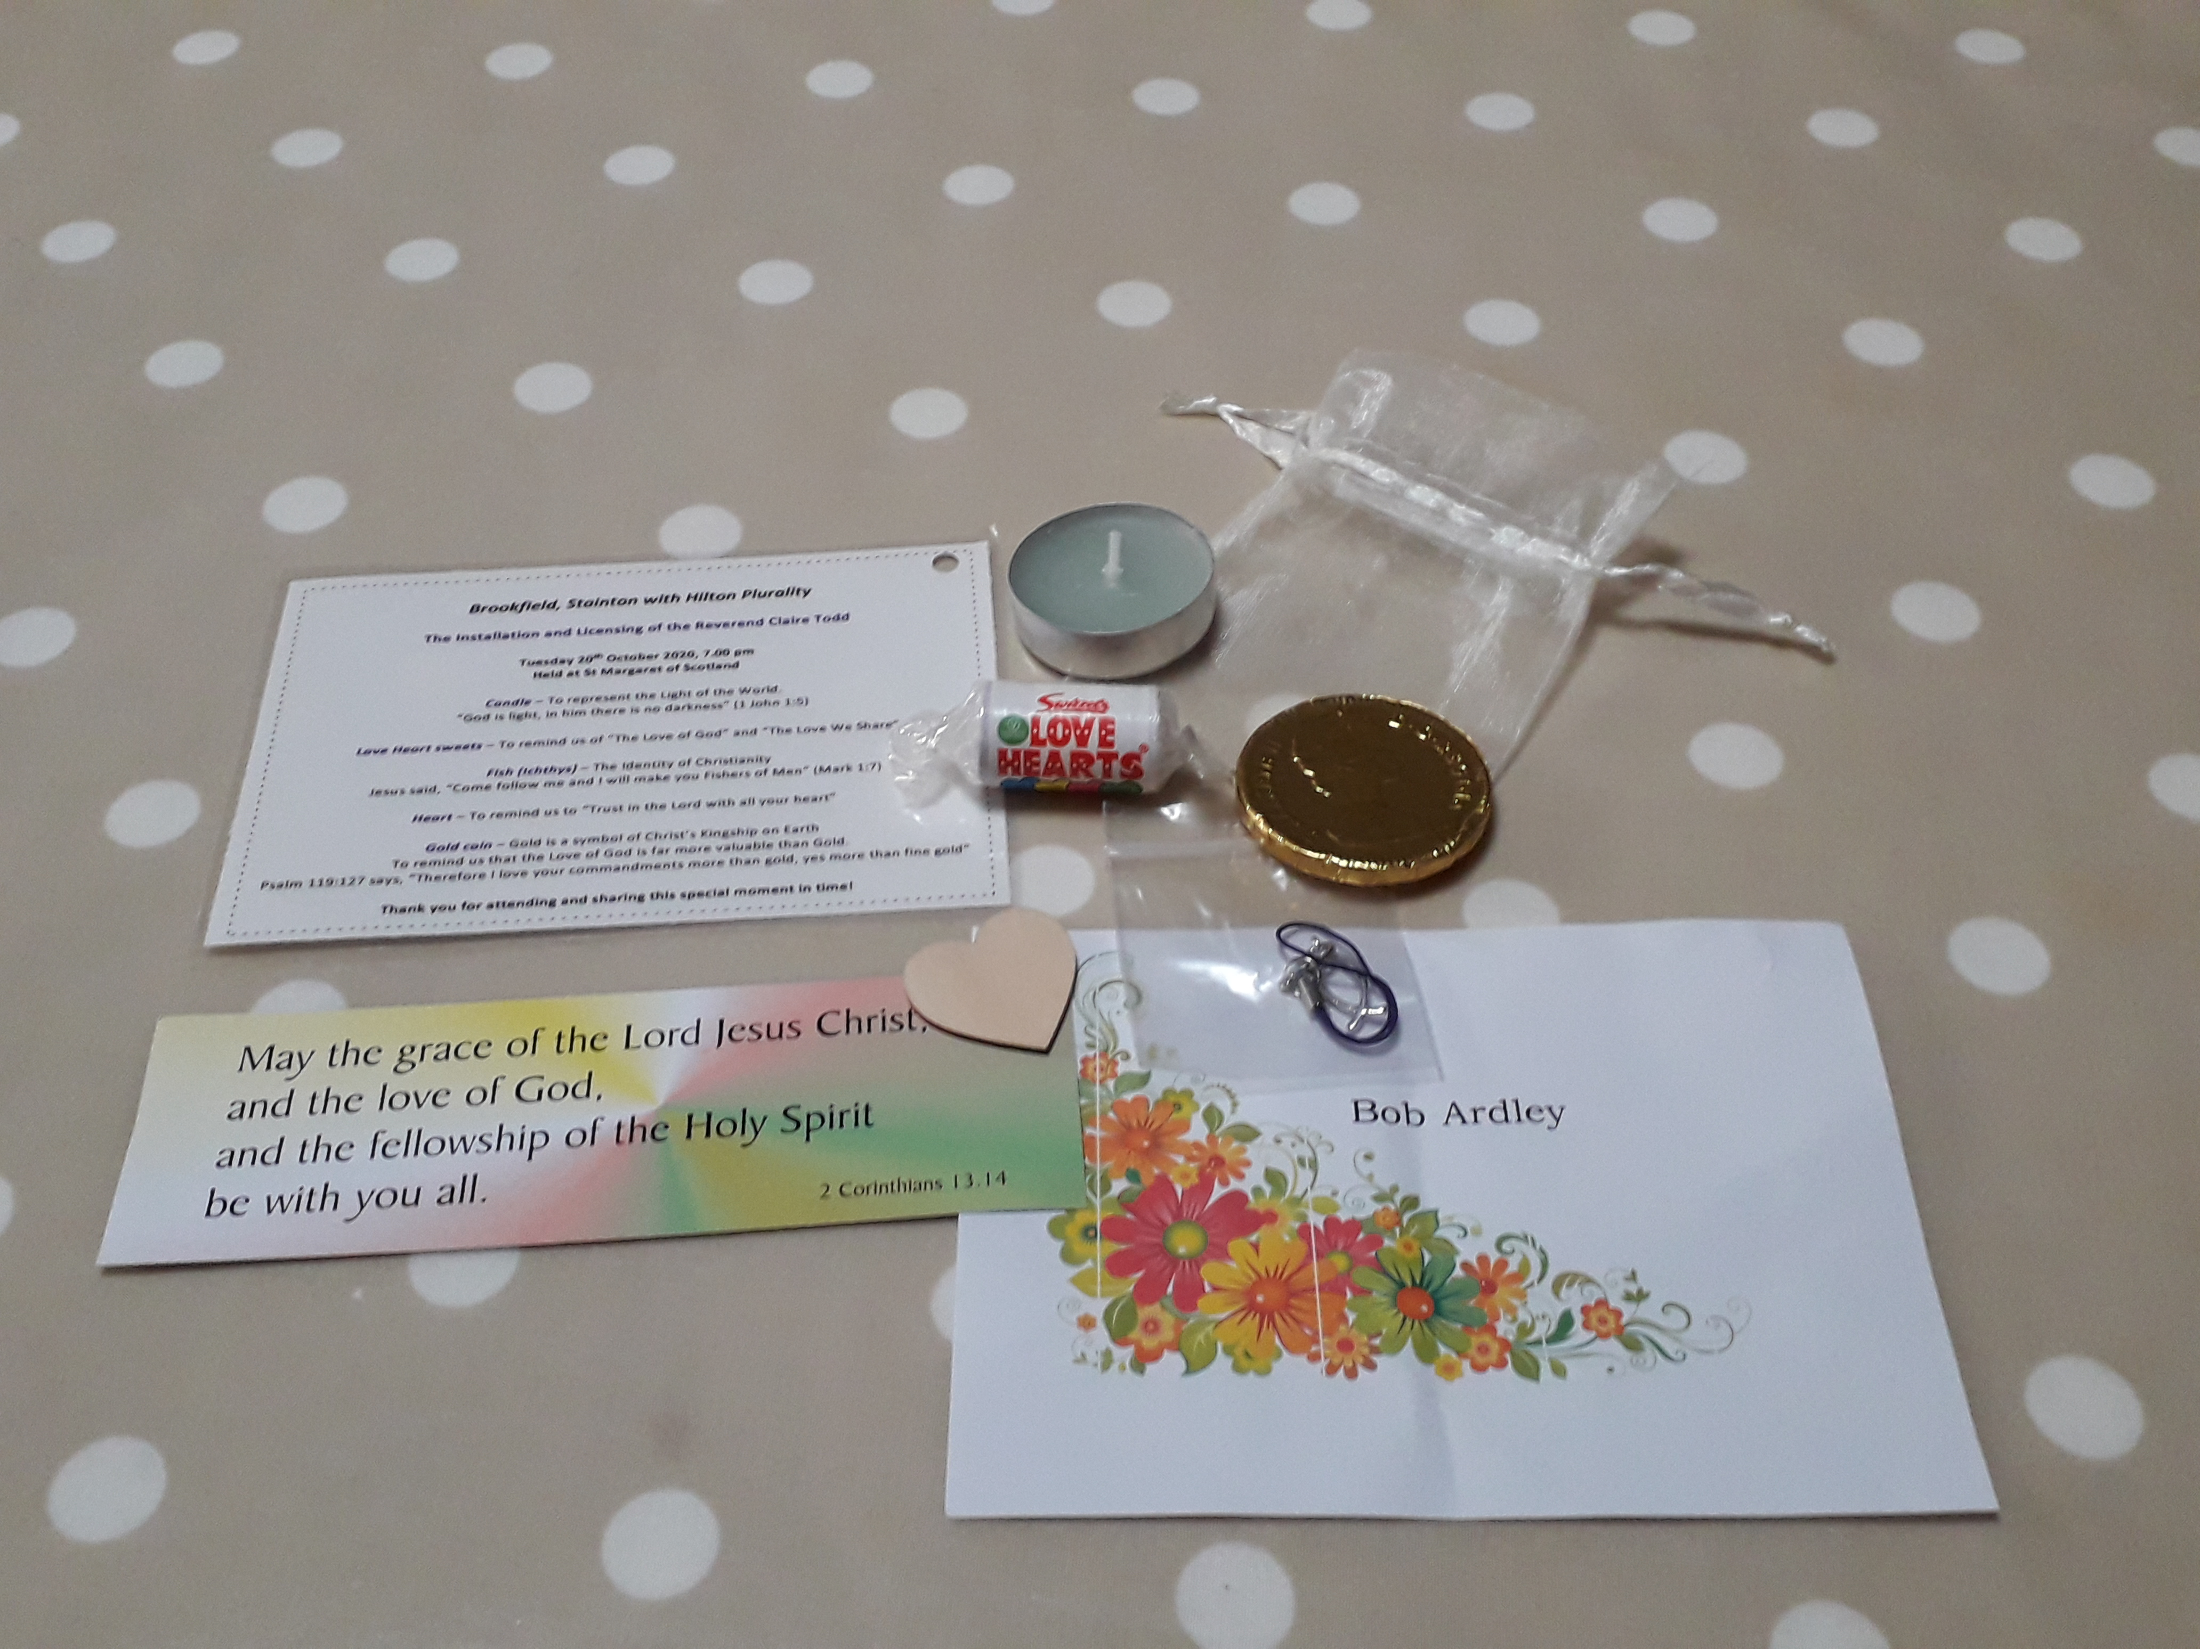

Claire, our new Priest-in-Charge, was so pleased that lots of people were able to attend her Licensing and Installation Service, whether in person or on-line. At the end of the Service Claire shared a glass of Prosecco (or orange juice!) with the congregation in celebration of the next step in her Ministry and in anticipation of our Church life under her leadership. She said: "Thank you for attending and sharing this special moment in time!"
To each person able to be present at St Margaret's she gave the following items as shown in this picture above:
- a named place-marker on one of the chairs in the Church;
- a bookmark with the words "The Grace" on it; and
- a "bag of goodies" and a card explaining the significance of each "goody".
A Candle - To represent the Light of the World.
"God is light, in Him there is no darkness" (1 John 1:5);
Some Love Heart sweets - To remind us of "The Love of God" and "The Love we share";
A silver Fish (ichthys) - The Identity of Christianity.
Jesus said: "Come follow me and I will make you Fishers of Men" (Mark 1:7);
A Heart - To remind us to "Trust in the Lord with all you heart"; and
A Gold Coin - Gold is a symbol of Christ's Kingship on Earth, to remind us that the Love of God is far more valuable than Gold.
The Psalmist says: "Therefore I love your commandments more than gold, yes more than fine gold" (Psalm 119:127)

With all good wishes

Bob

Mr R G Ardley,
Ashdale House,
26 Meldyke Lane,
Stainton,
Middlesbrough, TS8 9AU
Tel:01642-284525
mailto:bob.ardley@ntlworld.com

