Greetings to Stainton and Hemlington Church Members and Friends of Stainton Church

Welcome to the Stainton Church e-News for

Friday 5th April 2024

We hope you are well and keeping safe. If you need any
practical support, please do get in touch.

Easter flowers at St Peter’s Church Hilton

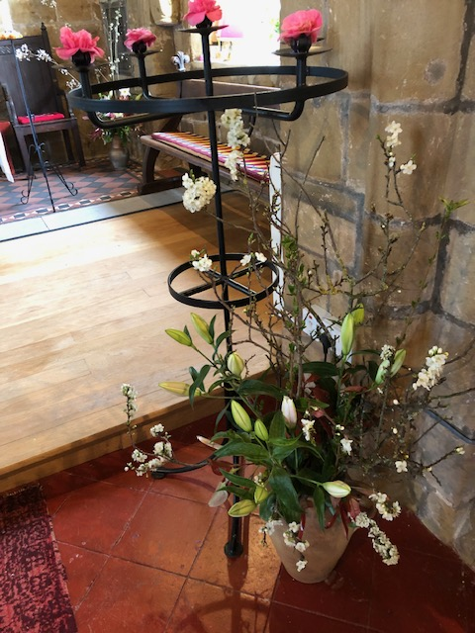

Your Editor is pleased to show e-News readers some photos of the lovely Easter Flowers in Hilton Church (photos kindly provided by Sally Hamlin).

_____________________________________

Services and Events in our Churches over the next two weeks

On Sunday 7th APRIL 2024 – Easter 2 – there will be a single Joint Church Family (Plurality) service of Holy Communion at Brookfield Church at which our Vicar, Revd Laura Wild, will preside.

Note: there will NOT be a service at Stainton Church or at Hilton Church on that day.

The lessons set for Easter 2 are:
- Acts 4:32-35
- Psalm 133
- 1 John 1:1 – 2:2
- John 20:19-31

The Diocesan Reflection for Easter 2 is given by our Bishop of Whitby, the Rt Revd Paul Ferguson. Bishop Paul reflects on the Gospel set for the day (John 20:19-21). The Reflection can be found at this link.

On Tuesday 9th April 2024 at 9.30am at Stainton Church there will be a half-hour Plurality Prayer Gathering.

On Holy Wednesday 10th April 2024 at 10.00am at Brookfield Church there will be a service of Holy Communion at which our Vicar, Revd Laura Wild, will preside.
_____________________________________

On Sunday 14th APRIL 2024 – Easter 3 there will be services of Holy Communion at which our Vicar, Revd Laura Wild, will preside, as follows:

At 8.00am at Hilton Church;

At 9.30am at Brookfield Church; and

At 11.00am at Stainton Church

The lessons set for Easter 3 are:
- Acts 3:12-19
- Psalm 4
- 1 John 3:1-7
- Luke 24:36b-48
The Diocesan Reflection for Easter 3 will be available at this link in due course from about the Thursday of the preceding week.

On Tuesday 16th April 2024 at 9.30am at Stainton Church there will be a half-hour Plurality Prayer Gathering.
On Wednesday 17th April 2024 at 10.00am at Brookfield Church there will be a service of Holy Communion at which our Vicar, Revd Laura Wild, will preside.
_____________________________________

Stainton with Hemlington Annual Meetings 2024

The 2024 Annual Meetings for our Parish (the Meeting of Parishioners (MoP) to elect the Churchwardens and the Annual Parochial Church Meeting (APCM) to elect some PCC Members and receive the 2023 Annual Accounts and 2023 Annual Report) will be held in Stainton Church on Sunday 28th April 2024 immediately after the 11.00am service that day. Fuller details, including nomination forms, are available at this link.

Members of Stainton Church are asked to consider who they want to serve on the PCC. This year we need to elect:
- Two Churchwardens to serve for a one-year term (2024-2025);
- Two Lay Reps to serve for a three-year term (2024-2027): and
- Two Lay Reps to serve for a one-year term (2024-2025)

Completed nomination forms should be returned to Bob Ardley, PCC Secretary, as soon as possible – the forms can be given to Bob at any Sunday service or delivered to him at home at 26 Meldyke Lane, Stainton.

The following Lay Reps continue on the PCC for the coming session:
- Julia Ardley, Deanery Synod Rep (2023-2026) – ex officio PCC member;
- Bob Ardley, Lay Rep (2023-2026); and
- Judith Clare, Lay Rep (2023-2026).

Copies of the meeting papers (Agendas for this year’s meetings and the Minutes of last year’s meetings; the Annual Report for 2023, and the Accounts for 2023) will be sent by e-mail (or hand delivered) to Stainton Church Members on the Electoral Roll on Saturday 6th April 2024.

_____________________________________

Please continue to pray …..

….. for Syria and Türkiye (Turkey)

For the people of Türkiye and Syria affected by the earthquakes on 6th February 2023.

… for Israel and Palestine

For an end to the war which is causing so much loss of life and destruction.

…. and for Ukraine

Pray for an early end to the war between Russia and Ukraine.
_______________________________

Please join us in praying for our Churches to Grow

Revitalise (*) is the Diocesan “Growing Health Churches” programme which seeks to help us be a viable flourishing presence into the future.
Can we invite you to use our Revitalise "prayer for growth" in your personal quiet times with God?

Revitalise us Lord,
Enthuse in our congregations the desire for mission. Give
Vision to our planning and
Inspire our thoughts as we seek your will.
Teach us to be more like you, Christ
Abiding in you and
Loving one another.
In growing healthy churches,
Sharing our faith, living Christ’s story
Every day, help us to be faithful disciples and bear much fruit. Amen.
(*) You can read more about Revitalise in the Archbishop’s address to the July 2023 Diocesan Synod meeting at this link.
______________________________________

Pastoral Support - Here are the contact details for our Vicar, Revd Laura Wild:

Address: The Vicarage, 89 Low Lane, Brookfield, Middlesbrough TS5 9EF
Phone: 01642-598621
E-mail: rev.laura.wild@gmail.com

Laura's normal "day off" is Friday - if you need to contact her on that day please leave a message on the answerphone.
______________________________________

With all good wishes to you

Bob Ardley

Ashdale House,
26 Meldyke Lane,
Stainton,
Middlesbrough TS8 9AU

Tel: 01642-284525
E-mail: bob.ardley@ntlworld.com

